INDUSTRIAL AUTOMATION | TECHNICAL MANUAL

TEMPERATURE MONITORING
AND DATA LOGGING SYSTEM
Installation, Configuration, Operation and Maintenance Manual

Document ID | TMS-UM-001
Revision | 1.0 (Draft for site review)
Date | 2026-11-07
Software baseline | Repository commit 981414c (software v1.0.0)
Audience | Technicians, system administrators, maintenance engineers, developers

CONFIDENTIAL - AUTHORIZED PERSONNEL ONLY
This manual contains system access credentials. Store the PDF and the DOCX securely, share them only with authorized personnel and do not e-mail or upload them to public services. Change default passwords where appropriate.

Document Control

Revision history
Rev | Date | Description | Prepared by | Status
1.0 | 2026-11-07 | First complete issue. Written from the project source code (repository commit 981414c, software v1.0.0) and from the screenshots and photographs supplied by the project owner. | Claude Code (AI-assisted) for the project owner | Draft for site review

Purpose and scope
This manual explains how to install, configure, operate, monitor and maintain the Temperature Monitoring and Data Logging System: PVR SZ-7526TX-REA temperature controllers read over RS-485 by a Raspberry Pi 5 node, which forwards the readings to a Flask web server running on an Ubuntu virtual machine. It is written so that a technician who has never configured the system can set up the Raspberry Pi node, configure the server, start both applications, log in to the website, monitor temperatures and export historical data.
It also explains what happens when something fails: Chapter 8 describes the exact behaviour of the system when the server, the Raspberry Pi or both are shut down for an hour, how the Raspberry Pi buffers readings as pending, and what the 7-day local retention really covers.

How this manual was verified
- Source code first. All files under raspberry_pi_node/, server/, scripts/, docs/ and dev_tools/ were read. Register addresses, serial parameters, file paths, service names, table names, timings and limits in this manual are taken from that code and cross-checked against the controller's instruction manual and register map. The chapter outline supplied with the request was used as a checklist, not as a source of facts.
- Supplied by the project owner. IP addresses, host names, user names, passwords, Wi-Fi details and the hardware photographs cannot be verified from the source code. They are reproduced as supplied and labelled accordingly.
- Not executed. No command in this manual was run against your Raspberry Pi, virtual machine or controller while it was written. Commands come from the project's own scripts and documents or are standard Linux usage. Example outputs are typical and will differ in detail. Try new procedures on a spare unit first.
- To be confirmed. Anything that could not be established from the code or the supplied material is marked To be confirmed. Appendix D lists all of them in one place.

Conventions used in this manual
Convention | Meaning
monospace text | A command, file name, path, setting or value to type or look for exactly as shown.
(Technician) / (Administrator) | Who normally performs the procedure. Technician = on-site person working on the hardware and the Raspberry Pi. Administrator = person with administrator rights on the Ubuntu server or the website.
To be confirmed | A fact that could not be verified from the source code. Check it on site before relying on it.
Supplied by owner | A value given by the project owner (credentials, IP addresses, host names).
Example output | Typical output shown for orientation. Your values will differ.

NOTE
A note gives background or a useful tip.

IMPORTANT
An important message describes something that affects results or safety of the data.

WARNING
A warning describes an action that can cause data loss, downtime or a security problem.

TO BE CONFIRMED
A to-be-confirmed box lists something to verify on site.

VERIFIED IN SOURCE
A verified-in-source box states what the project code actually does, with the file it comes from.

Roles
Role | Typical person | What they do with this system
Technician | Electrician / instrumentation technician | Wires RS-485, sets controller parameters, powers the Raspberry Pi, connects it to the network, checks the node on site.
System administrator | IT or automation engineer | Maintains the Ubuntu server, SSH access to the Raspberry Pi, backups, upgrades; uses the website role Administrator.
Operator (web role) | Shift operator | Dashboard, Monitoring, Data Logs, Nodes (view), Reports and exports.
Auditor (web role) | Quality / compliance | Same as Operator plus Audit Trail and audit reports.
Administrator (web role) | System administrator | Everything, including node registration, users, roles and system settings.

Source material reviewed
Area | Files
Raspberry Pi node | raspberry_pi_node/src/ (main, collector, modbus_client, registers, decoder, local_queue, uploader, server_client, health_monitor, config_manager, config_sync, commands, logging_config, validate_controller), config.example.yaml, temperature-node.service, requirements.txt
Server | server/run.py, server/app/ (config, models, routes, services, templates), server/migrations/, .env.example, requirements.txt
Scripts and tools | scripts/setup_raspberry_pi.sh, scripts/backup_database.py, dev_tools/read_temp_from_controllert.py, dev_tools/delete_controler_in_server_history.py
Project documents | README.md, docs/architecture.md, modbus-register-map.md, configuration-guide.md, installation-raspberry-pi.md, hardware-validation.md, troubleshooting.md, development-log.md, api.md
Controller documents (project folder, beside the repository) | SZ-7526TX_0.pdf (instruction manual REV3), SZ-7526TX-REA_PRM.pdf (register map). SZ-4042-C_PRM.pdf is the register map of a different controller model (SZ-4042-C); this software does not implement it and it is not used in this manual.
Supplied material | 10 website screenshots, 3 hardware photographs, system access details

Table of Contents
Right-click here and choose 'Update Field' (or press F9) to build the table of contents.

System Access Credentials and Network Configuration
CONFIDENTIAL - AUTHORIZED PERSONNEL ONLY
CONFIDENTIAL - AUTHORIZED PERSONNEL ONLY. This section contains passwords. Store this document in a secured location, restrict who can open it, never e-mail or upload it to public services, and change the default passwords where appropriate (see Chapter 17).

SUPPLIED BY OWNER - NOT VERIFIABLE FROM CODE
All values in this section are supplied by the project owner. The source code stores only hashed web passwords, so none of the passwords can be verified from the code. Confirm each value on site.

Remote Ubuntu virtual machine
Parameter | Configuration
IP address | 10.145.15.245
Hostname | temp-Virtual-Machine
Username | temp
Password | Temp@098
Operating system | Ubuntu (version To be confirmed; the project README supports Ubuntu 22.04 and 24.04)
Purpose | Remote server hosting the application and the database

NOTE
The user name temp stands for Temperature Monitoring System. It does not mean temporary.

Web application login
Parameter | Configuration
Website URL | http://10.145.15.245:8000
Username | admin
Password | avo@1234

To open the website, connect a computer to the plant network, start a web browser, type http://10.145.15.245:8000 in the address bar, and sign in with the user name and password above. The full procedure with screenshots is in Chapter 11. The website listens on TCP port 8000 and uses plain HTTP (no certificate), as configured by HOST and PORT in the server's .env file.

Raspberry Pi - Node 1
Parameter | Configuration
Hostname | temp-logging-system-node-1
Ethernet IP | 192.168.0.100
Username | pi
Password | avo1234
Device role | Temperature Monitoring Node 1

Wi-Fi configuration
Parameter | Configuration
Wi-Fi SSID | AVO_MACHINES
Wi-Fi password | b1n@ry010
Currently observed IP | 10.145.15.166
Network interface | wlan0

Do not treat the Wi-Fi IP address as permanent
The Wi-Fi address 10.145.15.166 is a DHCP address observed at the time of writing. The router may give the Raspberry Pi a different address after a restart or lease expiry. Do not treat it as a permanent address. The Ethernet address 192.168.0.100 is the address to use when you connect with a cable to that network.

Names you will meet in the system
Several different names are used. They are not interchangeable:
Name | Example in this system | Where it is used
Raspberry Pi host name | temp-logging-system-node-1 | The operating system name of the Pi (shown in the SSH prompt).
Node ID | temp_control_unit_1 | The application name of the node. Must be identical in the Pi's config.yaml and in the website under Nodes. Shown in Data Logs and in the Audit Trail (Figures 12-5 and 12-3).
Controller ID | Temp_Control_1, Temp_Control_2 | One per physical controller; unique within a node. Shown as Temp Control 1 and Temp Control 2 on the dashboard (Figure 12-1).
Slave ID (did) | 1 and 2 | The Modbus address set on each controller. It must match the controller's slave_id setting.
Ubuntu VM host name | temp-Virtual-Machine | The operating system name of the server.

Identify the Raspberry Pi's current IP address
The Raspberry Pi has two network interfaces with different addresses:
Interface | Address type | When to use it
eth0 (Ethernet cable) | 192.168.0.100 (supplied by owner; fixed or reserved - To be confirmed) | Commissioning and maintenance with a cable. The address does not depend on Wi-Fi.
wlan0 (Wi-Fi, SSID AVO_MACHINES) | Assigned by the Wi-Fi router (DHCP); can change | Normal operation: this is the path the node uses to reach the server at 10.145.15.245.

To find the Wi-Fi address, log in to the Raspberry Pi (by cable at 192.168.0.100, or with a keyboard and monitor) and run:
On the Raspberry Pi
hostname -I
ip -4 addr show wlan0
nmcli -f GENERAL.STATE,IP4.ADDRESS,IP4.GATEWAY device show wlan0

hostname -I lists all addresses of the Pi. The line starting inet under wlan0 is the Wi-Fi address. You can also read the address the node last used from the website: the node's page (Nodes > the node) shows Host / IP, and the Source IP column of the Audit Trail shows the address from which the node connected (for example 10.145.15.166 in Figure 12-5). The DHCP client list in the Wi-Fi router shows it as well.

Connect to the Raspberry Pi and to the server with SSH
SSH is a secure remote login. On Windows 10/11 it is built in (Windows Terminal or PowerShell):
From a Windows PC (first line: Pi by Ethernet; second: Pi by Wi-Fi; third: Ubuntu server)
ssh pi@192.168.0.100
ssh pi@<current-Wi-Fi-IP>
ssh temp@10.145.15.245

The first time you connect, SSH shows the host's fingerprint and asks Are you sure you want to continue connecting. Type yes. Then enter the password from the tables above (nothing is shown while you type). To leave the session, type exit. If you reinstall a device and SSH warns that the host key has changed, remove the old entry with ssh-keygen -R <address> and connect again.

Security recommendations
- Change the default passwords of the pi and temp accounts and of the website admin account after commissioning. The website enforces a minimum of 8 characters, a mix of letters with digits or symbols, and not containing the user name; a lock-out follows 5 failed attempts for 15 minutes.
- Create a separate website user for each person (Administration > Users) instead of sharing admin, so that the Audit Trail shows who did what.
- Prefer SSH keys to passwords for the pi and temp accounts once access is working.
- If the Wi-Fi password is changed on the router, the Raspberry Pi will lose its network until the new password is stored on the Pi (Chapter 4). The node keeps recording during that time and uploads the backlog afterwards (Chapter 8).
- Treat the node token (shown once when a node is registered) as a password. It is stored on the Pi in /etc/temperature-node/node.env.

CHAPTER 1

1 Introduction

1.1 Purpose of the system
The Temperature Monitoring and Data Logging System continuously reads the temperature and the operating state of PVR Controls SZ-7526TX-REA temperature controllers, stores every reading, and shows live and historical data in a web browser. It is designed for sites that need a trustworthy temperature record, including an honest record of when data is missing, and a tamper-resistant history of who changed what.
Three design rules shape everything in this manual (see README.md and docs/architecture.md):
- Nothing is invented. A failed poll is stored as a record with no temperature. Missing values stay empty; they are never estimated or carried forward.
- No data loss through outages. The Raspberry Pi stores every reading on its own disk first and deletes it only after the server confirms that it is stored (Chapter 8).
- Everything is traceable. Every login, configuration change, export and communication event is written to an append-only audit trail.

1.2 Applications and use cases
The SZ-7526TX-REA is a refrigeration temperature controller: its registers report a compressor relay, an alarm relay, defrost state, high/low-temperature faults, a door-open input and probe failure (docs/modbus-register-map.md). Typical uses of this system are:
- Monitoring cold rooms, freezers and other refrigerated storage from a central screen.
- Keeping a searchable temperature history with set point, compressor and alarm state for each controller.
- Producing temperature-excursion, fault, downtime and missing-data reports for quality or audit purposes.
- Monitoring several controllers per Raspberry Pi and several Raspberry Pi nodes per server.
IMPORTANT
The project makes no claim of compliance with any regulatory standard (README.md). Whether the reports are acceptable for a given regulation must be decided by the site's quality department.

1.3 System capabilities
Capability | What it means in practice
Live dashboard | One card per controller with temperature, set point, compressor and alarm state, faults and a clear status label.
Trend monitoring | Chart with minimum/maximum per time bucket, set point, fault changes and failed polls for 1 h, 6 h, 24 h, 7 d, 30 d or a custom range.
Data logs | Every poll attempt, filterable by time, node, controller, site, temperature, faults, communication state, quality and more.
Exports | Excel (.xlsx) and PDF export of exactly the records shown, plus eight audit and operational reports. Every export is recorded with a SHA-256 hash.
Node management | Register Raspberry Pi nodes, edit their configuration remotely (versioned), disable them, issue a new token.
Store-and-forward | The node buffers readings during server or network outages and uploads them in order afterwards.
Health monitoring | Heartbeat every 30 s with queue size, Wi-Fi signal, CPU temperature, disk space and clock synchronisation.
Audit trail | Append-only log of logins, configuration changes, communication events, faults and exports. Entries cannot be edited or deleted through the application.
Role-based access | Administrator, Operator and Auditor roles; permissions are checked on the server for every request.

1.4 Major hardware and software components
Component | Details (from the project)
Temperature controller | PVR Controls SZ-7526TX-REA, Modbus RTU slave. In this installation: slave ID 1 (Temp Control 1) and slave ID 2 (Temp Control 2). Its serial port is a 5-pin TTL header ("TTL OUT (RS485)"), connected to the bus through a TTL-to-RS-485 interface (Chapter 7).
Raspberry Pi | Raspberry Pi 5 (identified from the supplied photograph). The project supports Raspberry Pi 3B+/4/5/Zero 2 W with Raspberry Pi OS Bookworm or newer, Python 3.10 or newer.
RS-485 interface | Waveshare 2-channel RS-485 HAT (per config.example.yaml); serial port /dev/ttySC1.
Node software | Python application src.main (v1.0.0); pymodbus 3.11.3, pyserial 3.5, requests 2.32.3, PyYAML 6.0.2; local buffer in SQLite.
Server | Ubuntu virtual machine 10.145.15.245; Python, Flask 3.1.0 served by Waitress 3.0.2; SQLAlchemy 2.0.36 with Alembic migrations.
Database | SQLite file instance/temperature.db (default). PostgreSQL is supported through DATABASE_URL but has not been tested by the project.
Web interface | Jinja2 pages with Bootstrap 5 and Chart.js, all bundled locally (works without internet access).
Reports | openpyxl 3.1.5 (Excel), ReportLab 4.2.5 (PDF).

1.5 Limitations to be aware of
- Hardware validation. The project's development log states that the software was verified against the register-map documents and a simulator and not yet against a physical controller. Complete the commissioning checks in Chapter 7 and record them (Chapter 18).
- No e-mail or SMS alerts. Alarms and faults are visible on the dashboard and in reports only.
- Controller parameters cannot be changed remotely. The software only reads parameters. Remote controller commands (alarm mute, fault reset, log reset, defrost) are disabled unless enabled on both the server and the node.
- Exports are not stored on the server. Only the export's metadata and SHA-256 are kept; the file is delivered to your browser.
- One server process. The offline-detection monitor runs inside the server process, so run only one instance.
- Large databases. Very large SQLite databases (tens of millions of rows) make unfiltered Data Logs counts slower. Date filters keep normal use fast.

CHAPTER 2

2 System Architecture

2.1 Architecture block diagram
Figure 2-1 shows the complete path of a temperature reading from the controller to the person looking at the website.
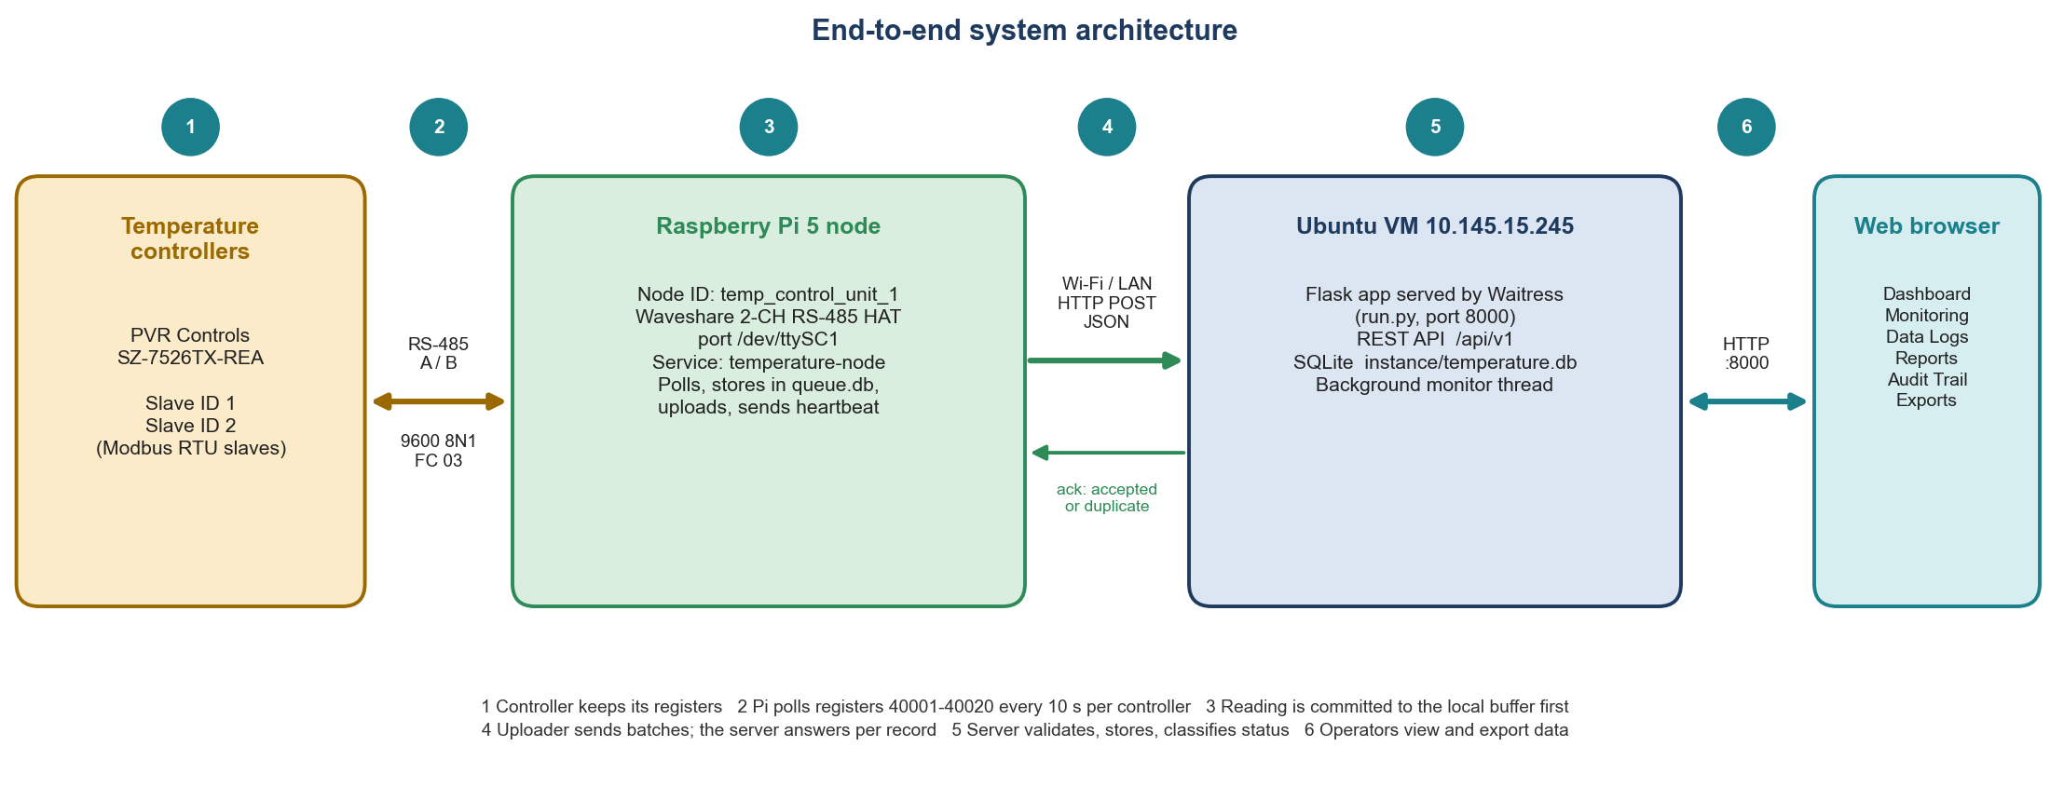
Figure 2-1 - End-to-end architecture: Temperature controller, RS-485, Raspberry Pi node, Wi-Fi/Ethernet, Ubuntu server with database, web application and end user.

2.2 Role of each component
Component | Role | Key facts
Temperature controller | Measures the temperature and controls the refrigeration equipment. Exposes its state in Modbus holding registers. | Slave (responds only when asked). Registers 40001-40020 are read-only status data.
RS-485 bus | Two-wire differential serial link between the Raspberry Pi and the controllers. | 9600 baud, 8 data bits, no parity, 1 stop bit (project default); half duplex.
Raspberry Pi node | Field computer. Asks each controller for its registers, decodes them, stores them, uploads them, reports its own health. | Always the initiator: the server never connects to the Pi.
Wi-Fi / Ethernet | Carries HTTP requests from the node to the server. | Node uses the server URL http://10.145.15.245:8000.
Ubuntu server | Receives readings, validates and stores them, tracks node and controller state, serves the website and exports. | Flask app run by Waitress (run.py), port 8000.
Database | Permanent storage of readings, events, nodes, users, audit trail and settings. | SQLite instance/temperature.db; readings and audit events are never purged.
Web application | Browser interface for monitoring, history, reports, administration. | Pages refresh themselves every 10 s (setting Dashboard refresh).
End user | Operator, auditor or administrator. | Signs in with a user name and password; permissions depend on the role.

2.3 How the Raspberry Pi communicates with the controllers
The node runs one bus collector thread per RS-485 port. For this installation there is one bus, rs485-1 on /dev/ttySC1, carrying both controllers. Every 10 seconds per controller the thread sends a Modbus RTU read-holding-registers request (function code 03) for registers 40001 to 40020 and waits up to 1 second for the reply. All traffic on a bus is serialised with a lock, because RS-485 is half duplex. Chapter 7 lists every register and Chapter 8 shows the request frame in hexadecimal.

2.4 How temperature data is collected
1. The controller answers with 20 register values. The node checks the identity registers (40001 must be 7507 and 40003 must be 115) so that a wrong address or wrong device can never produce plausible-looking data.
2. The decoder converts the raw control temperature (register 40006) using the resolution register rS (40005): rS = 0 means a scale of 0.1 °C, rS = 1 means 1 °C. The value 1001 means probe fail low and 1002 probe fail high; no temperature is reported in those cases.
3. The node builds one reading record with a unique ID, the acquisition time (UTC), the decoded values, the raw registers and a quality label. A failed poll becomes a record with comm_status other than ok and empty temperature.
4. The record is committed to the local buffer queue.db before anything else happens.

2.5 How the node transfers data to the server
A separate uploader thread takes the oldest pending records (up to 200 at a time) and sends them as JSON in an HTTP POST to /api/v1/readings, authenticated with the node ID and a secret token. The server stores the batch and answers per record accepted, duplicate or rejected. Only then does the node mark them delivered. If the server cannot be reached, the records stay pending and the uploader retries with a growing delay (2 s up to 300 s). A heartbeat every 30 s reports the node's health, and the same connection is used to fetch configuration and commands. Details: Chapter 8.

2.6 How the server processes and stores data
- Every record is validated (UUID, time, allowed values, temperature between -100 and 200 °C or empty). Invalid records are rejected individually.
- Records already stored (same UUID) are answered as duplicate, which makes retries harmless.
- Records are stored in temperature_readings and the controller's latest state is updated. Fault and alarm periods are derived from the fault register.
- A readings batch arriving more than 120 s after acquisition is flagged backfilled (delivered late after an outage).
- A background monitor marks a node offline when it has not been heard from for 120 s and records the event in the audit trail.

2.7 How the website retrieves and displays data
The website reads the database through the server. Pages such as the Dashboard and Monitoring poll the server's /ui-api/dashboard and /ui-api/series endpoints every Dashboard refresh interval (10 s by default) and update without reloading. Each controller is shown with an explicit status (Normal, Check data, Controller not responding, Stale data, Node offline, ...) so that an old value is never presented as live (Chapter 13).

2.8 Network layout
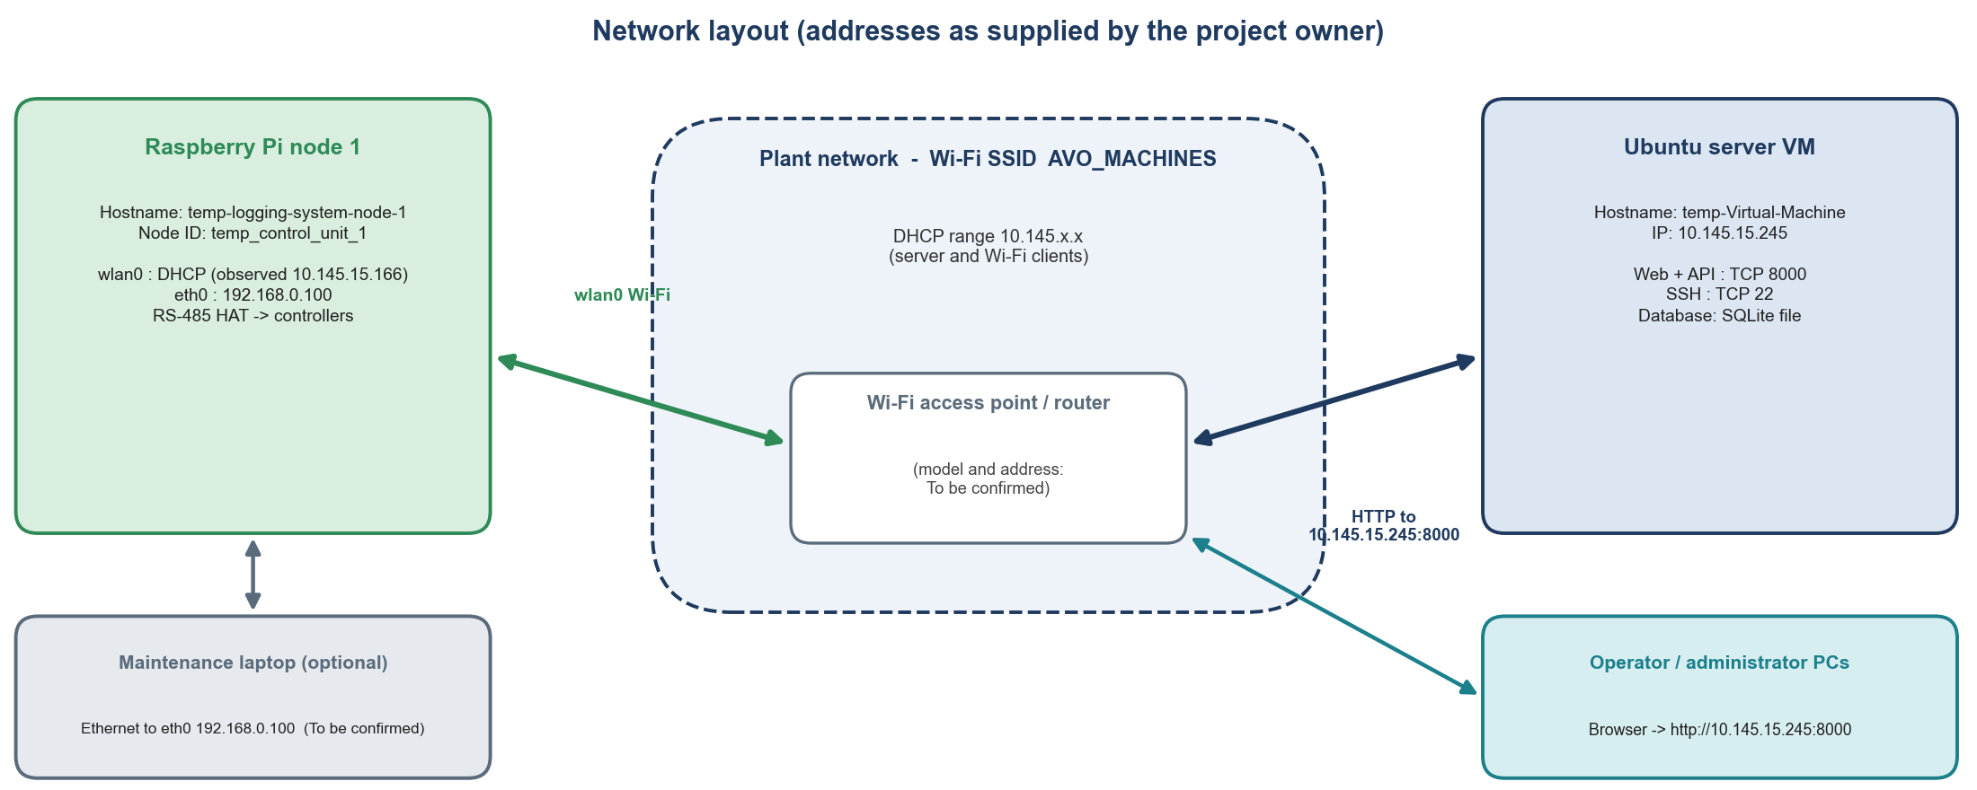
Figure 2-2 - Network layout with the addresses supplied by the project owner. The Wi-Fi address of the Raspberry Pi is assigned by DHCP and can change.

2.9 Hardware configuration
The photographs supplied by the project owner show the node hardware: a Raspberry Pi 5 in a black ventilated metal enclosure, with a Waveshare-style 2-channel RS-485 HAT mounted above the enclosure on brass standoffs and connected by a 40-way ribbon cable.
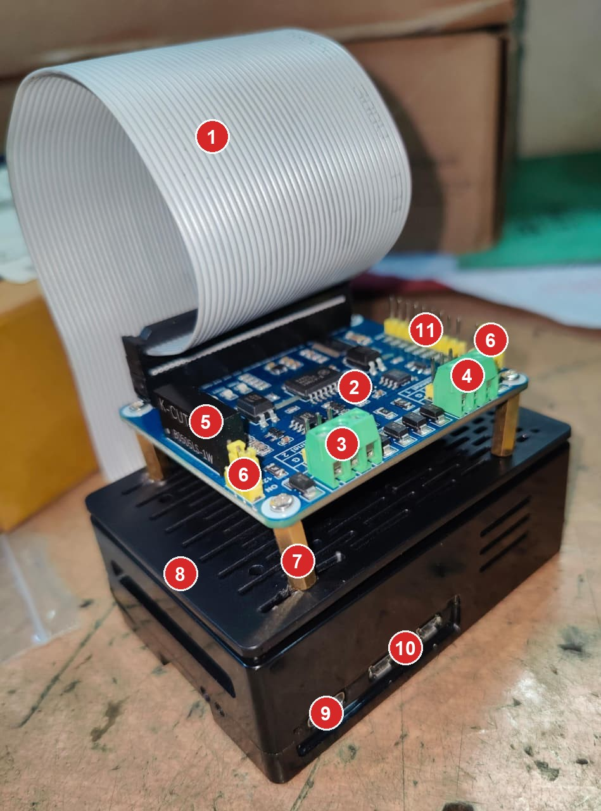
Figure 2-3 - Node hardware overview (photograph supplied by the owner, call-outs added).
No. | What is shown | Explanation
1 | 40-way ribbon cable | Carries the Raspberry Pi's 40-pin GPIO header (inside the enclosure) up to the HAT. The HAT is therefore powered and controlled through this cable.
2 | Interface circuitry of the HAT | Converts between the Pi's SPI interface and the two RS-485 channels. The chip markings are not legible in the photograph. The device names /dev/ttySC0 and /dev/ttySC1 used by the project indicate an SPI-UART bridge driver. Exact HAT model: To be confirmed.
3 | Terminal block, front (silkscreen Channel 2) | Screw terminals for one RS-485 channel. The project uses /dev/ttySC1, which the example configuration describes as the HAT's second channel.
4 | Terminal block, rear (Channel 1) | Second RS-485 channel. Not used by the current configuration.
5 | Black module marked K-CUT B0505LS-1W | A DC-DC converter module. Its presence indicates that the RS-485 side of the HAT has its own isolated supply; verify against the HAT documentation.
6 | Yellow jumpers | Configuration jumpers of the HAT (one near the DC-DC module, one beside each terminal block). Their functions are To be confirmed from the HAT documentation. Do not move them without checking.
7 | Brass standoffs | Mechanical spacers holding the HAT above the enclosure.
8 | Black ventilated metal enclosure | Holds the Raspberry Pi 5.
9 | USB-C connector on the enclosure front | Power input of the Raspberry Pi.
10 | Micro-HDMI connectors | Two video outputs, useful for a temporary monitor during setup (Chapter 3).
11 | 9-pin yellow header | Pin header on the HAT; its function is To be confirmed from the HAT documentation.

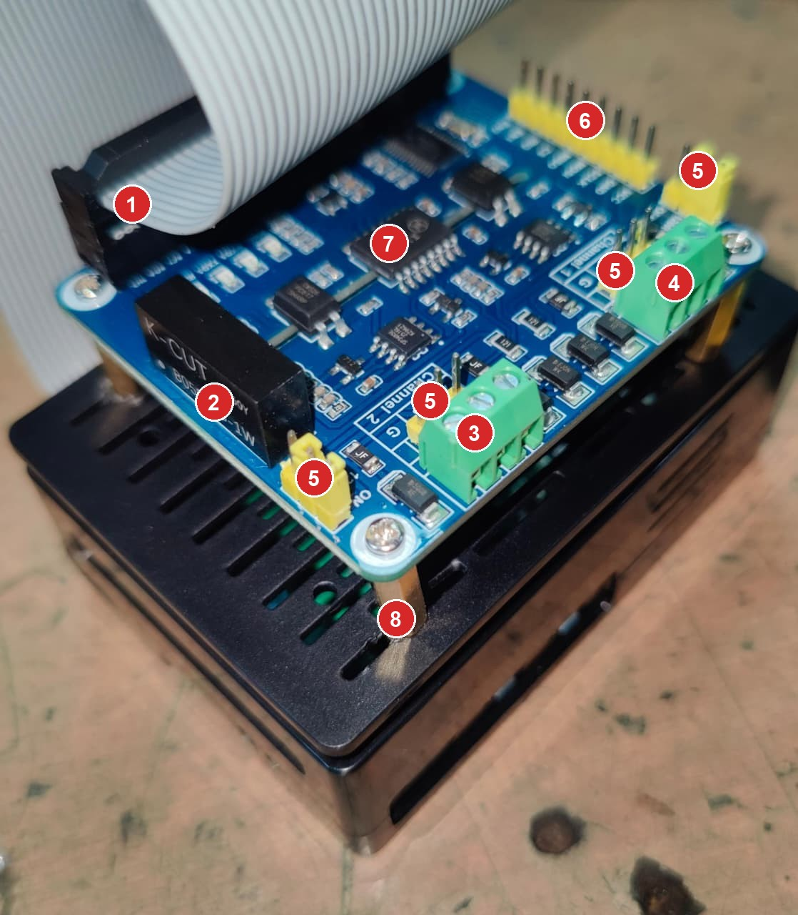
Figure 2-4 - Close-up of the RS-485 HAT (photograph supplied by the owner, call-outs added).
No. | What is shown | Explanation
1 | Ribbon-cable socket | 40-way connector on the HAT end of the ribbon cable.
2 | DC-DC module | K-CUT B0505LS-1W (legible in the photograph).
3 | Terminal block with silkscreen Channel 2 | The silkscreen near the terminals carries letters such as G. The full order of the three screw terminals is To be confirmed on the board before wiring (Chapter 7).
4 | Terminal block of Channel 1 | Unused.
5 | Jumper positions (four marked) | Pin headers with yellow jumpers beside the DC-DC module, beside each terminal block and at the top right edge.
6 | 9-pin header | Unlabelled in the photograph.
7 | Largest integrated circuit | Marking not legible. Presumably the UART bridge; To be confirmed.
8 | Standoff and mounting screw | Mechanical.

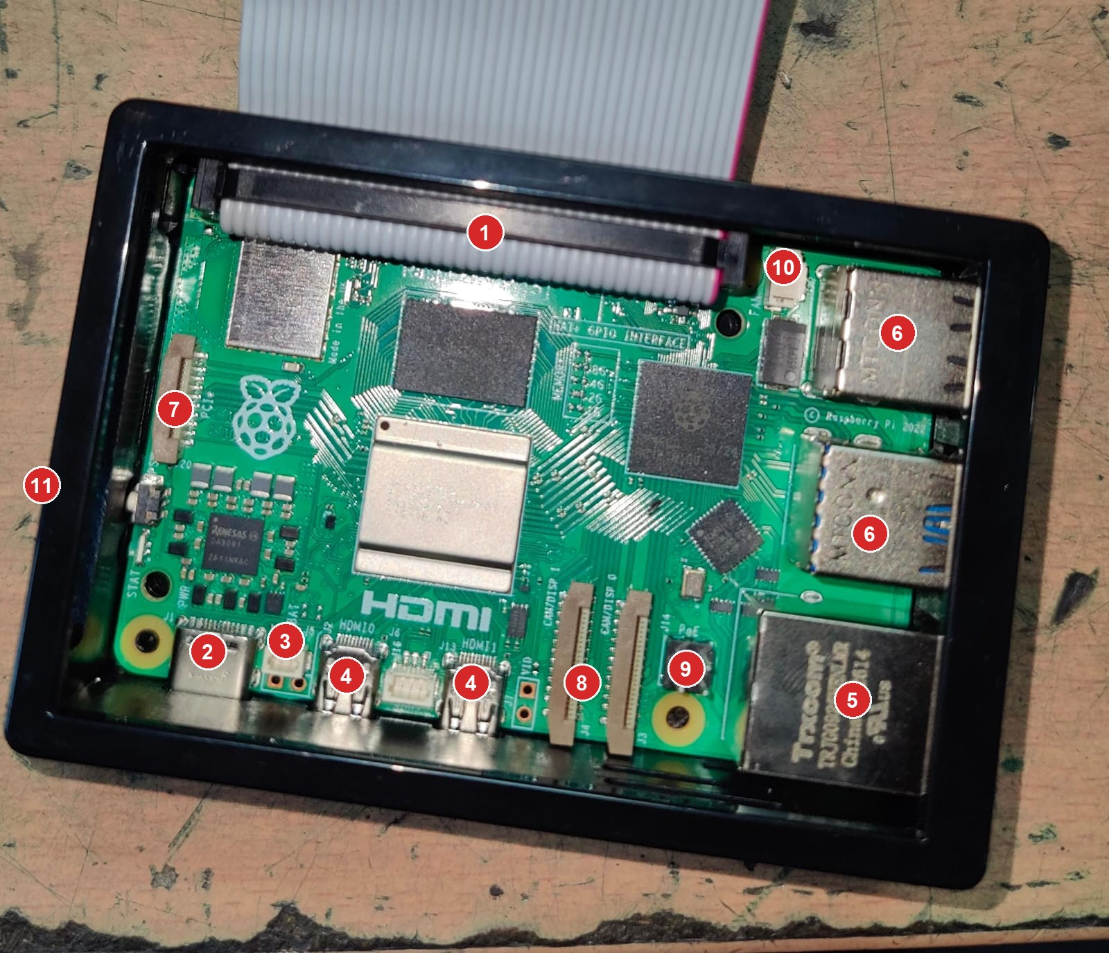
Figure 2-5 - The Raspberry Pi 5 board inside its enclosure (photograph supplied by the owner, call-outs added).
No. | What is shown | Explanation
1 | 40-pin GPIO header with the ribbon-cable connector | The HAT's signals (SPI, power, ground, interrupt) reach the Pi through this header.
2 | USB-C power input (J1) | Power the Raspberry Pi with a suitable supply (the official Raspberry Pi 5 supply is 5 V / 5 A; this is general Raspberry Pi guidance, not a project requirement).
3 | RTC battery connector (BAT) | Optional battery connector for the Pi 5's real-time clock. No battery is visible in the photograph. Without one the clock depends on network time (NTP); see Chapter 8.
4 | Micro-HDMI 0 and 1 | Video outputs.
5 | Gigabit Ethernet (RJ45) | Wired network; eth0, address 192.168.0.100 as supplied by the owner.
6 | USB ports (two stacks) | USB 3.0 (blue) and USB 2.0. Usable for a keyboard during setup.
7 | PCIe connector | Not used by this project.
8 | Camera / display connectors | Not used by this project.
9 | PoE header (J14) | Not used by this project.
10 | Fan connector | Not used by this project.
11 | Enclosure frame | The Raspberry Pi is mounted in the black enclosure.

2.10 Where the key information is
NOTE
What happens when the server or the Raspberry Pi is shut down for an hour? In short: if the server is down, nothing is lost: the Pi keeps recording and uploads everything afterwards. If the Raspberry Pi is down (or both), the hour is not recorded, because the Pi is the only device that reads the controllers; the gap is reported and shown in the website. The full explanation with timings, screens and a real example from your audit trail is in Chapter 8.

CHAPTER 3

3 Raspberry Pi Initial Configuration
This chapter prepares a new Raspberry Pi so that it is ready to receive the node software (Chapter 5). Perform it once per node. The Raspberry Pi in this installation is temp-logging-system-node-1.

3.1 What you need (Technician)
- Raspberry Pi 5 in its enclosure, with a suitable USB-C power supply (the official 5 V / 5 A supply is the general recommendation for the Pi 5).
- A good-quality microSD card or USB SSD. The project notes that cheap cards and power cuts are the most common cause of Raspberry Pi failures (docs/installation-raspberry-pi.md).
- The 2-channel RS-485 HAT with its 40-way ribbon cable (Chapter 2, Figures 2-3 to 2-5).
- A Windows computer with the Raspberry Pi Imager program, and either the plant Wi-Fi (SSID AVO_MACHINES) or an Ethernet cable to a network that reaches the server.
- Optional for first setup: micro-HDMI-to-HDMI cable, monitor and USB keyboard.

3.2 Prepare Raspberry Pi OS (Technician)
1. Start Raspberry Pi Imager on the Windows computer.
2. Choose Raspberry Pi 5 as the device and Raspberry Pi OS Lite (64-bit) (Raspberry Pi OS Bookworm or newer) as the operating system. The node software needs Python 3.10 or newer, and pymodbus 3.11 does not support older Python versions.
3. Choose the storage (the microSD card or SSD) and click Next, then Edit settings (OS customisation).
4. On the General tab set: hostname temp-logging-system-node-1; username pi and the password from the credentials section; Wi-Fi SSID AVO_MACHINES with its password and your Wi-Fi country; time zone Asia/Kolkata.
5. On the Services tab enable SSH with password authentication.
6. Save, confirm, and write the image. Wait until the Imager reports success, then remove the card.
NOTE
Current Raspberry Pi OS versions no longer create a default pi user. The user name and password you enter in the Imager become the only account, so enter them carefully.

3.3 First boot and connection (Technician)
1. With the Pi powered off, check that the ribbon cable and the HAT are fitted as in Figure 2-3 (the HAT is not needed for this chapter, but never connect or disconnect the ribbon cable while the Pi is powered).
2. Insert the card. Connect an Ethernet cable if you will use the cable first. Optionally connect a monitor and keyboard to the micro-HDMI and USB ports.
3. Connect power. The first boot takes one to two minutes because the system expands itself and applies your settings.
4. Find the Pi's address: the Wi-Fi router's client list, or from Windows ping temp-logging-system-node-1.local (this works only if name resolution is available on your network; To be confirmed). With an Ethernet cable the owner's address 192.168.0.100 is expected (To be confirmed whether it is fixed in the Pi or reserved in the router).

3.4 Log in over SSH (Technician)
On the Windows computer (use the current Wi-Fi address instead if you connect over Wi-Fi)
ssh pi@192.168.0.100

Answer yes to the fingerprint question, then type the password. The prompt changes to something like pi@temp-logging-system-node-1:~ $. All commands in the rest of this chapter are typed in this SSH session.

3.5 Update the operating system (Technician)
On the Raspberry Pi
sudo apt update
sudo apt full-upgrade -y
sudo reboot

sudo runs a command with administrator rights. apt update refreshes the list of available packages, apt full-upgrade -y installs all updates (this can take several minutes), and reboot restarts the Pi. Wait one minute and log in again.

3.6 Set and check the host name
On the Raspberry Pi
hostnamectl
sudo hostnamectl set-hostname temp-logging-system-node-1

hostnamectl shows the current Static hostname. The second command is needed only if it differs. The host name is only the operating-system name; the application name of the node (node ID, temp_control_unit_1) is set separately in the node configuration (Chapter 5).

3.7 Set the time zone and check time synchronisation
On the Raspberry Pi
sudo timedatectl set-timezone Asia/Kolkata
timedatectl

Example output - the last two lines matter
Local time: Sat 2026-11-07 13:30:12 IST
Universal time: Sat 2026-11-07 08:00:12 UTC
Time zone: Asia/Kolkata (IST, +0530)
System clock synchronized: yes
NTP service: active

IMPORTANT
The node stores all times in UTC and flags every reading taken while the clock is not synchronised (clock_unsynchronized, quality suspect). Make sure System clock synchronized: yes appears after the Pi has been online for a few minutes. The setup script enables systemd-timesyncd for this reason (scripts/setup_raspberry_pi.sh).

3.8 Enable the RS-485 HAT (Technician)
The example configuration uses the serial port /dev/ttySC1. Such ports exist only when the HAT's driver is enabled in the Raspberry Pi boot configuration. This step is hardware-specific and is not part of the project's source code, so it is marked To be confirmed: follow the documentation of your exact HAT model and revision.
TO BE CONFIRMED - HAT driver setting
For Waveshare 2-channel RS-485 HATs based on an SPI-UART bridge, the vendor documentation generally asks for SPI to be enabled and an overlay line such as dtoverlay=sc16is752-spi1,int_pin=24 to be added to /boot/firmware/config.txt on current Raspberry Pi OS, followed by a reboot. Confirm the exact line for your HAT before using it. In this installation the ports already work (/dev/ttySC1 is used by dev_tools/read_temp_from_controllert.py), so normally nothing needs to be changed on a Pi that has already been commissioned.

Check on the Raspberry Pi whether the HAT ports exist
ls -l /dev/ttySC*
dmesg | grep -i -E 'sc16|spi' | tail

ls -l /dev/ttySC* should list /dev/ttySC0 and /dev/ttySC1 (one per RS-485 channel). If nothing is listed the driver is not loaded: re-check the HAT documentation, the ribbon cable seating and the boot configuration.

3.9 Install Python and other packages
On the Raspberry Pi
python3 --version
sudo apt install -y python3 python3-venv python3-pip rsync sqlite3 git curl

python3 --version must show 3.10 or newer. The next command installs Python, its virtual-environment and pip tools, rsync (used by the installer), the sqlite3 command-line tool (used in this manual to inspect the buffer), git and curl. The node's Python libraries (pymodbus, pyserial, requests, PyYAML and their dependencies) are installed automatically into a private virtual environment by the installer in Chapter 5; you do not install them by hand.

3.10 Verify network connectivity and the server
On the Raspberry Pi
ping -c 4 10.145.15.245
curl -s http://10.145.15.245:8000/api/v1/ping

Example output
PING 10.145.15.245 (10.145.15.245) 56(84) bytes of data.
64 bytes from 10.145.15.245: icmp_seq=1 ttl=63 time=3.2 ms
...
4 packets transmitted, 4 received, 0% packet loss
{"server_time":"2026-11-07T08:01:30.123456Z","status":"ok","version":"1.0.0"}

ping tests that the server answers on the network (0 % packet loss expected). The curl command calls the server's unauthenticated health endpoint /api/v1/ping; a reply containing "status":"ok" proves that the Pi can reach the application itself, not just the machine. If ping works but curl does not, the server application is not running or a firewall blocks TCP port 8000 (Chapters 9 and 15).
VERIFIED IN SOURCE
/api/v1/ping is the only node-API route that does not require authentication (server/app/routes/api.py).

CHAPTER 4

4 Raspberry Pi Network Configuration
The node only ever initiates connections to the server (docs/architecture.md). It therefore needs a working route to 10.145.15.245:8000, by Wi-Fi, by Ethernet, or both. This chapter treats the two interfaces separately. The commands use NetworkManager (nmcli), the default on Raspberry Pi OS Bookworm.

4.1 Wi-Fi (interface wlan0)

List the interfaces and the available Wi-Fi networks
On the Raspberry Pi
nmcli device status
nmcli device wifi list

Command | What it does | What you should see
nmcli device status | Lists every network interface and whether it is connected. | A table with DEVICE TYPE STATE CONNECTION. wlan0 wifi connected AVO_MACHINES and/or eth0 ethernet connected Wired connection 1.
nmcli device wifi list | Scans for Wi-Fi networks in range. | One row per access point with SSID, channel, signal strength and security. AVO_MACHINES must be in the list; a * marks the one in use. Weak signal (below about 40) causes dropouts.
nmcli connection show | Lists the saved connection profiles. | Profiles such as AVO_MACHINES (type wifi) and Wired connection 1 (type ethernet).

Connect to a Wi-Fi network
On the Raspberry Pi (prompts for the password)
sudo nmcli --ask device wifi connect "AVO_MACHINES" ifname wlan0

--ask makes nmcli ask for the Wi-Fi password so that it does not remain in the shell history. On success it prints Device 'wlan0' successfully activated. The profile is saved and the Pi reconnects automatically after every reboot.

Verify the connection, address, interface and gateway
On the Raspberry Pi
nmcli -f GENERAL.STATE,IP4.ADDRESS,IP4.GATEWAY,IP4.DNS device show wlan0
ip -4 addr show wlan0
hostname -I
ip route

Example output (addresses are illustrative, apart from the observed 10.145.15.166)
GENERAL.STATE: 100 (connected)
IP4.ADDRESS[1]: 10.145.15.166/24
IP4.GATEWAY: 10.145.15.1
default via 10.145.15.1 dev wlan0 proto dhcp src 10.145.15.166 metric 600
10.145.15.0/24 dev wlan0 proto kernel scope link src 10.145.15.166 metric 600

Command | What it does | What you should see
nmcli ... device show wlan0 | Shows the state, address, gateway and DNS of the Wi-Fi interface. | 100 (connected) and an address in the Wi-Fi network.
ip -4 addr show wlan0 | Shows the IPv4 address of the interface. | A line inet 10.145.x.x/24. The address after inet is your Wi-Fi IP.
hostname -I | Lists all IP addresses of the Pi on one line. | For example 192.168.0.100 10.145.15.166 when both cable and Wi-Fi are up.
ip route | Shows the routing table, including the default gateway (default via ...). | One default via <router> line per interface that has a gateway. The route to 10.145.15.245 normally follows the Wi-Fi network.

Test connectivity to the server
On the Raspberry Pi
ping -c 4 10.145.15.245
curl -s http://10.145.15.245:8000/api/v1/ping

Turn off Wi-Fi power saving
The project recommends turning Wi-Fi power saving off because it causes dropouts (docs/installation-raspberry-pi.md). The project's one-line command selects the first active connection; naming the Wi-Fi profile is safer when an Ethernet cable is also connected:
On the Raspberry Pi
sudo nmcli connection modify "AVO_MACHINES" 802-11-wireless.powersave 2
sudo nmcli connection up "AVO_MACHINES"

Troubleshoot Wi-Fi connection failures
Symptom | Check | Fix
AVO_MACHINES not in nmcli device wifi list | Distance, antenna, access point switched off, 5 GHz-only network. | Move closer; confirm the access point; list again.
Connection fails with a secrets or authentication error | Wrong password; password changed on the router. | Repeat the connect command with the correct password, or delete the profile with sudo nmcli connection delete "AVO_MACHINES" and create it again.
Connected but no inet address | DHCP failure. | sudo nmcli connection down "AVO_MACHINES" && sudo nmcli connection up "AVO_MACHINES"; check the router's DHCP pool.
Address works, ping 10.145.15.245 fails | Different subnet without a route, client isolation on the access point, server down. | ip route; ping the gateway; ask the network administrator.
ping works, curl .../api/v1/ping fails | Server application stopped, or firewall blocks port 8000. | See Chapter 9. On the server: sudo ufw status.
Node drops offline periodically | Weak signal or Wi-Fi power saving. | Check the signal on the node page of the website (better than -70 dBm); disable power saving (above); consider Ethernet.
Pi address keeps changing | DHCP lease changes. | Ask for a DHCP reservation in the router (preferred), or configure a static address (below).

Configure a static Wi-Fi address (only if a DHCP reservation is not possible)
On the Raspberry Pi - replace the placeholders
sudo nmcli connection modify "AVO_MACHINES" ipv4.method manual \
ipv4.addresses <ip>/<prefix> ipv4.gateway <router-ip> ipv4.dns <dns-ip>
sudo nmcli connection up "AVO_MACHINES"

TO BE CONFIRMED
The subnet prefix, the router address and a free fixed address for the Wi-Fi network 10.145.x.x are not known from the supplied material. Obtain them from the network administrator before using a static address. A DHCP reservation in the router avoids this.

4.2 Ethernet (interface eth0)
The Ethernet address supplied by the owner is 192.168.0.100. Whether it is configured in the Pi itself or reserved by a router is To be confirmed. To check what is configured:
On the Raspberry Pi
nmcli -t -f NAME,DEVICE,TYPE connection show
nmcli -f ipv4.method,ipv4.addresses,ipv4.gateway connection show "Wired connection 1"
ip -4 addr show eth0

ipv4.method auto means the address comes from DHCP; manual means a fixed address is stored in the Pi. To fix the address at 192.168.0.100:
On the Raspberry Pi (no gateway on the cable)
sudo nmcli connection modify "Wired connection 1" ipv4.method manual \
ipv4.addresses 192.168.0.100/24 ipv4.never-default yes
sudo nmcli connection up "Wired connection 1"

Avoid two default routes
ipv4.never-default yes stops the Ethernet connection from becoming a second default route. With two default routes the Pi could send its traffic to the server over the wrong interface. Give the cable a gateway only if the server is reached through it (then the 24 prefix and a gateway must match that network - To be confirmed).

Difference between the two addresses. The Wi-Fi address (10.145.x.x, assigned by DHCP, can change) is the one the node normally uses to reach the server. The Ethernet address (192.168.0.100) belongs to a different network and is the stable address for commissioning and maintenance with a cable. Both can be active at the same time; SSH works on either.

CHAPTER 5

5 Uploading and Running the Raspberry Pi Program
This chapter installs the node software on the Raspberry Pi, configures it, runs it by hand, and proves that data reaches the server. Chapter 6 then makes it start automatically. The installer is the project's own script scripts/setup_raspberry_pi.sh.
IMPORTANT
Register the node on the website before starting it, because the one-time token that the node needs is created at registration (step 3). An unregistered node keeps recording locally but its data is not accepted by the server.

5.1 Files that make up the node
Location in the project | Purpose
raspberry_pi_node/src/ | The Python application (entry point python -m src.main).
raspberry_pi_node/config.example.yaml | Template of the local configuration file.
raspberry_pi_node/temperature-node.service | The systemd unit (Chapter 6).
raspberry_pi_node/requirements.txt | Pinned Python dependencies.
scripts/setup_raspberry_pi.sh | Installer: creates user, folders, virtual environment, configuration and service.
docs/ | Documentation (copied to the Pi by the installer).
dev_tools/read_temp_from_controllert.py | Stand-alone test that reads one temperature from a controller.

After installation the Raspberry Pi has this layout (created by the script):
Path on the Pi | Content
/opt/temperature-node/raspberry_pi_node/ | The application code.
/opt/temperature-node/venv/ | The private Python virtual environment.
/etc/temperature-node/config.yaml | Local configuration (edit this).
/etc/temperature-node/node.env | TEMP_NODE_TOKEN=... (secret, mode 640).
/var/lib/temperature-node/ | queue.db (local buffer) and remote_config.json (settings pushed from the server).
/var/log/temperature-node/node.log | Rotating log file (5 MB x 10 files); the same log also goes to journald.
/etc/systemd/system/temperature-node.service | The service definition.

5.2 Step 1 - Connect with SSH (Technician)
Follow Section 3.4. All commands below are typed on the Raspberry Pi unless a heading says On the Windows computer.

5.3 Step 2 - Create the project folder and upload the files (Technician)
The installer copies from the folder that contains raspberry_pi_node/, scripts/ and docs/. Upload those three folders (and dev_tools/ for the quick controller test). Choose one method.

Method A: tar and scp from Windows (recommended)
On the Windows computer (PowerShell)
cd "C:\Users\gokul\Documents\projects\Avo AC Unit Logging System"
cd avo_ac_loggin_system_with_rashberrypi
tar -czf node.tgz --exclude=__pycache__ --exclude=.venv --exclude=state `
raspberry_pi_node scripts docs dev_tools
scp node.tgz pi@192.168.0.100:/home/pi/

On the Raspberry Pi
mkdir -p ~/temperature-logging-system
tar -xzf ~/node.tgz -C ~/temperature-logging-system
ls ~/temperature-logging-system

tar -czf packs the folders into one compressed file (excluding caches and local virtual environments), scp copies it to the Pi, and tar -xzf unpacks it into ~/temperature-logging-system. ls must show docs, raspberry_pi_node and scripts. Do not upload raspberry_pi_node/config.yaml from a development PC; the Pi has its own configuration.

Method B: git clone, or a graphical copy
If the repository is reachable from the Pi, git clone <repository-url> ~/temperature-logging-system gives the same result. A graphical SFTP client such as WinSCP can also copy the three folders to /home/pi/temperature-logging-system (protocol SFTP, port 22, user pi).

5.4 Step 3 - Register the node on the website (Administrator)
1. Sign in to http://10.145.15.245:8000 as an Administrator (Chapter 11).
2. Open Nodes and click + Register node.
3. Enter the Node ID temp_control_unit_1, a friendly name, site and equipment, the serial port /dev/ttySC1, baud rate 9600, parity N, and one row per controller (Controller ID, name, slave ID). Give a reason (for example Initial registration) and save.
4. The next page shows the token once. Copy it immediately. It cannot be shown again; if lost, issue a new token on the node page.

5.5 Step 4 - Run the installer (Technician)
On the Raspberry Pi
cd ~/temperature-logging-system
sudo bash scripts/setup_raspberry_pi.sh

The script (scripts/setup_raspberry_pi.sh) does the following; it can be run again later to upgrade the software without losing configuration or data:
1. Checks that Python 3.10 or newer is installed, installs python3-venv, python3-pip and rsync.
2. Creates the system user tempnode (no login shell) and adds it to the group dialout so it may open the serial ports.
3. Creates /opt/temperature-node, /etc/temperature-node, /var/lib/temperature-node, /var/log/temperature-node, and copies the code and documentation.
4. Creates the virtual environment /opt/temperature-node/venv and installs requirements.txt into it.
5. Creates /etc/temperature-node/config.yaml from the example and an empty node.env if they do not exist yet.
6. Installs, reloads and enables the systemd service temperature-node.service, and enables time synchronisation.
7. Validates the configuration; if it is valid it starts the service, otherwise it tells you what to edit.

5.6 Step 5 - Edit the configuration (Technician)
On the Raspberry Pi (Ctrl+O, Enter to save; Ctrl+X to leave)
sudo nano /etc/temperature-node/config.yaml

The following is a complete configuration for this installation (one RS-485 channel with two controllers). It is based on config.example.yaml; the controller IDs Temp_Control_1 and Temp_Control_2 are the IDs that appear in the supplied Audit Trail screenshot.
/etc/temperature-node/config.yaml
node:
id: temp_control_unit_1 # must match the Node ID registered on the website
name: Temp Control Unit 1
site: ""
equipment: ""
server:
url: http://10.145.15.245:8000
token: null # leave null; the token goes into node.env
verify_tls: true
request_timeout_s: 10
upload_interval_s: 5
batch_size: 200
heartbeat_interval_s: 30
config_sync_interval_s: 60
backoff_initial_s: 2
backoff_max_s: 300
buses:
- name: rs485-1
port: /dev/ttySC1 # HAT channel used in this installation
baudrate: 9600 # 9600 | 19200 | 38400 (controller parameter bd)
parity: N # N | E | O (controller parameter PAr)
bytesize: 8
stopbits: 1
timeout_s: 1.0
retries: 2
inter_request_delay_ms: 50
controllers:
- id: Temp_Control_1
name: Temp Control 1
model: SZ-7526TX-REA
bus: rs485-1
slave_id: 1 # controller parameter did
enabled: true
poll_interval_s: 10
parameter_read_interval_s: 3600
include_raw_registers: true
comm_loss_threshold: 3
register_overrides: {address_offset: 0, read_strategy: auto}
- id: Temp_Control_2
name: Temp Control 2
model: SZ-7526TX-REA
bus: rs485-1
slave_id: 2
enabled: true
poll_interval_s: 10
parameter_read_interval_s: 3600
include_raw_registers: true
comm_loss_threshold: 3
register_overrides: {address_offset: 0, read_strategy: auto}
buffer:
path: /var/lib/temperature-node/queue.db
retention_days_delivered: 7
max_pending_records: 2000000
full_behavior: drop_oldest
min_free_disk_mb: 100
logging:
level: INFO
file: /var/log/temperature-node/node.log
format: text
max_bytes: 5000000
backup_count: 10
diagnostic_registers: false
safety:
allow_remote_control: false
state_dir: /var/lib/temperature-node
simulation: false

Live values: To be confirmed
The values /dev/ttySC1, 9600, N, slave IDs 1 and 2 and the poll interval come from config.example.yaml and from the tool dev_tools/read_temp_from_controllert.py. The live configuration of your Pi is the merge of this file and the settings the server pushes (/var/lib/temperature-node/remote_config.json). The audit trail in Figure 8-4 shows that port and controller changes were made from the website. Check the effective values on the node page (Nodes > node) or with the command in Step 7. Real values on the Pi: To be confirmed.

Meaning of the important keys
Key | Meaning | Limits (checked at start-up)
node.id | Application name of the node; must equal the Node ID on the website. | Letters, digits, _ . -, up to 64 characters.
server.url | Address of the server. Use https:// only behind a TLS proxy. | --
server.request_timeout_s | Time to wait for the server. | 1 to 120 s
server.upload_interval_s | Upload period when there is no backlog. | 1 to 3600 s
server.heartbeat_interval_s | Health report period. | 5 to 3600 s
buses[].port / baudrate / parity | Serial port and line settings. Must equal the controllers' bd and PAr. | baud 9600/19200/38400; parity N/E/O; 8 data bits; 1 stop bit
buses[].timeout_s / retries / inter_request_delay_ms | Reply timeout, extra attempts after a failure, silent time between requests. | 0.05-10 s; 0-10; 0-5000 ms
controllers[].slave_id | Modbus address of the controller (did). | 1 to 250
controllers[].poll_interval_s | Seconds between polls of that controller. | 1 to 3600 s
controllers[].comm_loss_threshold | Consecutive failed polls before communication lost is raised. | 1 to 100
buffer.retention_days_delivered | Days that already-delivered records stay in the local buffer. | default 7
buffer.max_pending_records / full_behavior | Capacity for undelivered records and what to do when full. | default 2 000 000; drop_oldest or stop_collecting
safety.allow_remote_control | Allows alarm mute / fault reset / log reset / defrost commands from the server. Can only be enabled here. | keep false unless the site approves
simulation | true only when polling the simulator; labels every reading simulated. | keep false

5.7 Step 6 - Store the token (Technician)
On the Raspberry Pi
sudo nano /etc/temperature-node/node.env

/etc/temperature-node/node.env
# Node API token shown once by the server when the node was registered
TEMP_NODE_TOKEN=<paste the token here>

The file is readable only by root and the tempnode group (mode 640). Do not copy the token into config.yaml, e-mails or chat messages.

5.8 Step 7 - Validate the configuration
On the Raspberry Pi
cd /opt/temperature-node/raspberry_pi_node
sudo -u tempnode env $(sudo grep ^TEMP_NODE_TOKEN /etc/temperature-node/node.env) \
/opt/temperature-node/venv/bin/python -m src.main \
--config /etc/temperature-node/config.yaml --check-config

This starts the program only far enough to validate the settings. configuration OK (remote version N) means success. INVALID configuration: is followed by a list of the problems (for example a serial port that does not exist, or a baud rate that is not 9600/19200/38400).
To read the settings the node is really using, including those pushed from the website:
On the Raspberry Pi
sudo cat /var/lib/temperature-node/remote_config.json

5.9 Step 8 - Check the controller communication before going live (Technician)
The project provides two read-only checks. Both open the serial port, so stop the service first; only one program can use a port.
Full read-only validation (On the Raspberry Pi)
sudo systemctl stop temperature-node
cd /opt/temperature-node/raspberry_pi_node
sudo -u tempnode /opt/temperature-node/venv/bin/python -m src.validate_controller \
--port /dev/ttySC1 --slave 1 --baud 9600 --parity N

Quick one-line temperature test (On the Raspberry Pi)
sudo systemctl stop temperature-node
cp ~/temperature-logging-system/dev_tools/read_temp_from_controllert.py ~/
/opt/temperature-node/venv/bin/python ~/read_temp_from_controllert.py

The quick test reads registers 40001-40006 of slave 1 on /dev/ttySC1 at 9600 baud, no parity, checks the identity values 7507 and 115 and prints Temperature: 18.0 °C (or Probe fail (low) / Probe fail (high)). Edit PORT, BAUD, PARITY and SLAVE_ID at the top of the file if your values differ. If the controller's address, baud rate or parity are unknown, use --scan (add --scan-ids 1-20) to search. The full procedure and a record sheet are in docs/hardware-validation.md; Chapter 7 summarises them.

5.10 Step 9 - Run the program manually and watch it (Technician)
On the Raspberry Pi - stop with Ctrl+C
sudo systemctl stop temperature-node
cd /opt/temperature-node/raspberry_pi_node
sudo -u tempnode env $(sudo grep ^TEMP_NODE_TOKEN /etc/temperature-node/node.env) \
/opt/temperature-node/venv/bin/python -m src.main --config /etc/temperature-node/config.yaml

Example start-up lines in the output
... temperature node temp_control_unit_1 v1.0.0 starting (config v5, simulation=False,
remote control disabled)
... bus rs485-1 on /dev/ttySC1: polling ['Temp_Control_1', 'Temp_Control_2']

Use the right user
Run the program as the user tempnode (as shown), never as pi or root. Files created by another user in /var/lib/temperature-node can stop the service from starting later.

Press Ctrl+C to stop. When satisfied, start the service again: sudo systemctl start temperature-node.

5.11 Step 10 - Check the logs and that data reaches the server
On the Raspberry Pi (Ctrl+C to leave)
sudo journalctl -u temperature-node -f
sudo tail -f /var/log/temperature-node/node.log

- server unreachable, buffering locally: ... means the node cannot reach the server; the data is safe in the buffer (Chapter 8).
- server rejected node credentials (check node id/token) means a wrong token or node ID.
- controller ... communication lost or poll failed (n in a row) means a controller does not answer.
Count buffered readings (On the Raspberry Pi)
sudo sqlite3 /var/lib/temperature-node/queue.db "select status, count(*) from readings group by status;"

While everything is healthy, pending is close to 0 (a few records at most) and delivered grows. On the website the node must show Online and a recent Last upload, the controllers must appear on the Dashboard, and new rows must appear in Data Logs (Figure 12-1 and Figure 12-3).

5.12 Upgrading the node software
Copy the new project folders to the Pi (Step 2) and run sudo bash scripts/setup_raspberry_pi.sh again. The configuration, the token and the buffer are kept.

5.13 Common errors
Message or symptom | Cause | What to do
port_error: cannot open serial port /dev/ttySC1 | HAT driver not loaded; wrong port; another program (for example your manual test) holds the port; tempnode not in dialout. | ls -l /dev/ttySC*; stop other users of the port; id tempnode must list dialout.
INVALID configuration | Typo or unsupported value in config.yaml. | Read the listed errors; fix; repeat --check-config.
no server token configured: data is buffered locally until the node is registered | TEMP_NODE_TOKEN is empty. | Paste the token into node.env and restart the service.
server rejected node credentials | Wrong token or node ID; token re-issued. | Install the current token (node page > Issue new token).
server refused node: this node has been disabled | Node disabled on the website. | Enable it on the node page. Data is still buffered on the Pi.
timeout: no valid response | Wrong slave ID, baud rate or parity, A/B swapped, no power on the controller. | Chapter 7; run validate_controller --scan.
Service not running after reboot | Service not enabled. | Chapter 6.

CHAPTER 6

6 Automatic Startup Configuration
The node software starts automatically through systemd, the Linux service manager. The installer in Chapter 5 already installs and enables the service; this chapter explains the unit file and the commands you use to control it.
VERIFIED IN SOURCE
The startup mechanism is raspberry_pi_node/temperature-node.service, installed as /etc/systemd/system/temperature-node.service and enabled by scripts/setup_raspberry_pi.sh. The service name is temperature-node.

6.1 The service file
/etc/systemd/system/temperature-node.service (as installed by the project)
[Unit]
Description=Temperature monitoring node (SZ-7526TX-REA Modbus RTU -> central server)
Documentation=file:///opt/temperature-node/docs/installation-raspberry-pi.md
After=network-online.target time-sync.target
Wants=network-online.target

[Service]
Type=notify
NotifyAccess=main
User=tempnode
Group=tempnode
SupplementaryGroups=dialout
WorkingDirectory=/opt/temperature-node/raspberry_pi_node
EnvironmentFile=-/etc/temperature-node/node.env
ExecStart=/opt/temperature-node/venv/bin/python -m src.main --config /etc/temperature-node/config.yaml
Restart=always
RestartSec=5
WatchdogSec=120
TimeoutStopSec=90

NoNewPrivileges=true
ProtectSystem=strict
ProtectHome=true
PrivateTmp=true
ReadWritePaths=/var/lib/temperature-node /var/log/temperature-node
ProtectKernelTunables=true
ProtectControlGroups=true

[Install]
WantedBy=multi-user.target

Setting | What it does
After=network-online.target time-sync.target / Wants=network-online.target | Start after the network is up (and after time synchronisation when available).
Type=notify, NotifyAccess=main | The program tells systemd when it is ready (READY=1) and then keeps reporting that it is alive.
User=tempnode, Group=tempnode, SupplementaryGroups=dialout | Run as the unprivileged service user, which may open the serial ports.
WorkingDirectory=/opt/temperature-node/raspberry_pi_node | Folder the program runs in (needed for -m src.main).
EnvironmentFile=-/etc/temperature-node/node.env | Loads TEMP_NODE_TOKEN; the leading - means a missing file is not an error.
ExecStart=/opt/temperature-node/venv/bin/python -m src.main --config ... | The command that is run: the virtual-environment Python, the application module and its configuration file.
Restart=always, RestartSec=5 | If the program exits for any reason, systemd starts it again 5 seconds later.
WatchdogSec=120 | The program signals every 15 s while all its worker threads are alive. If systemd hears nothing for 120 s it restarts the service.
TimeoutStopSec=90 | On stop, wait up to 90 s for the program to finish cleanly before killing it.
NoNewPrivileges, ProtectSystem=strict, ProtectHome, PrivateTmp, ReadWritePaths=... | Hardening: the service can write only /var/lib/temperature-node and /var/log/temperature-node.
WantedBy=multi-user.target | When the service is enabled, it starts during a normal boot.

6.2 Commands (Technician)
Command | What it does
sudo systemctl daemon-reload | Makes systemd re-read unit files. Needed after you change /etc/systemd/system/temperature-node.service.
sudo systemctl enable temperature-node | Starts the service automatically at every boot (the installer already did this).
sudo systemctl start temperature-node | Starts it now.
sudo systemctl stop temperature-node | Stops it now (wait: up to 90 s). Required before running a controller test.
sudo systemctl restart temperature-node | Stops and starts it; needed after editing config.yaml or node.env.
systemctl status temperature-node | Shows whether it is active (running), since when, and the last log lines.
systemctl is-enabled temperature-node | Prints enabled if it will start at boot.
sudo journalctl -u temperature-node -f | Follows the live log (Ctrl+C to leave). Use --since "1 hour ago" for history.
sudo systemctl disable --now temperature-node | Stops the service and prevents it from starting at boot.

Example: what a healthy service looks like
systemctl status temperature-node

Example output
● temperature-node.service - Temperature monitoring node (SZ-7526TX-REA Modbus RTU -> central server)
Loaded: loaded (/etc/systemd/system/temperature-node.service; enabled; preset: enabled)
Active: active (running) since Sat 2026-11-07 13:40:02 IST; 2h 3min ago
Main PID: 812 (python)
Status: "collecting"

6.3 Test the automatic start
1. Run sudo reboot.
2. After about two minutes, log in and run systemctl status temperature-node: it must say active (running) with a start time shortly after boot.
3. On the website the node should return to Online within a minute or two. A node_started event is written to the Audit Trail at every start (Figure 8-4).

6.4 Disable automatic startup
On the Raspberry Pi
sudo systemctl disable --now temperature-node

To bring it back: sudo systemctl enable --now temperature-node. A disabled node does not poll the controllers, so no data is recorded while it is off (Chapter 8).

CHAPTER 7

7 Temperature Controller Configuration
This chapter describes the controller that is read, exactly how the Raspberry Pi talks to it over RS-485, which registers are read, how the values are decoded, how to wire the bus and how to prove that the controller is responding. Every serial parameter and register in this chapter comes from raspberry_pi_node/src/registers.py, modbus_client.py, decoder.py, config.example.yaml and docs/modbus-register-map.md, and were checked against the two controller documents that are stored in the project folder next to the repository: SZ-7526TX_0.pdf (instruction manual) and SZ-7526TX-REA_PRM.pdf (register map).

7.1 The controller
Item | Value | Source
Make and model | PVR Controls SZ-7526TX-REA (software model name SZ-7526TX-REA) | registers.py, README.md
Documents behind the register map | Product Register Map for SZ-7526TX-REA, PVR/DSG/PRM Issue 01 Rev 00 (24-11-2023); SZ-7526TX Instruction Manual REV3 (23-11-2023) | docs/modbus-register-map.md; both PDFs are in the project folder beside the repository and were read for this manual
Protocol | Modbus RTU, half duplex, asynchronous | docs/modbus-register-map.md
Physical port | TTL OUT (RS485): a 5-pin header at the rear of the controller (instruction manual, Suggested Wiring Diagram); the register map calls it "TTL port compatible with RS 485 Slave". The manuals show no RS-485 A/B screw terminals and do not name the five pins, so a TTL-to-RS-485 interface is needed between the header and the bus. Type and pin-out of that interface in this installation: To be confirmed. | instruction manual p. 1; register map p. 1
Supply, outputs, probe | 230 VAC ±10 %, 50-60 Hz (standard; others on request); compressor relay 8(3) A 250 VAC; alarm relay 5 A 250 VAC; NTC control probe; AUX digital input (potential free); IP65 front; operating 0 to 60 °C; accuracy ±1 °C; measuring range -45.0 to 100.0 °C | instruction manual, Technical Data
Number of controllers in this installation | Two on one bus: slave ID 1 (Temp Control 1) and slave ID 2 (Temp Control 2) | config.example.yaml; Figure 12-1

7.2 Communication parameters
Parameter | Value used by the software | Notes
Baud rate | 9600 (allowed: 9600, 19200, 38400) | Controller parameter bd: 1 = 9600, 2 = 19200, 3 = 38400.
Data bits | 8 | Fixed by the controller.
Parity | None N (allowed: N, E, O) | Controller parameter PAr: 0 = none, 1 = even, 2 = odd.
Stop bits | 1 | Fixed by the controller.
Slave ID / Modbus address | 1 and 2 in this installation (allowed 1 to 250) | Controller parameter did. 0 disables communication on the controller.
Serial port on the Pi | /dev/ttySC1 | Waveshare HAT channel configured in this installation.
Function codes | 03 (read holding registers) for polling; 01 (read coils) for diagnostics only; 05 (write coil) only for guarded commands | 06 and 16 (write registers) are never used.
Registers per request | At most 50 | Controller limit ("At a time only 50 registers are accessible"); the software refuses larger requests.
Reply timeout | 1.0 s | timeout_s
Retries after a failure | 2 (so up to 3 attempts per poll) | retries, with 0.2 s and 0.4 s pauses between attempts.
Silent time between requests | 50 ms | inter_request_delay_ms
Communication interval | Every 10 s per controller | poll_interval_s. The two controllers are offset by 0.5 s.
Status registers read | 40001 to 40020 (20 registers) every poll | One request.
Parameter registers read | 40031 to 40068 (38 registers) every hour and on request | parameter_read_interval_s: 3600; read-only.
"Communication lost" threshold | 3 consecutive failed polls | comm_loss_threshold

Controller communication settings have no factory default
The instruction manual lists did, bd and PAr (index entries 25, 26 and 27) with no factory value ("-") and states for each that it "will not change on factory set", so restoring the factory defaults does not reset them. The values above are only the software's starting point. The real values must be read from the controller's Program Mode or found with validate_controller --scan. The software cannot write these parameters.

7.3 Set the controller's communication parameters (Technician)
did, bd and PAr are changed on the controller's own keypad in Program Mode. The procedure below follows the SZ-7526TX instruction manual (User Interface, Index and parameter descriptions 2 and 25-27):
1. If the keypad password PA (parameter 36, factory value 0) has been changed to something other than 0, you must enter it first; with PA = 0 Program Mode opens directly. If the keypad is locked (LP = 1) parameters can be viewed but not changed.
2. Touch and hold the DOWN / PROGRAM key for 2 seconds to enter Program Mode. The display flashes the first parameter, P1.
3. Scroll with the UP and DOWN keys to the parameter: did (Device ID), bd (baud rate) or PAr (parity).
4. Change the value with UP / DOWN and touch the SET key to store it. Values: did 1 to 250 (0 disables communication); bd 1 = 9600, 2 = 19200, 3 = 38400; PAr 0 = none, 1 = even, 2 = odd.
5. Touch and hold the DEFROST / RESET key for 2 seconds to leave Program Mode. After 30 s without a key press the controller returns to the parameter view by itself and after a further 30 s to the main screen.
Rules:
- Every controller on the same RS-485 bus must have a different did and the same bd and PAr.
- After changing a controller's did, bd or PAr, update slave_id, baudrate and parity in /etc/temperature-node/config.yaml (or on the node's configuration page of the website) and restart the node service. The server records parameter changes it detects on the device (Audit Trail, controller_parameters_changed).
- Never set did to 0 on a controller that must be monitored: that switches its communication off.

7.4 Registers used to collect data
The Raspberry Pi reads registers 40001 to 40020 in one request every poll. The register map uses Modicon reference numbers (4xxxx); the Modbus frame carries the zero-based protocol address, which is the reference minus 40001 (register 40006 is sent as address 5).
Register | Name | Type | How the software uses it
40001 | PVR Key | uint16 | Identity check: must equal 7507.
40002 | Software revision | uint16 | Reported as is.
40003 | Controller identification code | uint16 | Identity check: must equal 115.
40004 | Device (slave) ID | int16 | Cross-check against the polled slave ID (device_id_mismatch otherwise).
40005 | rS (resolution) | int16 | 0 → scale 0.1 °C; 1 → scale 1 °C; anything else → temperatures withheld (unknown_resolution).
40006 | Control temperature (display temperature) | int16, signed | The measured temperature, multiplied by the rS scale. 1001 = probe fail low, 1002 = probe fail high (compared on the raw value).
40007, 40009, 40013, 40015 | not used (NA) | -- | Read inside the block, never interpreted.
40008 | Actual temperature | not specified | Decoded like 40006 but only stored separately; never used as the primary temperature.
40010 | System status / delay status | bit field | Defrost (bit 5), keypad lock (bit 1), resolution (bit 2), delays (bits 8-10).
40011 | Relay status | bit field | Bit 0 = compressor relay, bit 1 = alarm relay (1 = ON).
40012 | Fault status | bit field | Bits 0-6 = faults (table below).
40014 | Compressor run hours | uint16 | Hours.
40016, 40017 | Balanced defrost time (P8H hours, P8m minutes) | uint16 | As is.
40018 | Set point (read only) | int16 | Set point, multiplied by the rS scale.
40019, 40020 | Temperature log high / low | int16 | Multiplied by the rS scale; 1007 = log reset (no value).

40012 bit | Fault code in the software | Meaning
0 | probe_fail_low | Control probe fail low (PFL)
1 | probe_fail_high | Control probe fail high (PFH)
2 | high_temp | High temperature (Ht)
3 | low_temp | Low temperature (Lt)
4 | door_open | Door open (do)
5 | compressor_fault | Compressor fault (CF)
6 | manual_compressor_fault | Compressor fault awaiting manual reset
7-15 | undocumented_fault_bits (flag) | Not documented by the manufacturer; the raw value is kept.

The measuring range from the manual is -45.0 °C to 100.0 °C; a control temperature outside it is withheld (quality invalid, flag out_of_range). The programmable parameters in 40031-40068 (set point SP, high/low limits P2/P3, defrost settings, did, bd, PAr, rS, ...) are listed in Appendix A. They are only read (hourly) so that changes made on the keypad appear in the audit trail. The keypad password PA (40065) is never transmitted, stored or logged.

7.5 The Modbus request on the wire
A poll of controller 1 is the following RTU frame (hexadecimal). The CRC bytes are sent low byte first.
Request for registers 40001-40020 (CRC computed with the standard Modbus CRC-16)
Request 01 03 00 00 00 14 45 C5
| | |---| |---| |---|
| | | | +-- CRC-16 (low, high)
| | | +--------- quantity = 0x0014 = 20 registers (40001..40020)
| | +---------------- start address = 0x0000 (= register 40001)
| +--------------------- function 03 = read holding registers
+------------------------ slave ID 1
Controller 2: 02 03 00 00 00 14 45 F6
Response 01 03 28 <40 data bytes: 20 registers, high byte first> CRC

Registers are 16-bit big-endian values. The reply contains 40 data bytes (0x28). The parameter block is requested the same way with start address 0x001E (= 40031) and quantity 0x0026 (= 38): 01 03 00 1E 00 26 A4 16.

Addressing check
The register map does not say whether the controller counts addresses from 0 or 1. The node therefore verifies the convention on every poll: if register 40001 does not read 7507 or 40003 does not read 115, the poll is reported as identity_mismatch and no temperature is published. A per-controller address_offset exists (-1, 0, +1) for the case where commissioning proves an off-by-one; change it only on that evidence.

7.6 Temperature data format and worked examples
40005 (rS) | 40006 raw | Calculation | Result
0 (0.1 °C) | 180 | 180 × 0.1 | 18.0 °C
0 (0.1 °C) | 65526 (0xFFF6 = -10) | -10 × 0.1 | -1.0 °C
1 (1 °C) | 18 | 18 × 1 | 18 °C
1 (1 °C) | 65526 (0xFFF6 = -10) | -10 × 1 | -10 °C
any | 1001 | probe fail low | no temperature; quality probe_fault
any | 1002 | probe fail high | no temperature; quality probe_fault

Illustrative register values for a healthy controller that agree with the dashboard in Figure 12-1 (18.0 °C, set point 15.0 °C, compressor OFF, alarm OFF, no faults), assuming rS = 0:
Register | Raw value | Meaning
40001 | 7507 | PVR key (identity OK)
40003 | 115 | Controller code (identity OK)
40004 | 1 | Device ID = slave 1
40005 | 0 | Resolution 0.1 °C
40006 | 180 | 18.0 °C
40018 | 150 | Set point 15.0 °C
40011 | 0 | Compressor OFF, alarm OFF
40012 | 0 | No faults

7.7 Data quality labels
Situation | comm_status | quality | Temperature
Normal | ok | good | value
rS and 40010 bit 2 disagree; device ID differs from slave ID; or the Pi clock is not synchronised | ok | suspect | value (scaled per rS)
40006 = 1001/1002 or fault bit 0/1 set | ok | probe_fault | empty
Out of measuring range, unknown rS, or identity check failed | ok / identity_mismatch | invalid | empty
No or invalid reply, Modbus exception, port error | timeout / exception / invalid_response / port_error / error | comm_error | empty

IMPORTANT
Values are never estimated or carried forward. A failed poll is stored as a record with an empty temperature.

7.8 RS-485 wiring (Technician)
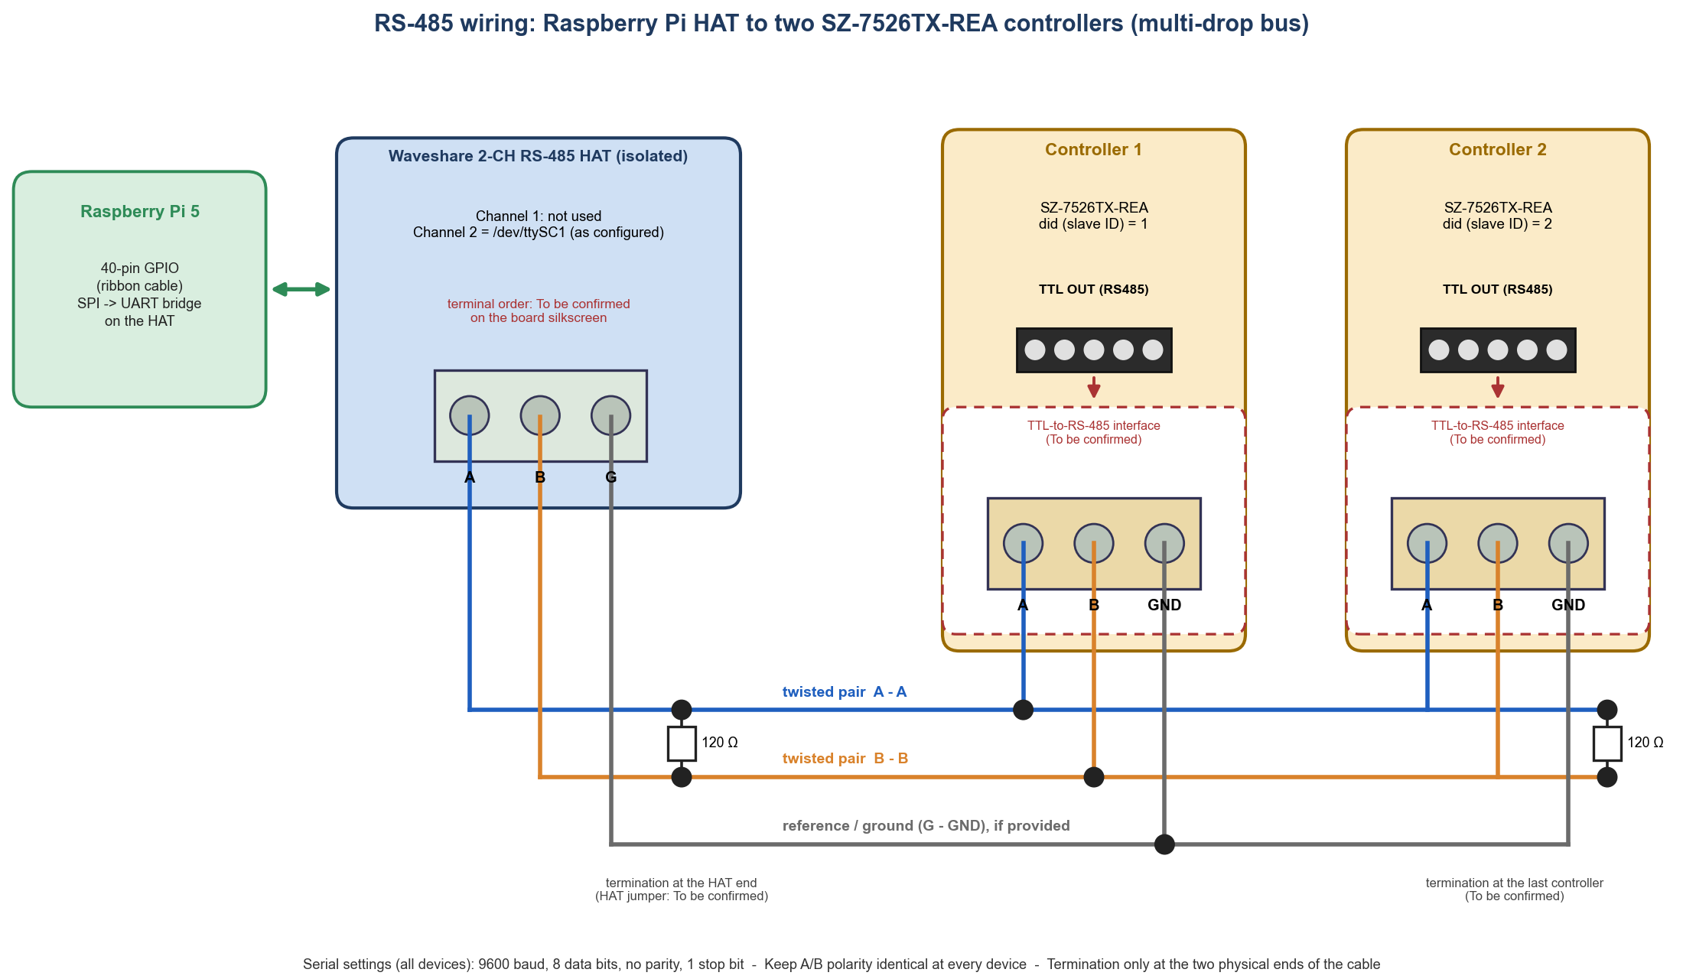
Figure 7-1 - RS-485 wiring between the HAT's second channel and two controllers on one multi-drop bus. Each controller's 5-pin TTL OUT (RS485) header is connected to the bus through a TTL-to-RS-485 interface. Items marked "To be confirmed" must be taken from the HAT silkscreen and the interface documentation.

Controller terminals (instruction manual, Suggested Wiring Diagram)
Terminal | Function
1, 2, 3 | Alarm relay: NO (1), C (2), NC (3); 5 A 250 VAC maximum.
4, 5, 6 | Compressor relay: NC (4), NO (5), C (6); 8(3) A 250 VAC maximum.
7, 8 | Supply 230 VAC 50-60 Hz: 7 = phase, 8 = neutral (as drawn in the diagram).
10 | AUX digital input (potential free): door-open or compressor-fault contact.
11 (marked *) | Common (ground) for the AUX input and the probe.
12 | NTC control probe (connects to the probe assembly, drawn as TO SZ-T75).
TTL OUT (RS485) | 5-pin header: the serial port read by the Raspberry Pi. The pins are not named in the manuals.

Mains voltage - qualified personnel only
Terminals 1 to 8 carry mains voltage (230 VAC). The manual states that improper wiring can cause irreparable damage and personal injury and that wiring must be done by qualified personnel, with the supply circuit connected through a protection switch. Terminals take wires up to 2.5 mm². Keep the probe wires out of any conduit that carries control or power lines. Do not touch the TTL header or its interface while the controller is powered.

Connections
- A and B. Connect HAT terminal A to terminal A and HAT terminal B to terminal B of the TTL-to-RS-485 interface of the first controller, using one twisted pair. Continue A-A, B-B to the interface of the second controller (daisy chain from device to device; avoid star wiring). The naming of A and B is not standardised between manufacturers, so labels may be inverted: if nothing answers, swap A and B first. This is the most common fault (docs/hardware-validation.md).
- TTL-to-RS-485 interface. The controller's own serial port is a TTL-level 5-pin header, not an RS-485 connector. Fit the interface that is intended for it, connect it to the header exactly as its documentation shows, and power it as it requires. Which interface is used here and its pin-out: To be confirmed.
- Ground / common. The HAT shows a terminal marked G. The module K-CUT B0505LS-1W on the HAT indicates an isolated RS-485 side, so a common reference between the HAT and the interfaces is generally recommended. The project says: common/GND connected if the adapter provides it. Whether your interface provides one: To be confirmed.
- Termination. A 120 Ω terminator is used only at the two physical ends of the cable. Short single-drop benches usually work without it. Whether termination is a jumper on the HAT and on the interface is To be confirmed.
- Power. The Raspberry Pi is powered through its USB-C input. A HAT normally receives its supply through the 40-way cable from the Pi's GPIO header (To be confirmed from the HAT documentation). Each controller is supplied with 230 VAC on terminals 7 and 8 (see the table above); the interface's own supply is To be confirmed. Power everything down before changing wiring.
- Cable routing. Keep the cable away from mains and contactor wiring (manual: Cautions - wiring).

Wiring procedure
1. Switch off the Raspberry Pi and isolate the controllers from the mains supply.
2. Identify the HAT's Channel 2 terminals (Figure 2-4) and the A / B terminals of each controller's TTL-to-RS-485 interface.
3. Connect A-A, B-B and (if provided) the common/ground with a twisted pair, daisy-chaining to the second controller.
4. Set did on each controller (1 and 2), bd and PAr identically on both.
5. Power on, then follow the next section to verify communication.

7.9 Verify that the controller is responding (Technician)
Level | How | What "working" looks like
1 Website | Dashboard card of the controller | Status Normal (or Check data) with a temperature and "Reading: n s ago". Controller not responding means communication failure.
2 Website | Data Logs, column Comm | ok on every row; timeout (red) on failed polls.
3 Node log | sudo journalctl -u temperature-node -f | No repeated poll failed lines; one communication restored after a fault.
4 Quick test | read_temp_from_controllert.py (Chapter 5, Step 8) | Prints Temperature: xx.x °C.
5 Validation tool | python -m src.validate_controller --port /dev/ttySC1 --slave 1 | [PASS] lines for addressing, device ID, baud, parity, did, resolution; the printed control temperature equals the controller display.

Communication failure types
comm_status | Meaning | Typical cause
timeout | No (valid) reply. A CRC error is also reported as timeout. | Wrong slave ID, baud rate or parity; A/B swapped; no power; cable fault; noise; did = 0.
exception | The controller replied with a Modbus exception code. | Illegal address (code 2) once is normal: the node then switches to reading only the documented registers.
invalid_response | Reply of the wrong shape. | Interference; wrong device.
port_error | The serial port cannot be opened or failed. | HAT driver not loaded, wrong port name, another program using the port, missing dialout membership.
identity_mismatch | A device answered but 40001/40003 are not 7507/115. | Another device at that address, wrong model, or an address offset.
error | Anything else. | See the node log.

What the supplied screenshots show
TO BE CONFIRMED - observations from the supplied screenshots
In the supplied Dashboard and Data Logs screenshots (Figures 12-1 and 12-3), Temp Control 2 shows Controller not responding: every poll is a timeout with an empty temperature, while Temp Control 1 reads 18.0 °C with set point 15.0 °C. Because both are configured on one bus, this means that slave ID 2 is not answering (not connected or not powered, did not set to 2, or a wiring/parity problem). Confirm on site. The failed polls are recorded exactly as designed and do not affect Temp Control 1.
Temp Control 1 is labelled Check data (quality suspect) with the flag resolution_mismatch: the resolution register rS (40005) and bit 2 of status register 40010 disagree, a known ambiguity of the register map (A5 in docs/modbus-register-map.md). The software scales by rS, as the register map specifies. Compare the website value with the controller's display; if they differ by a factor of 10, report it to the controller vendor. All temperatures in the supplied screenshots are whole degrees.

CHAPTER 8

8 Data Acquisition, Transmission and Fail-Safe Operation
This chapter explains, from the code, how one measurement travels from the controller to the database, what the Raspberry Pi does with it while the server is unreachable, and what happens when the server is shut down for an hour, when the Raspberry Pi is shut down for an hour, and when both are. It also explains the pending status and the 7-day retention that the node maintains.

8.1 Short answers
Question | Answer
Server (VM) down for 1 hour, Raspberry Pi running | No data is lost. The Pi keeps polling the controllers every 10 s and stores every reading as pending on its own disk (about 360 readings per controller per hour). When the server is back, the Pi uploads the backlog automatically, normally within about 6 minutes. The website is unreachable while the server is down.
Raspberry Pi down for 1 hour, server running | The hour is not recorded. Only the Pi reads the controllers, so no readings exist for that time. The server marks the node offline after 120 s and, when the Pi restarts, the node reports a data gap. The gap is visible in Monitoring and in the reports. Readings the Pi had stored before the power loss are still on its disk and are uploaded after it restarts.
Both down for the same hour | Same data result as the Pi alone: a one-hour gap. The order in which they start again does not matter; the Pi uploads when the server becomes reachable.
"Pending" status | A reading in the Pi's buffer queue.db that the server has not yet confirmed. It is kept on disk, survives restarts and power cuts, and is re-sent until the server confirms it. Pending readings are never deleted by age.
"7-day backup" | Readings the server has confirmed (delivered) are kept in the Pi's queue.db for 7 days (buffer.retention_days_delivered: 7) and then removed. It is a local safety copy, not a backup of the server and not an archive. The permanent record is the server database, which must be backed up (Chapter 16).

8.2 The journey of one measurement
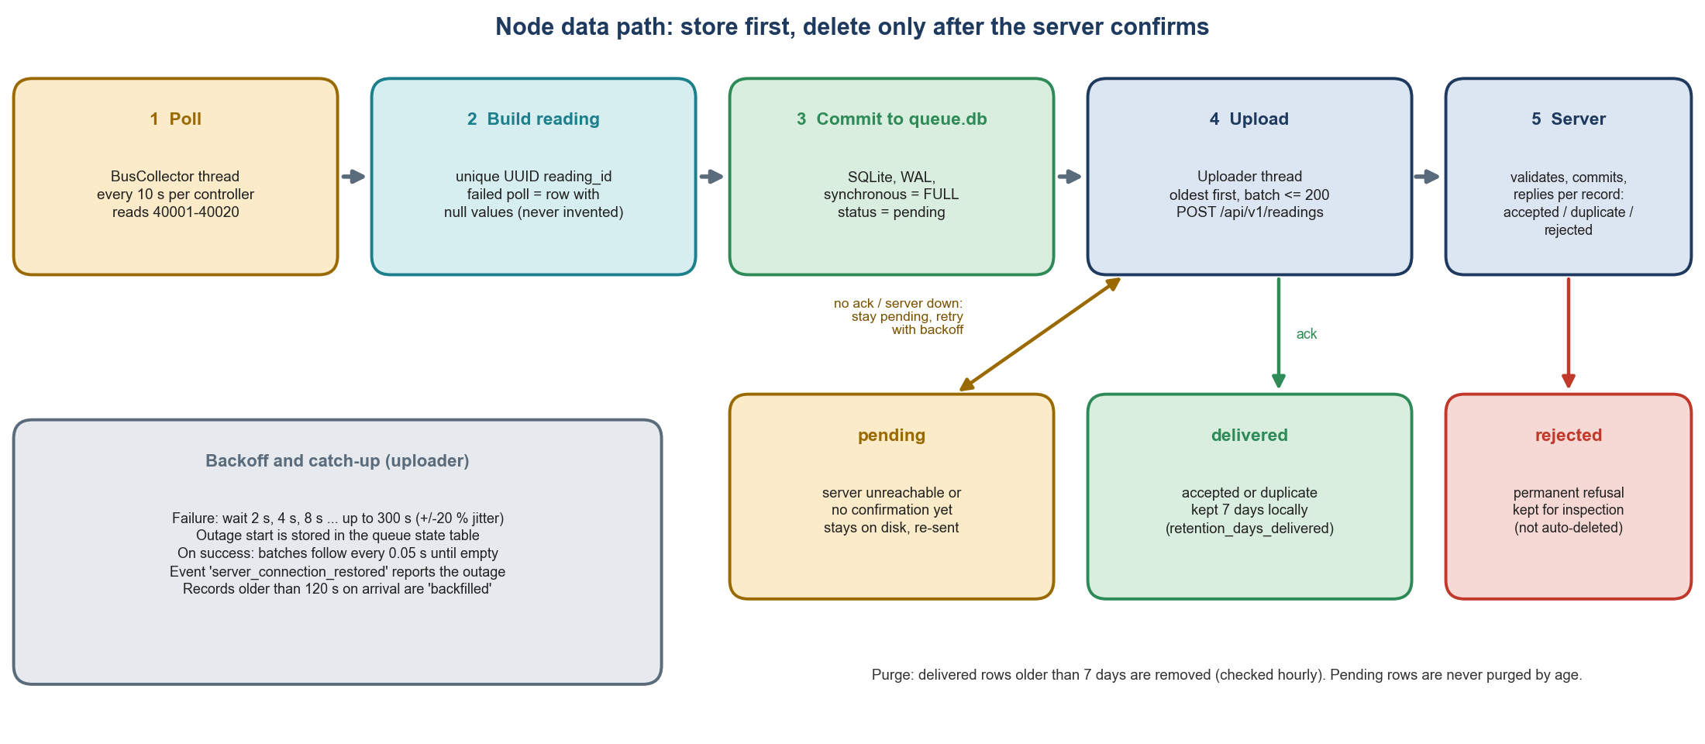
Figure 8-1 - Data path on the Raspberry Pi: poll, build, commit to the local buffer, upload, server confirmation, and the resulting record states.
1. Poll. Every 10 s the bus thread sends the read request for registers 40001-40020 to the controller over RS-485 (Chapter 7) and waits up to 1 s (up to 3 attempts).
2. Decode and build. The reply is checked (identity registers) and decoded. A reading record is created with a new UUID (reading_id), the acquisition time in UTC, all decoded values, the raw register values and a quality label. A failed poll also produces a record (empty temperature, comm_status other than ok).
3. Commit. The record is inserted into the local SQLite buffer with journal_mode=WAL and synchronous=FULL and gets the status pending. This is the first thing that happens; nothing depends on the network.
4. Upload. The uploader thread selects the oldest pending records (batch of up to 200) and sends them with HTTP POST to http://10.145.15.245:8000/api/v1/readings with the headers X-Node-ID and Authorization: Bearer <token>.
5. Server commit. The server validates each record, stores new ones, answers per record in three lists: accepted, duplicates, rejected. The answer is sent only after the database transaction is committed.
6. Mark delivered. The node changes accepted and duplicates records to delivered. rejected records (permanently refused) become rejected and are kept for inspection. Anything not mentioned in the answer stays pending and is retried.
7. Purge. Delivered records older than 7 days are deleted (checked at most once an hour, after a successful upload).
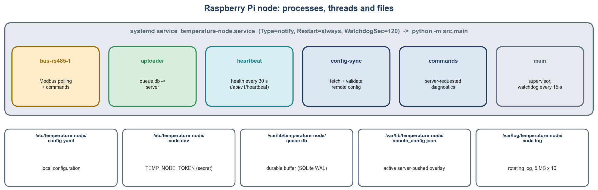
Figure 8-2 - The node's service, its threads and the files it uses.

8.3 What is sent to the server
Request | Purpose | When
POST /api/v1/readings | Batch of reading records; reply lists accepted / duplicates / rejected. | Every 5 s when idle; back-to-back (0.05 s apart) while a backlog exists. At most 200 per request by default (limit 1000).
POST /api/v1/events | Node events: comm_lost, comm_restored, modbus_error, data_gap, node_started, server_connection_restored, parameter_snapshot, controller_command. | Sent before readings in each upload cycle.
POST /api/v1/heartbeat | Health: software version, uptime, queue size, upload status, controller states, CPU temperature, free disk, Wi-Fi signal, clock status, recent errors. | Every 30 s.
GET /api/v1/config?current_version=N | Fetch a newer node configuration from the server. | Every 60 s, and immediately when a heartbeat reply announces a new version.
POST /api/v1/config/ack | Report that a configuration version was applied or rejected. | After each configuration.
GET /api/v1/commands, POST /api/v1/commands/<id>/result | Controller commands (disabled by default). | Checked every 60 s, and immediately when a heartbeat reply reports pending commands.
GET /api/v1/ping | Health check without authentication. | Manual test (Chapter 3).

Every request carries X-Node-ID: temp_control_unit_1 and Authorization: Bearer <token>. The server stores only a SHA-256 hash of the token. An unknown node ID is recorded as discovered (Nodes page, Unregistered devices) and refused with HTTP 401; a wrong token gives 401; a disabled node gets 403. Time stamps are ISO-8601 in UTC.
One reading record (abbreviated; illustrative values; field names from build_reading in collector.py)
{
"reading_id": "9b1c0f3e-2f6a-4a58-8d0e-5a0c1b6d7e11",
"node_id": "temp_control_unit_1", "controller_id": "Temp_Control_1", "slave_id": 1,
"model": "SZ-7526TX-REA", "source": "controller",
"acquired_at": "2026-11-07T07:44:24.512Z",
"comm_status": "ok", "comm_error": null, "quality": "suspect",
"quality_flags": ["resolution_mismatch"],
"temperature_c": 18.0, "setpoint_c": 15.0, "resolution_rs": 0,
"compressor_on": false, "alarm_on": false, "defrost_active": false,
"fault_flags": 0, "faults": [], "compressor_run_hours": 1234,
"raw_registers": {"40001": 7507, "40003": 115, "40004": 1, "40005": 0, "40006": 180},
"config_version": 5, "poll_duration_ms": 62
}

The server's reply to a batch
{"accepted": ["9b1c0f3e-2f6a-4a58-8d0e-5a0c1b6d7e11"], "duplicates": [], "rejected": []}

A failed poll is also a record (abbreviated)
{"reading_id": "...", "controller_id": "Temp_Control_2", "comm_status": "timeout",
"comm_error": "no valid response: Modbus Error: [Input/Output] ERROR: No response received",
"temperature_c": null, "quality": "comm_error", "raw_registers": null, ...}

8.4 The local buffer: queue.db and the pending status
Item | Detail
File | /var/lib/temperature-node/queue.db (plus queue.db-wal and queue.db-shm while running)
Tables | readings and events (identical layout) and state (key/value).
Columns of readings / events | seq (auto number), item_id (the UUID, unique), controller_id, occurred_at, payload (JSON), `status`, attempts, last_error, created_at, delivered_at
Status values | `pending` (not yet confirmed), `delivered` (confirmed; kept 7 days), `rejected` (permanently refused; kept)
Durability | PRAGMA journal_mode=WAL, PRAGMA synchronous=FULL: a record that was acknowledged to the poller survives a sudden power cut. Raspberry Pis often lose power without a clean shutdown.
Upload order | Oldest first (ORDER BY seq), so the server sees each controller's history in order.
Persistent state | outage_started_at, outage_failures, outage_last_error, last_alive_at, software_version, dropped_total, refused_since, refused_count

What is kept, and for how long
Data | Where | Retention | Notes
Pending readings and events | Pi: queue.db | Until the server confirms them. No age limit. | Capped at max_pending_records = 2 000 000 readings or until free disk falls below min_free_disk_mb = 100 MB (see below).
Delivered readings and events | Pi: queue.db | 7 days (retention_days_delivered), then deleted | Purged at most hourly, and only after a successful upload cycle. Local safety copy.
Rejected records | Pi: queue.db | Not deleted automatically | For inspection (status rejected, reason in last_error).
Node log file | Pi: /var/log/temperature-node/node.log | Rotating: 5 MB per file, 10 backups | At most about 55 MB. The same messages go to journald.
Readings, events, audit trail | Server: temperature.db | Never purged | The permanent record. Back it up.
Heartbeat history | Server: temperature.db | 90 days (setting Heartbeat history retention) | Not measurement data.

Capacity. With two controllers polled every 10 s the node creates 12 readings a minute, 17 280 a day. The default capacity of 2 000 000 pending readings is therefore about 115 days of backlog for two controllers (about 231 days for one). Seven days of delivered records are about 121 000 rows; at roughly 1 to 2 KB per row (an estimate, not measured) that is some 120-240 MB. Measure the real size with ls -lh /var/lib/temperature-node/queue.db*.

When the buffer is full
- full_behavior: drop_oldest (default): the oldest 1 % of pending readings are deleted to make room and a data_gap event states exactly how many were lost and the period they covered.
- full_behavior: stop_collecting: new readings are refused (and counted) until space is available; a data_gap event records the loss when collection resumes.
- Either way the loss is reported. With a healthy network this limit is never reached.

Inspect the buffer (Administrator)
On the Raspberry Pi
sudo sqlite3 /var/lib/temperature-node/queue.db \
"select status, count(*), min(occurred_at), max(occurred_at) from readings group by status;"
sudo sqlite3 /var/lib/temperature-node/queue.db "select key, value from state;"
ls -lh /var/lib/temperature-node/

Example output (healthy node)
pending|1|2026-11-07T08:41:14.103Z|2026-11-07T08:41:14.103Z
delivered|120531|2026-10-31T08:44:21.220Z|2026-11-07T08:41:04.101Z

The website shows the same number in the Buffered column of the Dashboard's Nodes table (the count of pending readings reported in the node's last heartbeat). It is normally 0 to a few; a growing number means the server is not accepting data.

8.5 What the server does with the data
- Validates every record (UUID, time after year 2000, allowed comm_status/quality/source values, temperatures between -100 and 200 °C or empty, a temperature must be empty when comm_status is not ok). One invalid record is rejected without affecting the others in the batch.
- De-duplicates on the node-generated UUID: a record that was stored earlier is answered duplicate. This is what makes every retry safe.
- Flags late arrivals: a record received more than BACKFILL_THRESHOLD_S = 120 s after it was acquired is marked backfilled. Its stored time is still the original acquisition time.
- Updates the latest state of the controller (dashboard) only if the record is newer than what is already shown, so a late backlog never overwrites live data.
- Tracks faults and alarms as periods (started, cleared) from the fault register and the alarm relay.
- Commits before answering: the node is told a record is stored only after the database transaction has been committed (synchronous=FULL, WAL).
- Watches the node: a background thread checks every 30 s and marks a node offline when it has had no contact for 120 s (setting Node offline after), writing a node_offline event and an Audit Trail entry; the next contact marks it online again.

8.6 Outage scenarios
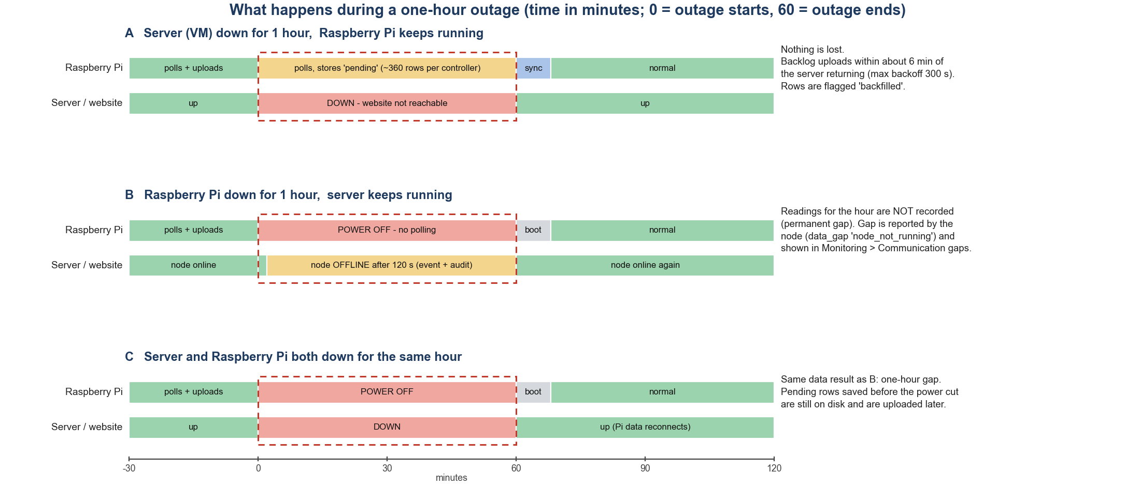
Figure 8-3 - Behaviour during a one-hour outage of the server (A), of the Raspberry Pi (B) and of both (C).

Scenario A - the server (Ubuntu VM) is shut down for one hour; the Raspberry Pi keeps running
When | What happens | Where you can see it
Minute 0 | The server stops. The node's next upload fails (connection refused or timeout after 10 s). The node stores outage_started_at and logs server unreachable, buffering locally. | Pi log
Minutes 0 to 60 | The node keeps polling every 10 s per controller and commits each reading as pending: about 360 readings per controller (about 720 for two controllers). The uploader retries after 2 s, 4 s, 8 s ... 256 s and then every 300 s (each delay varies by ±20 %), about 19 attempts in the hour. Heartbeats fail every 30 s and are logged as warnings. | sqlite3 count of pending; Pi log
Minute 60 | The server starts again. Its start-up applies database migrations (AUTO_MIGRATE) and writes server_started to the audit trail. The first monitor check runs 30 s later. | Audit Trail, server log
Minute 60 to about 66 | The node's next retry succeeds (at the latest about 300 s plus 20 % after the server is reachable). It sends events, then readings in batches of 200 with only 0.05 s between them: 720 readings take about four batches, a few seconds. It then records server_connection_restored with the outage start, end, failed attempts and backlog size. | Audit Trail: node_reconnected
Afterwards | Normal operation. The backlog rows are stored with their original timestamps and marked backfilled; the Pi's copies become delivered and are purged after 7 days. | Data Logs

What you see on the website after recovery: the Data Logs and Monitoring pages show a continuous series with no gap for the outage period. Filter Ingestion = Backfilled in Data Logs to list the rows that arrived late; the Excel export has a Backfilled column. Because the Data Logs view is frozen at the time it was opened, press Refresh data to see rows that arrived afterwards. During the outage the website itself cannot be opened.
Brief offline/online flicker after a server restart
Because the server's monitor thread only runs while the server is running, and the node's last-contact time is one hour old when the server restarts, the node may briefly show Offline and then Online again within the first minute after a server restart, before its first heartbeat arrives. This follows from the code (monitor.py, ingestion.py) and has not been tested on your system.

Scenario B - the Raspberry Pi is shut down for one hour; the server keeps running
When | What happens | Where you can see it
Minute 0 | Power is lost (or the Pi is shut down). Nothing is polled. Records that were already in queue.db stay on disk. The node's last_alive_at was refreshed at most 15 s earlier. | --
About minute 2 to 2.5 | The server sees no contact for more than 120 s and, at its next 30-second check, marks the node offline: event node_offline (error) and an Audit Trail entry with outcome failure. The Dashboard shows the node as Offline (Nodes online = 0) and the controller cards as Node offline (the values shown are the last ones received, not live). | Dashboard, Nodes, Audit Trail
Minutes 2 to 60 | No new readings arrive. The controllers keep running by themselves; their own control is unaffected. | Monitoring: line break and gap
Minute 60 | Power returns and the Pi boots. systemd starts temperature-node after the network is up. At start the node compares last_alive_at with the clock: if the gap is longer than max(60 s, 3 × the shortest poll interval) it queues a data_gap event "Node was not running from ... to ..." (reason node_not_running, with the duration), then a node_started event. | Pi log
Minute 60 onward | Polling resumes immediately. The first heartbeat marks the node online (node_online). The queued events reach the server and appear as node_started and data_gap_reported in the Audit Trail. Any pending readings saved before the power loss are uploaded and flagged backfilled. | Audit Trail, Monitoring

Data impact: a permanent one-hour gap. The controller does not keep a history that the system could read afterwards (registers 40019/40020 hold only the most recent high and low values), so the missing hour cannot be reconstructed. The system does not invent values: Monitoring lists the period under Communication gaps (calculated) and breaks the chart line, and the reports Missing data periods and Node downtime list it (downtime is inferred from missing heartbeats, and labelled as such).

Scenario C - the server and the Raspberry Pi are both shut down for one hour
- The data result is the same as in Scenario B: no readings exist for the hour (the Pi was off). Records the Pi had stored before the power loss are still on its disk.
- The start order does not matter. If the Pi boots first it buffers (events node_started and data_gap and new readings are pending) and uploads as soon as the server is reachable, within the 300 s retry limit. If the server starts first, the node is marked offline until the Pi sends its first heartbeat.
- A server that is switched off normally writes server_stopped to the audit trail when its process exits; after a sudden power loss that entry is not written (the audit trail then shows server_started without a preceding server_stopped). The database itself is protected by WAL and synchronous=FULL.

Other situations
Situation | Behaviour
Wi-Fi or network fails, Pi and server both running | Same as Scenario A from the Pi's point of view (buffer and retry); the server also marks the node offline after 120 s because heartbeats stop. After the network returns: node_online, backlog uploaded, rows flagged backfilled.
RS-485 or a controller fails, Pi and server running | Failed polls are stored (empty temperature, comm_status timeout, quality comm_error). After 3 consecutive failures (about 30 s) a comm_lost event is sent; the Dashboard shows Controller not responding. When the controller answers again a comm_restored event is sent. Nothing is estimated.
Raspberry Pi's clock wrong after boot (no network time yet) | Readings are flagged clock_unsynchronized and quality suspect until the clock is synchronised. The server also calculates the node's clock skew from each heartbeat.
Raspberry Pi disk full or buffer full | Policy drop_oldest or stop_collecting with a data_gap event that gives the number of lost readings and the period.
The service crashes or hangs | systemd restarts it after 5 s (Restart=always); a hung process that stops signalling is restarted after 120 s (WatchdogSec). A dead worker thread is restarted within 15 s by the supervisor.

8.7 A real example from your audit trail
Figure 8-4 is a section of the supplied Audit Trail (2026-11-06, displayed in Asia/Kolkata). It is a real record of the behaviour described in Scenario B.
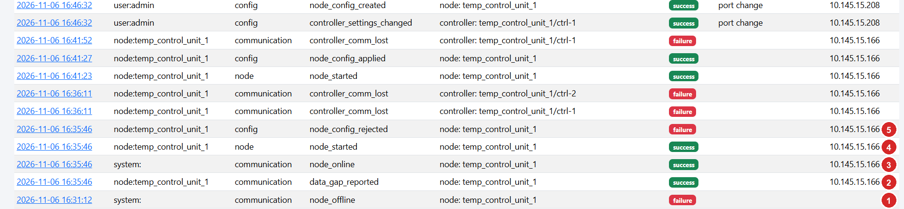
Figure 8-4 - Audit Trail excerpt showing a node outage and recovery (call-outs added).
No. | Time | Entry | Explanation
1 | 16:31:12 | node_offline (actor system, outcome failure) | The server's monitor marked temp_control_unit_1 offline after 120 s without contact. The server wrote it, so there is no source IP.
2 | 16:35:46 | data_gap_reported (actor node) | After restarting, the node reported a data gap. The details of this entry (click the time) give the period, duration and reason.
3 | 16:35:46 | node_online (actor system) | The first contact from the node: it is online again.
4 | 16:35:46 | node_started | The node software started (a power cycle or a service restart).
5 | 16:35:46 | node_config_rejected (failure) | The node rejected a configuration version pushed from the server. Open the entry to read the reason; the project's troubleshooting guide names a serial port that does not exist on the Pi as the typical cause. The previous configuration stayed in force. A later entry at 16:41:27 shows node_config_applied.

From 16:31:12 to 16:35:46 is 4 minutes 34 seconds between the offline mark and the node's return. The Audit Trail alone cannot tell whether the Pi lost power or only its service restarted; the details of the data_gap_reported entry state the period the node was not running. Further examples are in Figure 12-2: the Communication gaps (calculated) table lists four gaps for Temp Control 1 (10 min and 1 min on 2026-11-06, 5 min and 8 min on 2026-11-07), 24 minutes in total.

8.8 Fail-safe mechanisms at a glance
Mechanism | Where | Protects against
Store first: durable local queue (WAL, synchronous=FULL) | Node local_queue.py | Power cuts, crashes: acknowledged readings survive.
Delete only after server confirmation; UUID per reading; server de-duplication | Node uploader.py, server ingestion.py | Lost or repeated batches; every retry is safe.
Exponential backoff 2-300 s with jitter; outage start persisted | Node uploader.py | Server or network outage; hammering a recovering server; outage reported after a node restart.
Batch halving on HTTP 400/413; per-record rejection and quarantine | Node uploader.py, server | A single bad record blocking the queue.
Failed polls stored as records with empty values | Node collector.py | Silent gaps; invented numbers.
Identity check on every poll (7507 / 115) | Node modbus_client.py, decoder.py | Wrong device, wrong address convention.
comm_lost / comm_restored events after 3 failures | Node collector.py | Unnoticed controller failure.
Supervisor restarts dead threads; systemd Restart=always, WatchdogSec=120 | Node main.py, service file | Thread crash, process crash or hang.
Start-up data_gap (node_not_running) and node_started events | Node main.py | Unexplained holes after a power loss.
clock_unsynchronized flag | Node health_monitor.py | Wrong time stamps after boot without network time.
Buffer capacity and free-disk guard with data_gap event | Node local_queue.py | Full disk, runaway backlog.
Remote configuration validated before use; last good version kept; new server URL tested first | Node config_manager.py, main.py | A bad configuration disabling the node.
Server answers only after commit; duplicate handling; older batches never overwrite newer state | Server ingestion.py | Acknowledging unsaved data; concurrent retries; backfill corrupting live values.
Offline detection after 120 s; online/offline events | Server monitor.py | A silent node failure.
WAL, synchronous=FULL, busy_timeout 10 s | Server app/__init__.py | Power loss on the server; short database locks.
Append-only audit trail (ORM guard and database triggers) | Server models/audit.py | Tampering with history.
No writes to controllers during polling; remote commands off by default (four gates) | Node modbus_client.py | Accidental control actions.
Server restart on failure (Restart=on-failure, see Chapter 9) | Server systemd unit | Server process crash.

8.9 What the system does not protect against
- Raspberry Pi powered off: nothing reads the controllers, so no data exists for that time. There is no second reader and no redundancy.
- Failure or corruption of the Pi's storage card: pending (unsent) readings on it would be lost.
- A very long outage that exceeds the buffer capacity (default 2 000 000 readings, about 115 days for two controllers) or fills the disk: the oldest pending readings are dropped, with a data_gap event.
- Loss of the server's database file without a backup. The server has no replication; scripts/backup_database.py or the procedure in Chapter 16 is needed.
- No notifications: nobody is alerted by e-mail or SMS; alarms are visible on the website only.
- Controller-internal logs: the system does not read any event history from the controller.
- Wrong time on the Pi is flagged but not corrected by the application.

8.10 Test the fail-safe behaviour on site (Administrator)
The project's commissioning procedure (docs/hardware-validation.md) includes these tests. Run them in a maintenance window and keep the results.
Test | How | Expected result
Network or server outage, 5 minutes | Unplug the Pi's network (or sudo systemctl stop temperature-server on the server) for about 5 minutes, then restore it. | No gap in Data Logs; the outage rows are marked buffered/backfilled; the node page shows the reconnection event; Buffered returns to about 0.
Controller communication loss | Disconnect the RS-485 cable for about one minute and reconnect. | Controller not responding, comm_lost, failed polls with no temperature; then comm_restored.
Pi restart | sudo reboot on the Pi. | node_offline, then node_online, node_started and data_gap_reported in the Audit Trail; a gap in Monitoring.
Watch the buffer | On the Pi: watch -n 5 'sudo sqlite3 /var/lib/temperature-node/queue.db "select status,count(*) from readings group by status"' | pending rises during the outage and returns to about 0 afterwards.

CHAPTER 9

9 Ubuntu Remote Server Configuration
This chapter builds the server from scratch on the Ubuntu virtual machine (10.145.15.245). The steps follow the "Ubuntu server" section of the project's README.md. The server is a Flask web application served by Waitress (server/run.py) with an SQLite database; it listens on TCP port 8000.
IMPORTANT
The project's other documents (docs/installation-windows.md, parts of docs/troubleshooting.md) describe a Windows server. This installation uses Ubuntu, so follow this chapter and the Ubuntu section of README.md. The same code runs on both.

9.1 Layout on the server
The README and the helper script dev_tools/delete_controler_in_server_history.py use the following layout under the user's home folder. The project's server/ folder is copied to the VM as temperature-logging-system (folder name To be confirmed on the VM):
Path on the VM | Content
/home/temp/temperature-logging-system/ | The server code (contents of the project's server/ folder): run.py, app/, migrations/, requirements.txt, .env.example
.../.venv/ | Python virtual environment
.../.env | Server settings and the secret key (mode 600)
.../instance/temperature.db | The SQLite database (plus temperature.db-wal and temperature.db-shm while running)
.../instance/secret_key | Generated session key, only used if SECRET_KEY is empty in .env
.../logs/server.log | Rotating log (10 MB x 10 files by default)
/etc/systemd/system/temperature-server.service | The service that starts the server at boot (Section 9.12)

9.2 1-2 Access the virtual machine and connect with SSH (Administrator)
Use the hypervisor's console, or connect from a Windows computer on the network:
On the Windows computer
ssh temp@10.145.15.245

Type yes for the fingerprint question and enter the password from the credentials section. The prompt becomes temp@temp-Virtual-Machine:~$.

9.3 3 Update Ubuntu
On the server
sudo apt update
sudo apt upgrade -y
cat /etc/os-release | head -3

The last command shows the Ubuntu version (the README supports 22.04 and 24.04; the installed version is To be confirmed). Reboot with sudo reboot if the upgrade asks for it.

9.4 4-5 Install Python, pip, venv support and tools
On the server
sudo apt install -y python3 python3-venv python3-pip git sqlite3 curl
python3 --version

python3-venv provides virtual environments and python3-pip the package installer. sqlite3 is the command-line tool used later to inspect the database; curl is for tests.

9.5 6-7 Create the application folder and upload the server files
On the Windows computer (PowerShell; the backtick continues the line)
cd "C:\Users\gokul\Documents\projects\Avo AC Unit Logging System"
cd avo_ac_loggin_system_with_rashberrypi
tar -czf server.tgz --exclude=.venv --exclude=instance --exclude=logs --exclude=.env `
--exclude=__pycache__ -C server .
scp server.tgz temp@10.145.15.245:/tmp/

On the server
mkdir -p ~/temperature-logging-system
tar -xzf /tmp/server.tgz -C ~/temperature-logging-system
ls ~/temperature-logging-system

The exclusions keep your development PC's virtual environment, database, logs and secrets out of the transfer. ls must show run.py, app, migrations, requirements.txt and .env.example (use ls -a to see .env.example).

9.6 8 Create the virtual environment and install the dependencies
On the server
cd ~
python3 -m venv temperature-logging-system/.venv
temperature-logging-system/.venv/bin/pip install --upgrade pip
temperature-logging-system/.venv/bin/pip install -r temperature-logging-system/requirements.txt

The dependencies are pinned in requirements.txt: Flask 3.1.0, Werkzeug 3.1.3, Flask-SQLAlchemy 3.1.1, SQLAlchemy 2.0.36, Flask-Migrate 4.0.7, Alembic 1.14.0, Flask-Login 0.6.3, Flask-WTF 1.2.2, WTForms 3.2.1, Waitress 3.0.2, openpyxl 3.1.5, ReportLab 4.2.5, python-dotenv 1.0.1, tzdata 2024.2. The installation needs internet access for pip (or an internal package mirror).

9.7 9-12 Configure environment variables, database, application and port
On the server
cd ~/temperature-logging-system
cp .env.example .env
SECRET=$(.venv/bin/python -c "import secrets; print(secrets.token_urlsafe(48))")
sed -i "s|^SECRET_KEY=.*|SECRET_KEY=$SECRET|; s|^HOST=.*|HOST=0.0.0.0|; s|^PORT=.*|PORT=8000|" .env
chmod 600 .env
nano .env

The commands copy the template, generate a random secret key for session signing, make the server listen on all interfaces (HOST=0.0.0.0, needed so that the Raspberry Pi and browsers can reach it) on port 8000, and restrict the file to your user. The remaining entries of .env are shown below with the values for this installation.
Setting | Value | Meaning
HOST | 0.0.0.0 | Bind address. 127.0.0.1 would accept only local connections.
PORT | 8000 | TCP port of the website and node API.
WAITRESS_THREADS | 8 | Worker threads of the Waitress server.
SECRET_KEY | (random, generated above) | Signs session cookies. Keep it secret.
DATABASE_URL | (empty / commented out) | Default: SQLite file instance/temperature.db. PostgreSQL is possible (postgresql+psycopg://...) but untested by the project.
DISPLAY_TIMEZONE | Asia/Kolkata | Initial display time zone. Administrators can change it later in System settings. Data is always stored in UTC.
SESSION_TIMEOUT_MINUTES | 30 | Idle time after which a user must sign in again.
LOGIN_MAX_FAILURES / LOGIN_LOCKOUT_MINUTES | 5 / 15 | Account lock-out.
PASSWORD_MIN_LENGTH | 8 | Minimum password length (mixed with digits or symbols).
ENABLE_REMOTE_CONTROL | false | Initial value of the controller-command master switch.
MAX_REQUEST_BYTES, API_MAX_BATCH | 4194304, 1000 | Request and batch limits for the node API.
EXPORT_MAX_ROWS_XLSX / EXPORT_MAX_ROWS_PDF | 500000 / 20000 | Larger exports are refused with a message, never truncated.
BACKFILL_THRESHOLD_S | 120 | Readings arriving later than this are flagged backfilled.
LOG_LEVEL, LOG_FORMAT, LOG_DIR | INFO, text, (default logs/) | Logging.
AUTO_MIGRATE | true | Apply database upgrades automatically at start-up.

VERIFIED IN SOURCE
Real environment variables take precedence over values in .env (server/app/config.py). If SECRET_KEY is empty a random key is created in instance/secret_key, so sessions survive restarts either way.

9.8 Create the database, roles and the first administrator
On the server
cd ~/temperature-logging-system
.venv/bin/python -m flask --app run db upgrade
.venv/bin/python -m flask --app run seed
.venv/bin/python -m flask --app run create-admin --username admin

Command | What it does
flask --app run db upgrade | Creates instance/temperature.db and all tables (Alembic migration 0001_initial_schema), including the triggers that make the audit trail append-only.
flask --app run seed | Creates the permissions and the three default roles (Administrator, Operator, Auditor).
flask --app run create-admin --username admin | Creates the user admin with the role Administrator. It asks for the password twice (hidden). The password must satisfy the policy: at least 8 characters, letters mixed with digits or symbols, not containing the user name.

Use the password from the credentials section. The program prints user admin created with role Administrator.

9.9 Open the firewall port
On the server
sudo ufw status
sudo ufw allow OpenSSH
sudo ufw allow 8000/tcp
sudo ufw status

If ufw is inactive, nothing blocks port 8000 and you may skip the allow rules. If it is active, TCP 8000 must be allowed so that the Raspberry Pi and the browsers can connect. Do not enable ufw without first allowing SSH (second command), or you lock yourself out. The current state of the firewall is To be confirmed.

9.10 13 Run the server manually
On the server (stop with Ctrl+C)
cd ~/temperature-logging-system
.venv/bin/python run.py

Expected log line
... Temperature server 1.0.0 listening on http://0.0.0.0:8000

At start-up the program applies database migrations, seeds the roles, writes a server_started entry to the audit trail and starts the monitor thread that detects offline nodes. Run only one server process; the monitor runs inside it.

9.11 14 Test the server
On the server, with run.py running in another session
curl -s http://localhost:8000/api/v1/ping
curl -sI http://localhost:8000/login | head -1

Expected output
{"server_time":"2026-11-07T08:20:00.000000Z","status":"ok","version":"1.0.0"}
HTTP/1.1 200 OK

Then test from another machine: open http://10.145.15.245:8000 in a browser on the plant network, or run curl -s http://10.145.15.245:8000/api/v1/ping on the Raspberry Pi. If it works locally but not remotely, check HOST=0.0.0.0, ufw and the network.

9.12 15 Start the server automatically after reboot
On the server (from README.md)
sudo tee /etc/systemd/system/temperature-server.service >/dev/null <<'EOF'
[Unit]
Description=Temperature Monitoring Server
After=network-online.target
Wants=network-online.target

[Service]
User=temp
WorkingDirectory=/home/temp/temperature-logging-system
ExecStart=/home/temp/temperature-logging-system/.venv/bin/python run.py
Restart=on-failure
RestartSec=5

[Install]
WantedBy=multi-user.target
EOF
sudo systemctl daemon-reload
sudo systemctl enable --now temperature-server
sudo systemctl status temperature-server

Line | Meaning
After/Wants=network-online.target | Start once the network is up.
User=temp | Run as the user temp, not as root.
WorkingDirectory=... and ExecStart=... | Run run.py with the virtual-environment Python from the application folder (so .env and instance/ are found).
Restart=on-failure, RestartSec=5 | Restart 5 s after a crash. A clean systemctl stop is not restarted.
WantedBy=multi-user.target | Started at boot when enabled.

Command | Use
sudo systemctl start|stop|restart temperature-server | Start, stop or restart the website and API. Restart after changing .env.
systemctl status temperature-server | State and last log lines.
sudo systemctl disable --now temperature-server | Stop and prevent start at boot.
sudo journalctl -u temperature-server -f | Follow the live log.

TO BE CONFIRMED
The unit name temperature-server and its content come from the README. Confirm the name used on your VM with systemctl list-units --type=service | grep -i temperature.

9.13 16 Check the server logs
On the server
sudo journalctl -u temperature-server --since "1 hour ago"
tail -f ~/temperature-logging-system/logs/server.log

Pages that fail show "Internal error (reference ...)" in the browser; search server.log for that reference to find the cause.

9.14 Upgrading the server software
1. Stop: sudo systemctl stop temperature-server.
2. Back up the database (Chapter 16).
3. Upload the new code as in step 6-7, which does not touch .env, .venv or instance/.
4. Update dependencies: ~/temperature-logging-system/.venv/bin/pip install -r ~/temperature-logging-system/requirements.txt.
5. Start: sudo systemctl start temperature-server. Database upgrades are applied automatically (AUTO_MIGRATE).

9.15 17 Troubleshooting the server
Symptom | Likely cause | Fix
Browser cannot connect | Service stopped, HOST=127.0.0.1, firewall, wrong IP. | systemctl status temperature-server; check .env; sudo ufw status; ss -ltnp | grep 8000.
Address already in use | Another process (or a second copy of the server) uses port 8000. | sudo ss -ltnp | grep 8000; stop it or change PORT.
Service fails right after start | Syntax or configuration error, missing module. | sudo journalctl -u temperature-server -n 50; run .venv/bin/python run.py by hand to see the error.
database is locked warnings | Many simultaneous large exports on SQLite. | They retry for up to 10 s. For heavy use consider PostgreSQL.
Pages show "Internal error (reference ...)" | Application error. | Find the reference in logs/server.log.
Times look shifted | Display time zone setting. | Administration > System settings > Display time zone. Data is stored in UTC.
Node data refused (401/403) | Wrong token, unknown node ID, disabled node. | Nodes page; issue a new token; check the node's node.env.

CHAPTER 10

10 Database Configuration and Data Storage

10.1 Which database is used
The server uses SQLite, a single-file database, through SQLAlchemy and Alembic migrations (server/migrations/). SQLite needs no database server, no user and no password. The file is instance/temperature.db below the application folder (/home/temp/temperature-logging-system/instance/temperature.db). Connections use PRAGMA journal_mode=WAL, PRAGMA synchronous=FULL, PRAGMA foreign_keys=ON and PRAGMA busy_timeout=10000 (server/app/__init__.py), so an acknowledged reading survives a power loss. PostgreSQL can be selected with DATABASE_URL; the project documents it but has not tested it.

10.2 How the database is created
flask --app run db upgrade (Chapter 9) applies the migration 0001_initial_schema and creates every table and the audit-trail triggers. The server also runs the upgrade at every start-up when AUTO_MIGRATE=true. Nothing else has to be created by hand.

10.3 Tables and their purpose
Table | Purpose
temperature_readings | One row per poll attempt of a controller, exactly as reported by the node; never updated. Temperature is empty when the controller could not be read.
nodes | One row per Raspberry Pi node: identity, token hash, latest health values.
controllers | One row per controller per node, with its latest state (for the dashboard) and its latest parameter snapshot.
communication_events | Node-reported and server-generated events (comm lost/restored, node online/offline, data gaps, ...).
node_heartbeats | Heartbeat history (purged after the configured retention, default 90 days).
fault_events | Fault and alarm periods derived from the fault register (start, clear, code).
node_config_versions | History of node configurations pushed from the server, with delivery and acknowledgement status.
controller_config_history | Server-side controller settings and parameter changes detected on the device.
controller_commands | Requested controller commands and their results.
discovered_nodes | Unregistered devices that tried to connect (never trusted).
audit_events | The append-only audit trail (updates and deletes are blocked by database triggers).
export_records | Every export or report: who, when, filters, record count, file name, SHA-256.
users, roles, permissions, role_permissions | Accounts (password hashes only) and role-based access.
system_settings | Administrator-editable settings (time zone, offline limit, ...).

Main fields of temperature_readings
Field | Description
reading_uid | UUID generated on the node (unique; used for de-duplication).
node_id, controller_id | Links to nodes and controllers.
acquired_at | Time the node polled the controller (node clock, UTC).
received_at | Time the server stored the record (server clock, UTC).
backfilled | True when the record arrived more than 120 s after acquired_at.
source | controller or simulated.
comm_status, comm_error | ok, timeout, exception, invalid_response, port_error, identity_mismatch, error and the error text.
quality, quality_flags | good, suspect, probe_fault, invalid, comm_error and the reasons (for example resolution_mismatch).
temperature_c | Control (display) temperature from register 40006. NULL if there is no valid value.
actual_temperature_c, setpoint_c, temp_log_high_c, temp_log_low_c, resolution_rs | Registers 40008, 40018, 40019, 40020, 40005.
compressor_on, alarm_on, defrost_active, keypad_locked | Decoded status bits.
fault_flags, fault_codes | Raw fault register 40012 and the decoded codes.
system_status, relay_status, compressor_run_hours | Registers 40010, 40011, 40014.
raw_registers, extra_json | The registers as received (JSON) and further values (delays, defrost time, warnings).

10.4 How node and controller information is stored
nodes.uid holds the Node ID (temp_control_unit_1); controllers.uid holds the Controller ID (Temp_Control_1, Temp_Control_2) and is unique within a node. The tables keep the node's last contact, heartbeat, IP address (last_ip), software version, running configuration version, queue size and clock state, and for each controller the last reading, last good reading, last temperature, set point, quality and communication status.

10.5 How timestamps are recorded
All timestamps are stored as UTC. The node stamps each reading when it polls (ISO-8601 with Z), and the server adds received_at. The website converts to the display time zone (Asia/Kolkata, setting Display time zone) when it shows or exports data; date filters typed on the website are interpreted in that time zone. India Standard Time is UTC+05:30, so 13:14 IST is 07:44 UTC. The footer of every page repeats this: "all data stored in UTC, displayed in Asia/Kolkata".

10.6 How historical data is retrieved
Data Logs, exports and charts all use the same filter (server/app/services/queries.py): time range on acquired_at, node, controller, site, equipment, temperature limits, fault, communication state, compressor, alarm, quality, source and ingestion type. Indexes on (controller, time), (node, time) and the time column keep queries fast. The default window is the last 24 hours.

10.7 Check the database from the command line (Administrator)
On the server
cd ~/temperature-logging-system
sqlite3 instance/temperature.db ".tables"
sqlite3 instance/temperature.db "PRAGMA integrity_check;"
sqlite3 instance/temperature.db "select count(*), max(acquired_at) from temperature_readings;"
sqlite3 instance/temperature.db "select c.uid, count(*), max(r.acquired_at) from temperature_readings r \
join controllers c on c.id = r.controller_id group by c.uid;"
.venv/bin/python -m flask --app run db current

.tables lists the tables; integrity_check must print ok; the counts prove that readings are being stored and when the latest one arrived (in UTC); the last command shows the migration revision the database is at. Use read-only queries on a running server; never edit rows by hand.
Destructive developer tool
dev_tools/delete_controler_in_server_history.py deletes the readings, events, fault events, configuration history and commands of the listed controllers (ctrl-1, ctrl-2 of node temp_control_unit_1) and the controller rows themselves. It asks for the word yes. It exists to clear test controllers; it removes data from the permanent record and should never be run on real data. Stop the server and make a backup first.

10.8 Back up the database
The project's script scripts/backup_database.py uses SQLite's online backup API, verifies the copy with PRAGMA integrity_check and keeps the newest 30 copies. It expects the repository layout (a server/ folder next to scripts/), which differs from the VM layout. The following stand-alone script does the same on the VM:
/home/temp/backup_db.py (create with nano)
#!/usr/bin/env python3
"""Consistent online backup of the temperature database (adapted from scripts/backup_database.py)."""
import datetime, pathlib, sqlite3, sys

SRC = pathlib.Path("/home/temp/temperature-logging-system/instance/temperature.db")
DEST = pathlib.Path("/home/temp/backups")
KEEP = 30

DEST.mkdir(parents=True, exist_ok=True)
target = DEST / f"temperature-{datetime.datetime.now():%Y%m%d-%H%M%S}.db"
with sqlite3.connect(f"file:{SRC}?mode=ro", uri=True) as src, sqlite3.connect(target) as dst:
src.backup(dst)
result = dst.execute("PRAGMA integrity_check").fetchone()[0]
if result != "ok":
sys.exit(f"integrity check FAILED on {target}: {result}")
for old in sorted(DEST.glob("temperature-*.db"))[:-KEEP]:
old.unlink()
print(f"backup written: {target}")

On the server
python3 /home/temp/backup_db.py
crontab -e

Line to add in crontab: backup every night at 02:30
30 2 * * * /usr/bin/python3 /home/temp/backup_db.py >> /home/temp/backups/backup.log 2>&1

Keep a copy elsewhere
A backup on the same machine does not protect against loss of the machine. Copy the files in /home/temp/backups/ to another computer regularly (for example scp temp@10.145.15.245:/home/temp/backups/*.db D:\TemperatureBackups\).

10.9 Restore the database
On the server (replace the file name with the backup you want)
sudo systemctl stop temperature-server
cd ~/temperature-logging-system/instance
mv temperature.db temperature.db.broken
rm -f temperature.db-wal temperature.db-shm
cp /home/temp/backups/temperature-YYYYMMDD-HHMMSS.db temperature.db
sqlite3 temperature.db "PRAGMA integrity_check;"
sudo systemctl start temperature-server

Stop the server first so that nothing is writing. Moving the old file aside (instead of deleting it) keeps it available for analysis. After the restart, readings that the Raspberry Pi still holds as pending or as delivered within the last 7 days are not re-sent automatically after a restore: a record the node marked delivered is not sent again. Data between the backup time and the failure can therefore only be recovered from the Pi's local copy (Chapter 8) by a developer.

CHAPTER 11

11 Website Access and Login
The website is the Flask application on the Ubuntu server. It is reached with an ordinary web browser; nothing has to be installed on the computer.
Item | Value (supplied by owner)
Website URL | http://10.145.15.245:8000
Username | admin
Password | avo@1234

11.1 Procedure
1. Connect the computer to the appropriate network. The computer must be able to reach 10.145.15.245 on TCP port 8000 (the plant network, for example Wi-Fi AVO_MACHINES or a cable on the same network, or a VPN into it).
2. Check the connection (optional). In PowerShell: Test-NetConnection 10.145.15.245 -Port 8000. TcpTestSucceeded : True means the server is reachable.
3. Open a web browser (Edge, Chrome or Firefox).
4. Type the address http://10.145.15.245:8000 in the address bar and press Enter. Use http:// (not https://): the server has no certificate.
5. The sign-in page appears. It has a Sign in box with Username and Password fields, a Sign in button, and the note "Access is logged. Accounts lock temporarily after repeated failures." No screenshot of this page was supplied.
6. Enter the username and password and click Sign in. A wrong entry shows "Invalid username or password."; after 5 failures the account is locked for 15 minutes ("Account temporarily locked after repeated failures. Try again later.").
7. The Dashboard opens (Figure 12-1). Your name and role are shown at the top right, for example admin (Administrator).
NOTE
After 30 minutes without activity the session ends and the sign-in page appears again (SESSION_TIMEOUT_MINUTES). Every sign-in, failed sign-in and sign-out is recorded in the Audit Trail. In the supplied Audit Trail (Figure 12-5) the entry at 08:56:38 is a failed login for the user name "admini" (a typing error).

11.2 Navigating the website
The dark bar at the top is on every page. The page you are on is underlined. Which items you see depends on your role.
Menu item | Opens | Permission needed
Dashboard | Live status of all controllers and nodes | view_dashboard
Monitoring | Trend chart and statistics for one controller | view_data
Data Logs | Every stored reading, with filters and export | view_data
Nodes | Raspberry Pi nodes, controllers and their health | view_nodes
Reports | Excursion, fault, downtime, missing-data and audit reports | export_data
Audit Trail | Append-only history of events | view_audit
Exports | History of every export and report | export_data
Administration > Users, Roles & permissions | User accounts and the permission matrix | manage_users
Administration > System settings | Time zone and monitoring limits | manage_settings
User menu (top right) | Change password and Sign out | any signed-in user

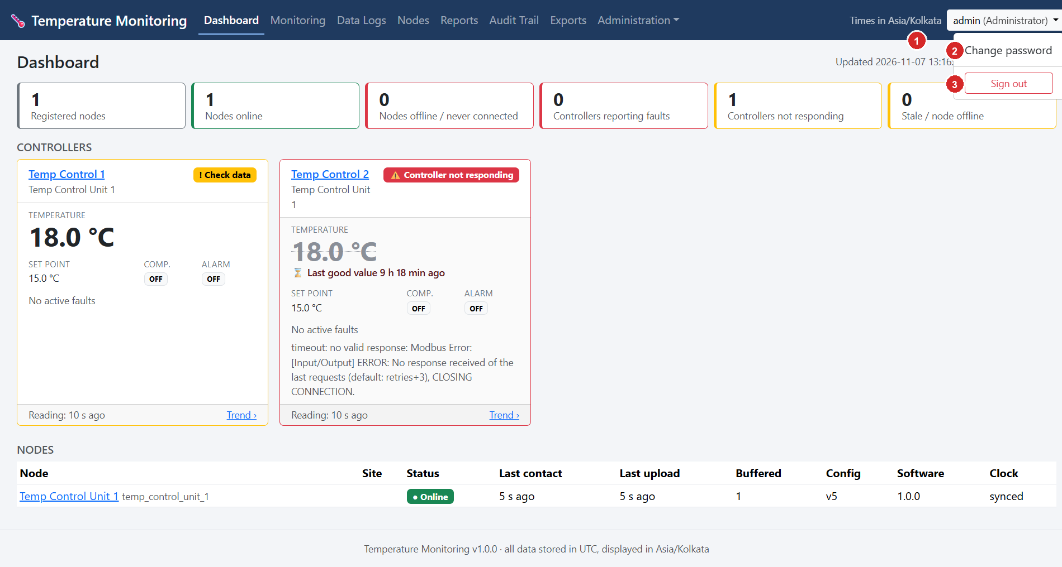
Figure 11-1 - The user menu at the top right of any page (call-outs added). The screenshot was captured with the menu open.
No. | Element | How to use it
1 | User button, e.g. admin (Administrator) | Click to open the menu. It shows the signed-in user and the role.
2 | Change password | Opens the password page (Figure 11-2).
3 | Sign out | Ends the session. Always sign out on a shared computer.

11.3 Change your password
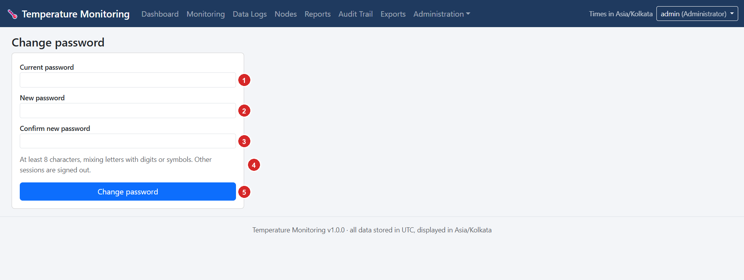
Figure 11-2 - Change password page (call-outs added).
No. | Field or control | Explanation
1 | Current password | Your present password. If it is wrong the page says "Current password is incorrect."
2 | New password | At least 8 characters, mixing letters with digits or symbols, and not containing your user name.
3 | Confirm new password | Type the same new password again.
4 | Hint text | "At least 8 characters, mixing letters with digits or symbols. Other sessions are signed out." Changing the password signs you out on all other browsers.
5 | Change password | Saves the change (recorded in the Audit Trail). Expected result: "Password changed." and the Dashboard.

CHAPTER 12

12 Website Features and Page-by-Page Explanation
This chapter explains every page for which a screenshot was supplied, and the pages that exist in the source code but were not captured (Nodes, node and controller pages, Reports, sign-in). Every figure has numbered call-outs that are explained in the table below it.

12.1 Dashboard
Purpose. The live overview: how many nodes and controllers are healthy, and the current temperature, set point and alarm state of every controller. It refreshes itself every 10 seconds.
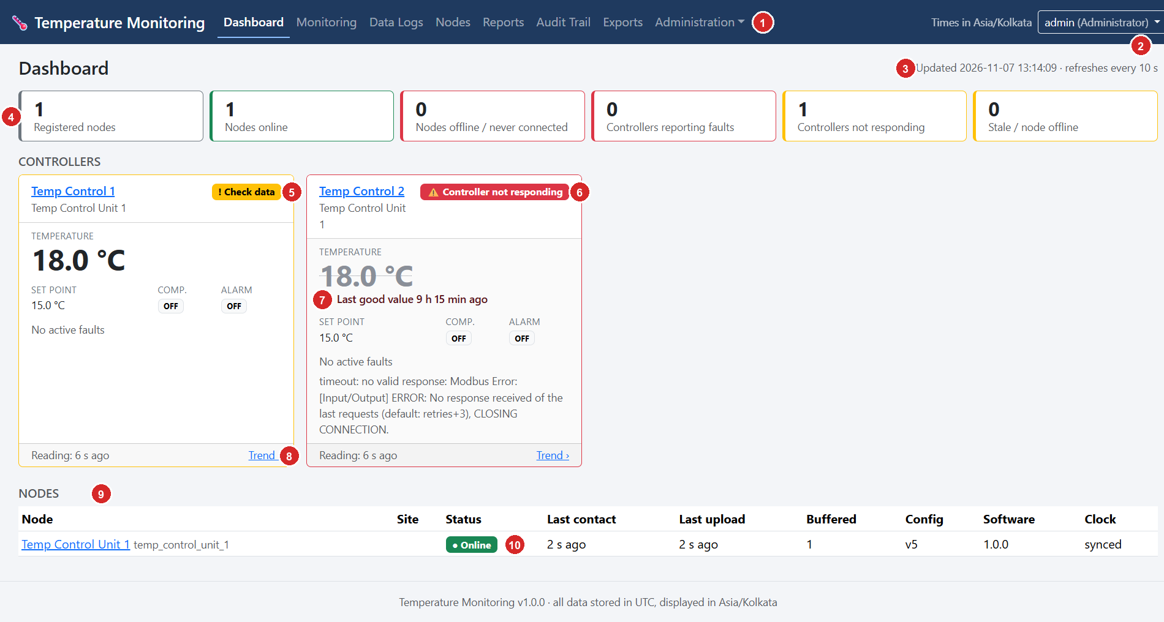
Figure 12-1 - Dashboard (screenshot supplied by the owner, 2026-11-07 13:14, call-outs added).
No. | Element | Explanation and how to use it
1 | Navigation bar | Switch pages. The active page (Dashboard) is underlined.
2 | User menu | Change password, sign out.
3 | "Updated ... refreshes every 10 s" | Time of the last refresh (display time zone) and the refresh interval (setting Dashboard refresh). No reload is needed.
4 | Summary tiles | Left to right: Registered nodes (1), Nodes online (1), Nodes offline / never connected (0, red when above 0), Controllers reporting faults (0, red), Controllers not responding (1, amber) and Stale / node offline (0, amber). A non-zero amber or red tile needs attention.
5 | Controller card Temp Control 1 | Name (click it for the controller page), node name, status badge ! Check data (the reading is valid but a consistency check flagged it; see Chapter 7), Temperature 18.0 °C, Set point 15.0 °C, Comp. (compressor) OFF, Alarm OFF, "No active faults", "Reading: 6 s ago" and a Trend › link. A card border in yellow/red repeats the status.
6 | Controller card Temp Control 2 | Status badge Controller not responding and the error text from the node ("timeout: no valid response ..."). The large temperature is greyed and struck through because it is not live.
7 | "Last good value 9 h 15 min ago" | How old the last valid temperature is. Never read the greyed value as current.
8 | Trend › | Opens the Monitoring page for that controller (Figure 12-2).
9 | NODES table | One row per Raspberry Pi: Node (name and Node ID), Site, Status, Last contact, Last upload, Buffered (readings waiting on the Pi; normally 0 to a few), Config (running configuration version, v5), Software (1.0.0) and Clock (synced when the Pi's clock is NTP-synchronised).
10 | Status badge Online | Green = heard from within the last 120 s. Offline (red), Never connected and Disabled (grey) are the other states.

Expected result. Healthy installation: Nodes online equals Registered nodes, every controller card says Normal, Reading ages stay below about 15 s and Buffered is near 0. Chapter 13 explains each status.

12.2 Monitoring
Purpose. Trend and statistics for one controller over a chosen period, with missing data made visible.
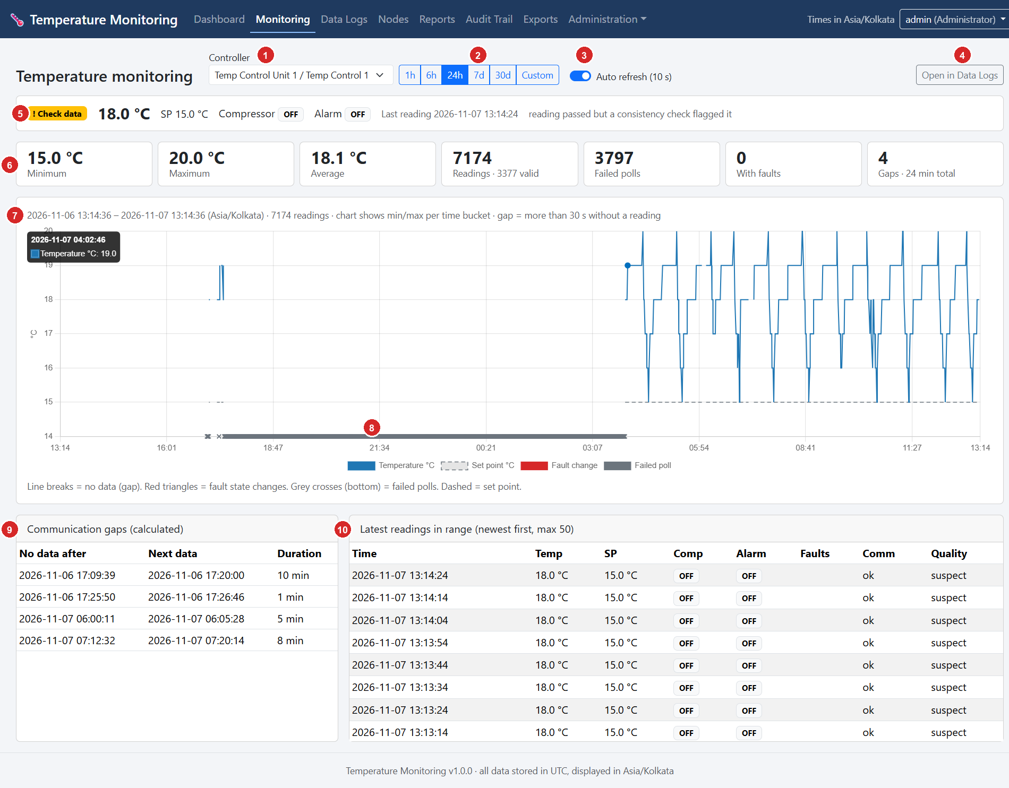
Figure 12-2 - Temperature monitoring page for Temp Control Unit 1 / Temp Control 1 over 24 hours (screenshot supplied by the owner, call-outs added).
No. | Element | Explanation and how to use it
1 | Controller drop-down | Choose the controller (shown as node / controller).
2 | Range buttons | 1h, 6h, 24h, 7d, 30d or Custom (enter a from/to date). The selected range (24h) is highlighted.
3 | Auto refresh (10 s) | When on, the page updates itself every 10 s. Turn it off to study the chart without it moving.
4 | Open in Data Logs | Opens Data Logs with the same controller and period so you can see the individual rows or export them.
5 | Status strip | Current status badge (! Check data), the latest temperature 18.0 °C, set point (SP) 15.0 °C, Compressor and Alarm state, the time of the last reading and an explanation of the status.
6 | Statistic tiles | Minimum, Maximum, Average (of valid readings), Readings (7174, of which 3377 valid), Failed polls (3797), With faults (0) and Gaps (4, 24 min in total). Statistics use recorded readings only.
7 | Chart | Blue line = temperature (minimum/maximum per time bucket). Dashed line = set point. Red triangles = fault-state changes. Grey crosses along the bottom = failed polls. A break in the line means no data (a gap is more than 30 s without a reading). Hover over a point for its time and value.
8 | Failed-poll marks | The grey band along the bottom shows a long period of failed polls (a continuous run of crosses). Failed polls carry no temperature, so the line is absent there.
9 | Communication gaps (calculated) | Each gap: No data after, Next data, Duration. Here four gaps (10 min, 1 min, 5 min, 8 min). They are calculated from missing readings, never estimated.
10 | Latest readings in range | The newest 50 readings: Time, Temp, SP, Comp, Alarm, Faults, Comm, Quality. Here every row has Comm ok and Quality suspect.

12.3 Data Logs
Purpose. Every stored poll attempt, with powerful filters, paging and export. This is the page to use for investigations and for exporting.
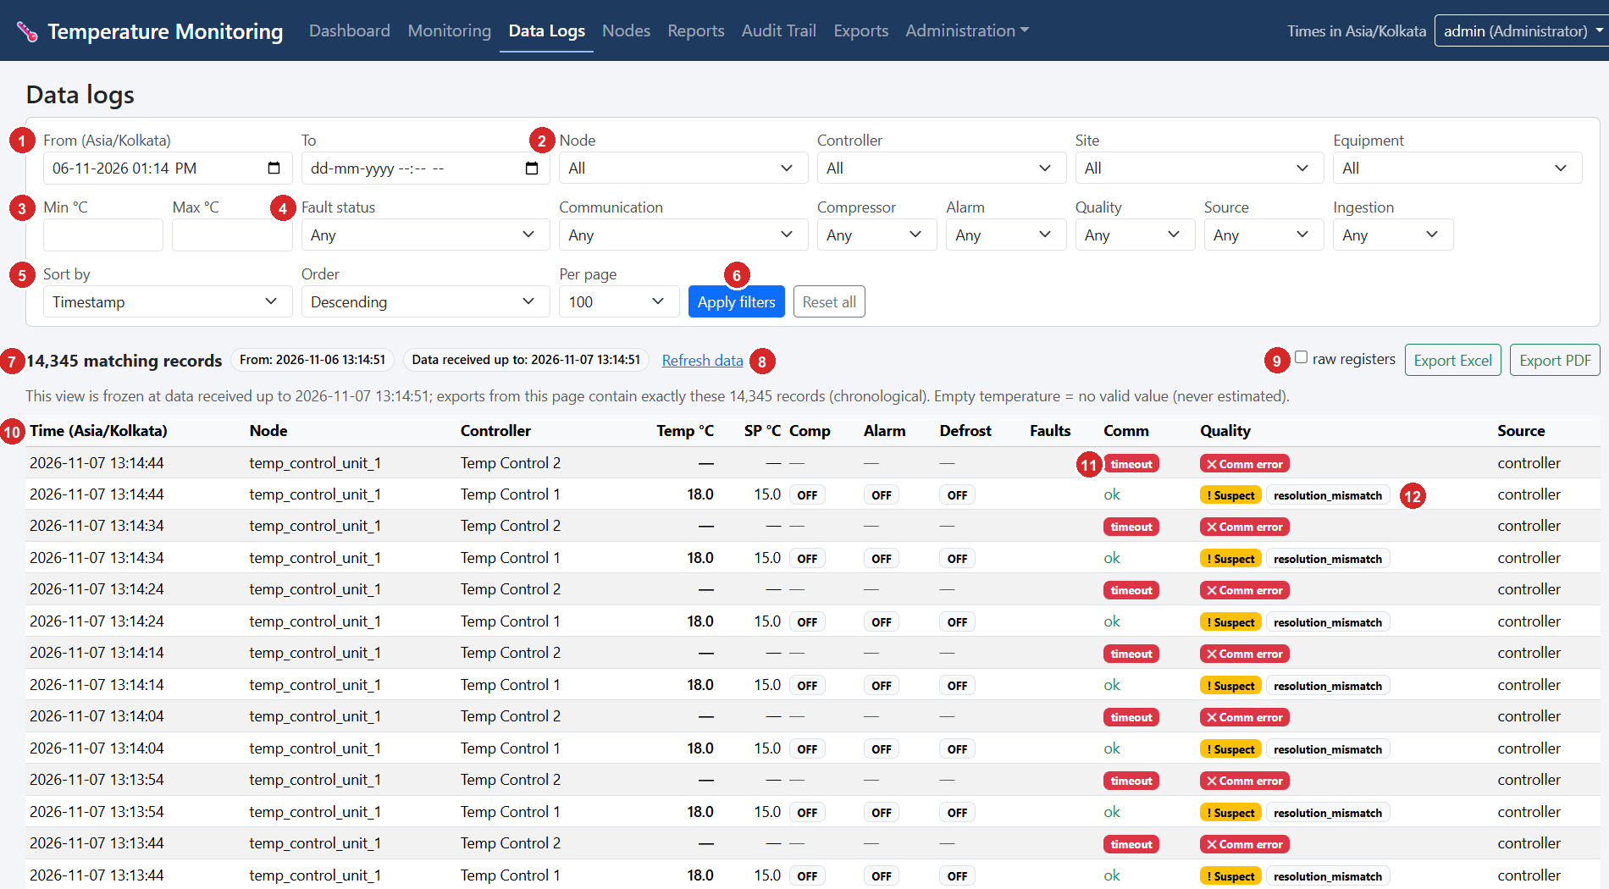
Figure 12-3 - Data Logs page, upper part (screenshot supplied by the owner, call-outs added).
No. | Element | Explanation and how to use it
1 | From / To | Start and end of the period in the display time zone (Asia/Kolkata). Leave To empty for "until now". The default is the last 24 hours.
2 | Node, Controller, Site, Equipment | Restrict to one node, controller, site or equipment.
3 | Min °C / Max °C | Show only readings whose temperature is in this range.
4 | Fault status, Communication, Compressor, Alarm, Quality, Source, Ingestion | Fault status (any/none/a specific fault), Communication (OK, any failure, timeout, exception, ...), Compressor and Alarm (on/off), Quality (good, suspect, probe fault, invalid, communication error), Source (controller or simulated), Ingestion (live or backfilled = delivered late after an outage).
5 | Sort by, Order, Per page | Sort by timestamp, temperature, node, controller or fault status, ascending or descending; 50, 100, 250 or 500 rows per page.
6 | Apply filters / Reset all | Apply filters runs the query; Reset all returns to the default (last 24 hours).
7 | "14,345 matching records" | Number of rows matching the filters, with the data-freeze time: Data received up to 2026-11-07 13:14:51. The note under it explains that this view is frozen so that paging and exports contain exactly the same records.
8 | Refresh data | Re-runs the query including data that arrived after the page was opened.
9 | raw registers, Export Excel, Export PDF | Exports exactly the records of this view (Chapter 14). Tick raw registers to add the raw register values to the Excel file.
10 | Table header | Time (display time zone), Node, Controller, Temp °C and SP °C (set point), Comp, Alarm, Defrost, Faults, Comm, Quality, Source.
11 | Comm column | ok, or a red timeout and similar. A failed poll shows "-" for temperature and set point.
12 | Quality column | A yellow ! Suspect with the reason (here resolution_mismatch), or a red Comm error for failed polls.

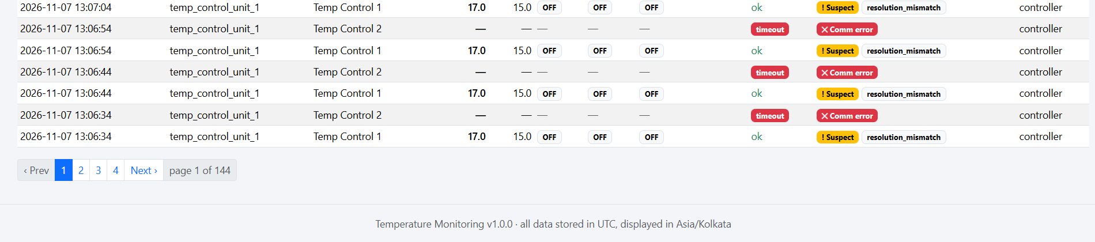
Figure 12-4 - Data Logs, bottom of the page: paging (Prev, page numbers, Next, "page 1 of 144").
Paging. Use Prev, the page numbers and Next. 14,345 records at 100 per page are 144 pages. A temperature shown as "-" means no valid value; it is never estimated.

12.4 Nodes, node page and controller page (no screenshot supplied)
DESCRIBED FROM SOURCE, NOT FROM A SCREENSHOT
No screenshots of these pages were supplied. The description below comes from the page templates in server/app/templates/nodes/ and controllers/.

Nodes list
Columns: Node ID, Name, Site / location, Equipment, Status, Last contact, Controllers, Config (running / latest) (a pending, delivered or rejected badge shows a configuration still on its way or refused), Software. Buttons: Communication events (a log of all node events) and, for administrators, + Register node. Below the table, administrators see Unregistered devices that tried to connect (Node ID, host name, IP, attempts) with a Register... shortcut; their data is not accepted until they are registered.

Node page
Area | Content
Header buttons (administrators) | Edit configuration, Test connectivity (queues a read-only identity check of registers 40001-40005 for every enabled controller), Issue new token (the old token stops working immediately; the new one is shown once), Disable / Enable (a disabled node's submissions are refused; the Pi keeps buffering).
Details | Site, location, equipment, registration date, token hint (last 4 characters), authentication failures.
Health (last heartbeat) | Last contact, last heartbeat, last data upload, last good poll, Readings buffered, upload failures in a row, software version, uptime, Host / IP, clock state (synchronised or skew), CPU temperature, free disk, Wi-Fi signal.
Configuration | Running version on the node versus latest on the server, a list of versions with status (applied, rejected, pending, delivered) and any error the node reported.
Controllers | Per controller: slave ID, status, temperature, set point, compressor, alarm, last reading and the node's own view of communication ("fails in a row", last error).
Recent communication events, Commands, Heartbeats | The latest events, queued controller commands and their results, and the latest heartbeats (config version, buffered, upload failures).

Edit configuration (administrators)
Opens a form with the node's description (friendly name, description, site, location, equipment), Server URL override, upload and heartbeat intervals, batch size, the serial bus (bus name, Serial port, Baud rate, Parity, timeout, retries, inter-request delay), one row per controller (Controller ID, Name, Slave ID, poll interval, Parameter read (s), Address offset, Read strategy, Enabled), the buffer limits (retention days, Max buffered records, When buffer is full, Min free disk), Log level, Diagnostic register logging, an Advanced JSON box for several buses, and a mandatory Reason for change. Saving creates a new numbered version. The node fetches it within about a minute, validates it, and either applies it (and acknowledges applied) or keeps its current version (rejected, with the errors shown on the node page).

Controller page
Opened by clicking a controller name. Buttons: Trend, Data logs, Node. Cards: Latest reading (control and actual temperature, set point, resolution rS, compressor/alarm/defrost, faults, keypad lock, log high/low, compressor run hours, communication, quality and decoder warnings, and the raw registers as received with their signed values), Configuration (server), Device parameters 40031-40068 (read-only snapshot with the time it was read), Configuration history, Fault and alarm periods, and, for administrators, Controller commands. Write commands (alarm mute, fault reset, log reset, defrost) are available only when the control_controllers permission, the system setting Allow controller commands and safety.allow_remote_control: true on the node are all in place, and you type the controller ID and a reason to confirm. Read-only checks (identity check, read parameters) are always available.

12.5 Reports (no screenshot supplied)
The Reports page generates reports as Excel or PDF. Choose the Report, the period (From, To), optionally a Node and Controller, and the extra fields that appear for some reports, then click Generate Excel or Generate PDF.
Report | Content | Permission
Temperature history | Opens Data Logs with your period and filters, where you export the exact records. | export_data
High / low temperature excursions | Periods above or below limits you enter (High limit °C, Low limit °C). Gaps inside an excursion are flagged. | export_data
Controller faults and alarms | Fault and alarm periods from the fault register (Ht, Lt, door, compressor, probe). | export_data
Node downtime and communication interruptions | Node downtime inferred from missing heartbeats plus recorded communication events. | export_data
Missing data periods | Gaps between readings and periods without a valid temperature. | export_data
Configuration changes | Changes to nodes, controllers, settings (filter by event category). | view_audit
User activity | Logins and actions by user (filter by user and outcome). | view_audit
Data export activity | Who exported what and when. | view_audit
Audit trail | The audit trail for a period (filters: category, user, outcome). | view_audit

Every section of a report is labelled RECORDED (stored as it happened), CALCULATED (derived from recorded readings) or INFERRED (estimated from missing data). Every generated report is entered in the export history.

12.6 Audit Trail
Purpose. An append-only history of what happened: logins, configuration changes, communication events, faults, exports. Entries cannot be edited or deleted through the application, which enforces this in the program and with database triggers. Secrets are never recorded.
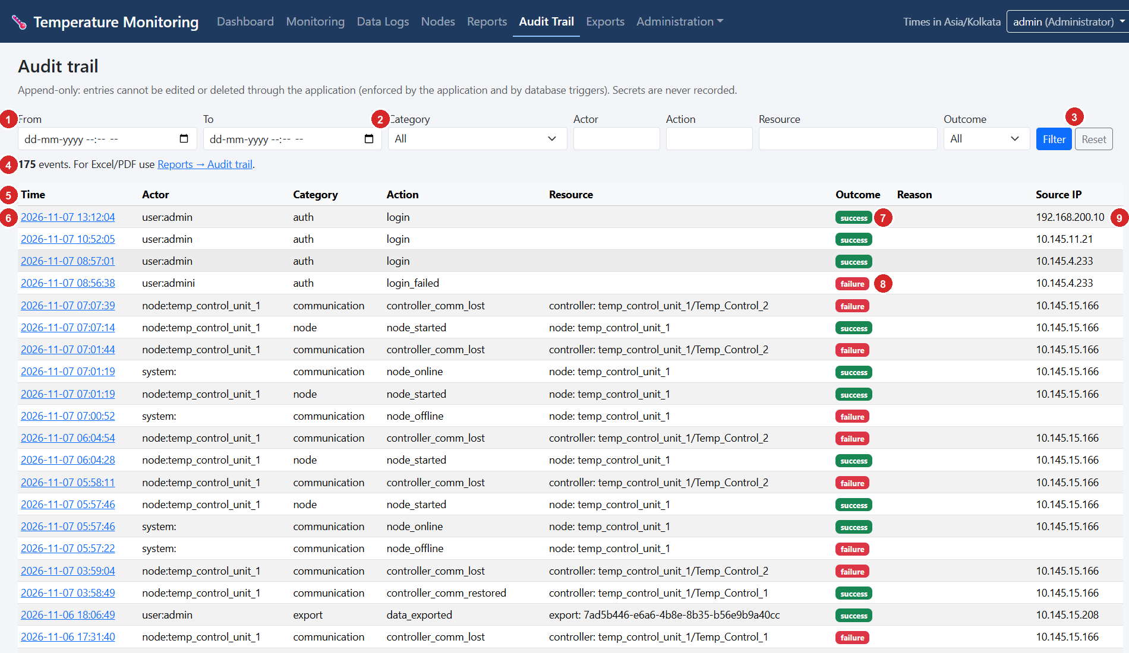
Figure 12-5 - Audit Trail, top of the page (screenshot supplied by the owner, call-outs added).
No. | Element | Explanation and how to use it
1 | From / To | Restrict to a period (date and time in the display time zone).
2 | Category, Actor, Action, Resource | Filter by category (auth, communication, node, config, command, export, system, user_admin, controller, fault), by who did it (e.g. user:admin, node:temp_control_unit_1, system:), by action name or by resource text.
3 | Outcome, Filter, Reset | Outcome: success, failure or denied. Filter applies; Reset clears.
4 | "175 events" line | Number of matching entries, and a pointer: for Excel/PDF use Reports > Audit trail.
5 | Table header | Time, Actor, Category, Action, Resource, Outcome, Reason, Source IP.
6 | Time (link) | Click the time to open the entry with all its details (before/after values, request ID, extra information).
7 | Outcome badge | Green success, red failure.
8 | A failure row | Here a failed login (login_failed) and controller_comm_lost events, in red.
9 | Source IP | Address the request came from, for example the node 10.145.15.166 or an operator's PC. Entries created by the server itself (for example node_offline) have no source IP.

Typical actions: login, login_failed, node_started, node_online, node_offline, controller_comm_lost, controller_comm_restored, data_gap_reported, node_reconnected, node_config_created, node_config_applied, node_config_rejected, controller_settings_changed, command_requested, data_exported, server_started, server_stopped. The page shows 100 entries per page (here "page 1 of 2"); use Prev / Next.

12.7 Exports (export history)
Purpose. A record of every file generated: who, when, what, how many records, and a SHA-256 fingerprint of the file. The files themselves are not stored on the server.
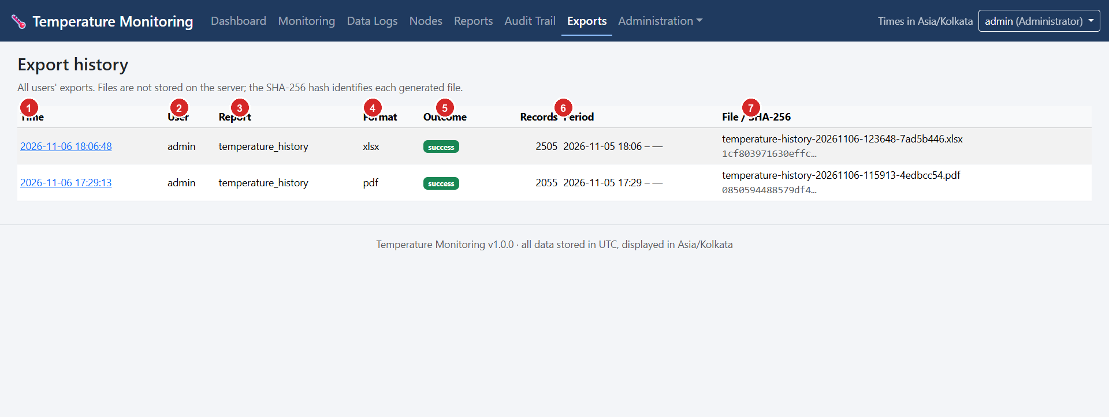
Figure 12-6 - Export history (screenshot supplied by the owner, call-outs added).
No. | Column | Explanation
1 | Time (link) | When the export was generated (display time zone). Click for the detail page with the filters used and the full hash.
2 | User | The user who generated it (here admin).
3 | Report | The report type, here temperature_history.
4 | Format | xlsx (Excel) or pdf.
5 | Outcome | success, or a failure reason such as a rejected oversized export.
6 | Records / Period | Number of records (2505 and 2055 in the screenshot) and the period start. "-" for an open end.
7 | File / SHA-256 | The generated file name (temperature-history-20261106-123648-7ad5b446.xlsx) and the start of the SHA-256 hash.

Check a file against its fingerprint. On the Windows computer run Get-FileHash <file> -Algorithm SHA256 and compare the result with the hash on the export's detail page. They match only if the file is unchanged.

12.8 Administration: Users
Purpose. Manage the people who can sign in. Requires the manage_users permission.
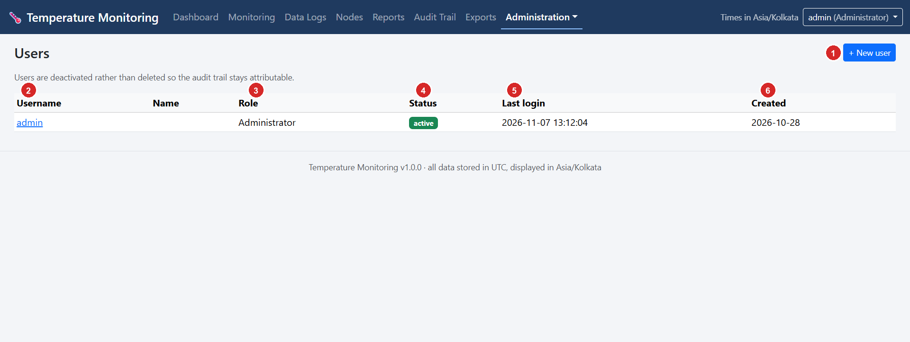
Figure 12-7 - Users page (screenshot supplied by the owner, call-outs added).
No. | Element | Explanation and how to use it
1 | + New user | Opens the form Username, Full name, Email, Role, Active, Password, Reason for change. The password must meet the policy.
2 | Username (link) | Click to edit the user: change name, e-mail, role, active state or password. Changing role, status or password signs that user out everywhere.
3 | Role | Administrator, Operator or Auditor.
4 | Status | active (green) or inactive. Users are deactivated rather than deleted so that the audit trail stays attributable.
5 | Last login | Time of the last successful sign-in.
6 | Created | Date the account was created.

12.9 Administration: Roles and permissions
Purpose. Shows and edits which role may do what. Permissions are enforced on the server for every request; changes are audited and take effect on the next request.
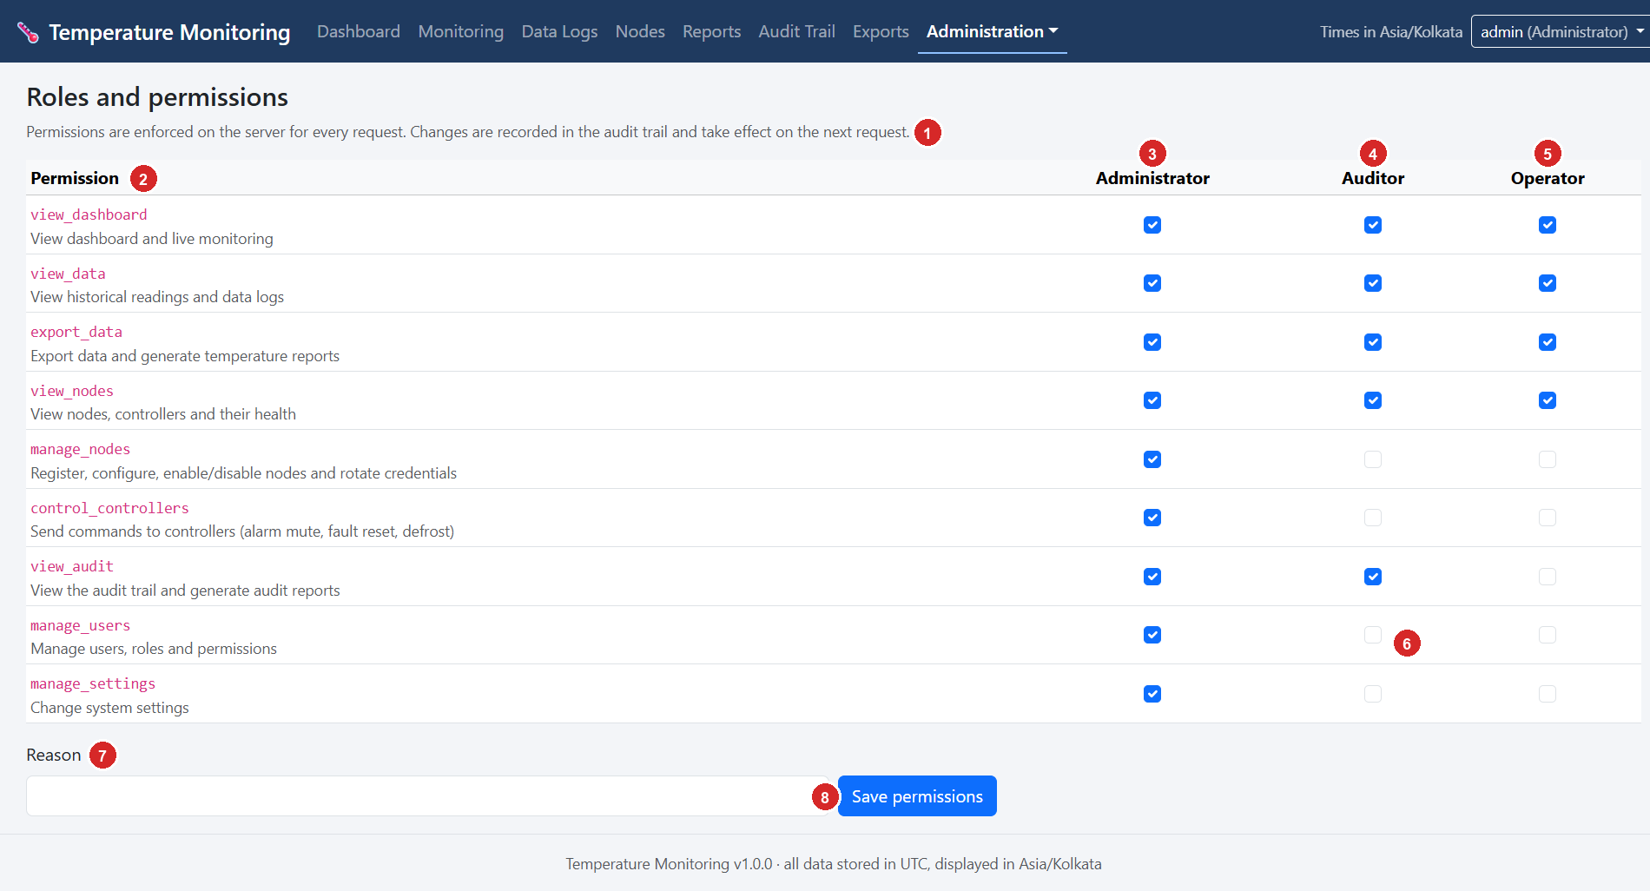
Figure 12-8 - Roles and permissions (screenshot supplied by the owner, call-outs added).
No. | Element | Explanation and how to use it
1 | Introduction text | "Permissions are enforced on the server for every request. Changes are recorded in the audit trail and take effect on the next request."
2 | Permission column | Each permission with its description: view_dashboard, view_data, export_data, view_nodes, manage_nodes, control_controllers, view_audit, manage_users, manage_settings.
3 | Administrator column | All nine permissions are ticked.
4 | Auditor column | View dashboard, data, exports and nodes, plus view_audit.
5 | Operator column | View dashboard, data, nodes and export data; no audit, no management.
6 | A checkbox | Tick or untick to grant or remove a permission for a role. An empty box means the role does not have it.
7 | Reason | Mandatory text explaining the change (recorded in the audit trail).
8 | Save permissions | Applies the matrix.

The last active administrator cannot be removed. Keep manage_users, manage_settings and manage_nodes limited to administrators.

12.10 Administration: System settings
Purpose. Site-wide limits that change how data is classified and displayed. Requires manage_settings. Every change needs a reason and is audited.
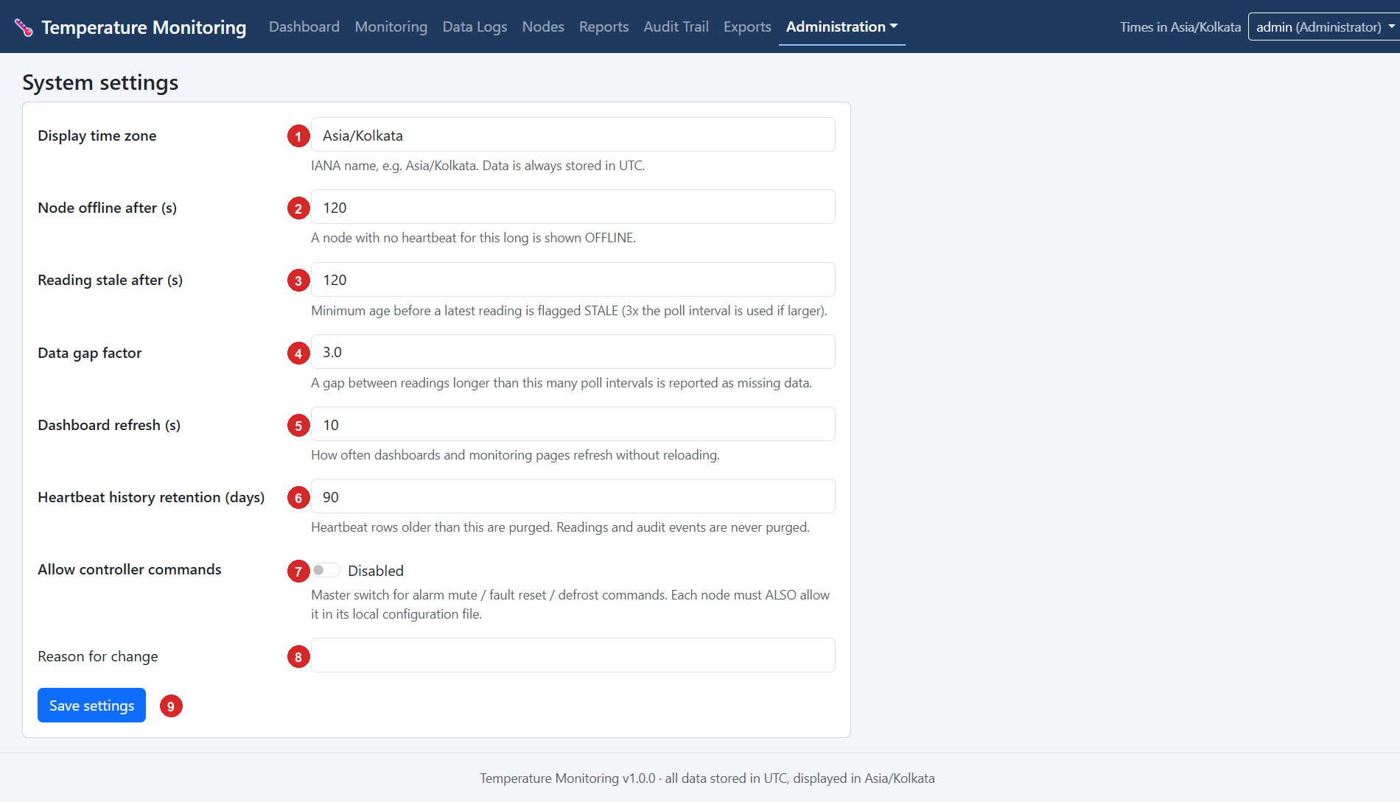
Figure 12-9 - System settings page (screenshot supplied by the owner, call-outs added).
No. | Setting | Explanation (value in the screenshot)
1 | Display time zone | IANA name such as Asia/Kolkata (shown). All data is stored in UTC and converted for display.
2 | Node offline after (s) | A node with no heartbeat for this long is shown OFFLINE (120). Allowed 30 to 86400.
3 | Reading stale after (s) | Minimum age before a latest reading is flagged STALE (120). Three times the poll interval is used if larger. Allowed 10 to 86400.
4 | Data gap factor | A gap longer than this many poll intervals (minimum 30 s) is reported as missing data (3.0).
5 | Dashboard refresh (s) | How often dashboards and monitoring pages refresh without reloading (10). Allowed 2 to 3600.
6 | Heartbeat history retention (days) | Heartbeat rows older than this are purged (90). Readings and audit events are never purged.
7 | Allow controller commands | Master switch for alarm mute, fault reset and defrost commands (Disabled). Each node must also allow it in its own file.
8 | Reason for change | Mandatory explanation of the change.
9 | Save settings | Stores the changes.

CHAPTER 13

13 Monitoring Temperature Data
This chapter shows an operator how to read the temperature correctly and how to recognise missing, outdated or failed data.

13.1 Open the monitoring page and identify node and controller
- Dashboard for the overview; click Trend › on a controller card, or open Monitoring and choose the controller in the drop-down (Figure 12-2, item 1).
- Which node? The card shows the node's friendly name (Temp Control Unit 1); the Nodes table and the Monitoring drop-down show it too; the Node ID is temp_control_unit_1 (Figure 12-1).
- Which controller? The card title is the controller's name (Temp Control 1, Temp Control 2). Its controller ID (Temp_Control_1) and slave ID (1) are on the node page and the controller page.
- Several channels. One node can serve many controllers, and the system can have many nodes. Each controller provides one control temperature (register 40006). The actual temperature (register 40008) is stored separately and shown on the controller page and in exports.

13.2 Read the current temperature and its time
- The large number on the card (18.0 °C) and in the Monitoring status strip is the latest valid control temperature; the set point (SP 15.0 °C), compressor and alarm state are beside it.
- "Reading: 6 s ago" is the age of the newest poll attempt. "Last reading 2026-11-07 13:14:24" is its time in the display time zone (Asia/Kolkata). In an Excel export both the local and the UTC time are given.
- India Standard Time is UTC+05:30, so a reading shown as 13:14 IST was taken at 07:44 UTC.

13.3 Statuses: how to recognise missing, outdated and failed data
A latest value is presented as live only when it is recent, the node is online and the controller answered. Every other case gets an explicit label (colour is never the only signal). The thresholds are Node offline after 120 s and Reading stale after the larger of 120 s and three times the poll interval.
Controller status | Colour | Meaning | What to do
Normal | green | Recent valid reading, no fault. | Nothing.
Check data (suspect) | amber | The reading passed but a consistency check flagged it (for example resolution_mismatch, or an unsynchronised Pi clock). | See the flag in Data Logs; Chapter 7.
Controller fault | red | The controller reports a fault such as high temperature, low temperature, door open or compressor fault. | Check the controller and the equipment.
Probe fault | red | Temperature probe failure (PFL/PFH); no temperature is shown. | Check the probe.
Invalid measurement | red | Value outside the documented range or failed validation. | Check the controller settings (rS) and wiring.
Controller not responding | red | The node cannot read the controller (timeout and similar). The value shown is the last good one, greyed. | Chapter 7: wiring, slave ID, power.
Stale data | amber | The latest reading is older than the stale limit although the node is online. | Check the node's polling and uploads.
Node offline | red | The node has not been heard from for more than 120 s; the values shown are the last received. | Check the Pi's power and network.
No data yet | grey | No reading has ever been received. | Finish commissioning.
Disabled | grey | The node or controller is disabled. | Enable it if it should run.

Node status | Meaning
Online (green) | Contact within the last 120 s.
Offline (red) | No contact for more than 120 s. "no contact since ..." is shown.
Never connected | Registered but never heard from.
Disabled | Switched off by an administrator; submissions are refused.

13.4 Find communication failures and data gaps
- Dashboard tiles: Controllers not responding, Nodes offline, Stale / node offline.
- Monitoring: grey crosses for failed polls, line breaks and the Communication gaps (calculated) table (Figure 12-2).
- Data Logs: filter Communication = Any failure or Timeout, and look at the Comm and Quality columns (Figure 12-3).
- Nodes page: Communication events and the node page's event list (comm_lost, comm_restored, data_gap, node_offline).
- Audit Trail: the same events with outcome failure in red (Figure 8-4).
- Reports: Missing data periods and Node downtime and communication interruptions.

13.5 Verify that the Raspberry Pi is sending data correctly
Where | What to look at | Healthy
Dashboard, NODES table | Status, Last contact, Last upload, Buffered, Config, Clock | Online; both ages a few seconds; Buffered near 0; Config equals the latest version; Clock synced.
Node page, Health | Last heartbeat, last data upload, last good poll, readings buffered, upload failures in a row, CPU temperature, free disk, Wi-Fi signal | Failures 0; Wi-Fi better than about -70 dBm; plenty of free disk.
Data Logs | Newest row time | Within about 10-25 s of now, with Ingestion = live.
Audit Trail / events | node_started, node_offline entries | Few; each restart is explained.

13.6 The complete workflow from controller to screen
1. The controller measures the temperature and keeps it in register 40006.
2. Every 10 s the Raspberry Pi reads registers 40001-40020 over RS-485 and decodes them.
3. The reading is committed to the Pi's local buffer (status pending).
4. Within about 5 s the uploader sends it to the server, which stores it and confirms; the Pi marks it delivered.
5. The server updates the controller's latest state and any fault periods.
6. The browser asks the server for the dashboard data every 10 s and redraws the cards.
7. Result: a value on the screen is normally no more than about 25-30 seconds old (10 s poll + up to 5 s upload + up to 10 s refresh). If it is older, a status label says so.

CHAPTER 14

14 Exporting Temperature Logs
The website exports stored readings as an Excel workbook (.xlsx) or a PDF report. Both come from exactly the same filtered record set as the Data Logs page, so an Excel and a PDF made from the same view contain the same readings. Every export is recorded in the export history with a SHA-256 hash (Figure 12-6).

14.1 Export the readings shown in Data Logs
1. Open Data Logs (Figure 12-3).
2. Select the Node and/or Controller you need.
3. Set the From and To date and time (display time zone).
4. Apply any other filters (fault status, communication, quality, temperature limits) and click Apply filters. Check the record count in item 7. Note: when filters that remove some readings are used, gap analysis is not included in the export because the series is no longer complete.
5. Click Export Excel or Export PDF. Tick raw registers first if you want the raw register values in the Excel file.
6. The browser downloads the file. If a message says that the export is too large, narrow the period or the filters (limits: 500 000 rows for Excel, 20 000 rows for PDF). Exports are never silently truncated.
7. Find the file in the browser's download folder (normally C:\Users\<you>\Downloads). The name is temperature-history-<yyyymmdd-hhmmss>-<8 characters>.xlsx (or .pdf); the time in the name is UTC.
8. Open it: double-click the .xlsx file in Microsoft Excel (if Excel shows Protected View click Enable Editing).
NOTE
Reports other than the temperature history (excursions, faults, downtime, missing data, audit) are generated from Reports; see Section 12.5. The Temperature history entry there opens Data Logs.

14.2 Excel workbook layout
Sheet | Content
Summary | Report title, Report ID, time generated (local and UTC), generated by, time zone, period, number of records and every filter used. Then a per-controller table (Node, Controller, Site, Equipment, Readings, Valid temps, Min °C, Max °C, Avg °C, Comm failures, Readings with faults, Gaps, Gap time, Simulated) and notes explaining that statistics are calculated from the exported readings.
Readings | One row per reading, oldest first, with a frozen header row and filter buttons. Columns below.
Gaps | Node, Controller, No data after, Next data at, Duration (periods longer than the gap factor × poll interval, minimum 30 s).
Fault events | Controller, Kind, Code, Description, Started, Cleared, Duration, Status.

Columns of the Readings sheet
Column | Meaning
Timestamp (local) | Acquisition time in the display time zone, as a real Excel date-time.
Timestamp (UTC) | The same instant in UTC (ISO-8601).
Node | Node ID.
Controller | Controller name (or ID).
Temperature °C | Control (display) temperature, register 40006. Empty = no valid value (communication failure or probe fault).
Set point °C | Register 40018.
Actual temp °C (40008) | Register 40008 (type not specified by the manufacturer; informational).
Compressor, Alarm, Defrost | ON / OFF (empty if unknown).
Faults | Decoded fault codes.
Comm status | ok, timeout, exception, invalid_response, port_error, identity_mismatch, error.
Comm error | Error text for failed polls.
Quality | good, suspect, probe_fault, invalid, comm_error.
Quality flags | Reasons such as resolution_mismatch.
Source | controller or simulated.
Backfilled | yes if the reading was delivered late (after an outage), otherwise no.
Config version | Node configuration version in force when the reading was taken.
Reading ID | The unique UUID of the reading.
Raw registers | Only when raw registers was ticked: the registers as received (JSON).

Sample of the exported data
The following is an illustrative extract in the layout of the Readings sheet (selected columns; the Node column, always temp_control_unit_1 here, and the remaining columns are omitted), using values like those in Figure 12-3:
Timestamp (local) | Controller | Temperature °C | Set point °C | Comm status | Quality | Quality flags | Backfilled
07-11-2026 13:13:44 | Temp Control 1 | 18.0 | 15.0 | ok | suspect | resolution_mismatch | no
07-11-2026 13:13:44 | Temp Control 2 | (empty) | (empty) | timeout | comm_error | (empty) | no
07-11-2026 13:13:54 | Temp Control 1 | 18.0 | 15.0 | ok | suspect | resolution_mismatch | no

14.3 PDF report layout
The PDF contains the title and report metadata (Report ID, generated, by whom, time zone, period, records, filters), the summary statistics per controller, the fault and alarm events (the first 300), the communication gaps, trend charts (for the first six controllers), and the chronological readings table in which highlighted rows mark periods without data. Each page carries the Report ID in its footer.

14.4 Verify and keep exports
- The website does not keep the file. Keep your own copy in a controlled folder.
- To prove that a copy is unchanged: Get-FileHash .\temperature-history-....xlsx -Algorithm SHA256 and compare with the hash in Exports (Figure 12-6).
- Excel and PDF show only recorded values. Statistics, gaps and durations are calculated from them and labelled as such in the workbook notes.

CHAPTER 15

15 Troubleshooting
Start with the website (Dashboard, node page, Audit Trail) to see where the chain is broken, then use the commands below. The chain is: controller - RS-485 - Raspberry Pi - network - server - database - website. Commands marked Pi are typed on the Raspberry Pi, VM on the Ubuntu server.

15.1 Problem table
Problem | Possible cause | Diagnostic | Solution
Raspberry Pi does not connect to Wi-Fi | Wrong or changed password; SSID out of range; DHCP failure. | Pi: nmcli device status, nmcli device wifi list, nmcli -f GENERAL.STATE,IP4.ADDRESS device show wlan0 | Reconnect with sudo nmcli --ask device wifi connect "AVO_MACHINES"; see Chapter 4.
Raspberry Pi cannot reach the server | Network connectivity issue; server stopped; firewall; wrong server.url. | Pi: ping -c 4 10.145.15.245; curl -s http://10.145.15.245:8000/api/v1/ping; ip route | Fix the route; start the server (systemctl status temperature-server); allow port 8000 (sudo ufw status); correct server.url. The Pi keeps buffering meanwhile.
No temperature readings | RS-485 communication failure: wiring, A/B swapped, TTL-to-RS-485 interface missing or unpowered, wrong slave ID, baud or parity, controller unpowered, did = 0. | Pi: sudo journalctl -u temperature-node -f; stop the service and run validate_controller --scan or read_temp_from_controllert.py | Check wiring (swap A/B), set matching did/bd/PAr, check power; Chapter 7.
Website not accessible | Server application stopped; VM down; wrong address; port 8000 blocked. | Windows: Test-NetConnection 10.145.15.245 -Port 8000. VM: systemctl status temperature-server; sudo ss -ltnp | grep 8000 | Start the service; check HOST=0.0.0.0; open the firewall; Chapter 9.
Data not updating on the website | Client application stopped; Pi off or offline; uploads failing. | Website: node status and Last upload. Pi: systemctl status temperature-node; journalctl -u temperature-node -n 50 | Restart: sudo systemctl restart temperature-node. If upload errors are shown, see the next rows.
Database not storing readings | Application or database error on the server; disk full; read-only file. | VM: tail -n 100 ~/temperature-logging-system/logs/server.log; df -h; sqlite3 instance/temperature.db "PRAGMA integrity_check;" | Free disk space; fix permissions of instance/; restore from backup if corrupt (Chapter 10).
Raspberry Pi program does not start after reboot | Service not enabled; configuration invalid; serial port missing. | Pi: systemctl is-enabled temperature-node; systemctl status temperature-node; ... --check-config | sudo systemctl enable --now temperature-node; fix the configuration; Chapter 6.
Incorrect temperature value | Register mapping or scaling issue: rS changed; resolution_mismatch; wrong controller; offset. | Compare with the controller display; open the controller page and the raw registers; Pi: validate_controller | Check rS (40005); run the validation procedure; set address_offset only if validation proves it.
One controller shows Controller not responding, the other is fine | Slave ID not set, controller off, wiring to that controller. (Seen in the supplied screenshots for Temp Control 2.) | Data Logs: Comm column for that controller; Pi log: poll failed (n in a row) | Check that controller's power, did, bd, PAr and A/B. Disable the controller on the node page if it is not installed yet, so it stops generating failed polls.
Quality suspect with resolution_mismatch | rS (40005) and bit 2 of 40010 disagree (known ambiguity A5). | Controller page: resolution rS and decoder warnings | Compare with the display; scaling follows rS. Report to the vendor if values are 10x off.
Quality suspect with clock_unsynchronized | The Pi clock is not NTP-synchronised. | Pi: timedatectl; systemctl status systemd-timesyncd | Restore network access to a time server; wait for System clock synchronized: yes.
Node shows Offline although the Pi is on | No contact for 120 s: network, wrong URL, service stopped, server rejected credentials. | Pi log: server unreachable or server rejected node credentials | Fix network/URL; install the correct token.
Node log: server rejected node credentials | Wrong token or Node ID; token re-issued. | Node page: Auth failures | Put the current token in /etc/temperature-node/node.env, restart the service.
Node appears under Unregistered devices | The Node ID is not registered on the server. | Nodes page | Register it with exactly that Node ID (Chapter 5, Step 3).
Configuration stays delivered or rejected | The node refused it (for example a serial port that does not exist) or has not reconnected. | Node page: Configuration, version page Node errors | Fix the error and save a new version.
Buffered count keeps growing | Server unreachable or refusing records. | Pi: sqlite3 ... select status,count(*) ...; Pi log | Restore the connection; the backlog drains automatically (Chapter 8).
Gaps in the chart | The node was not running (power, restart) or the buffer overflowed. | Audit Trail: node_offline, data_gap_reported; Monitoring: gap table | A gap while the Pi was off cannot be recovered. Investigate why the Pi lost power.
port_error: cannot open serial port | HAT driver not loaded; wrong port; port in use; tempnode not in dialout. | Pi: ls -l /dev/ttySC*; id tempnode; sudo lsof /dev/ttySC1 | Stop other users of the port; load the HAT driver; Chapter 3.
Times look shifted by hours | Display time zone setting; browsing in another zone. | Footer text; Administration > System settings | Set Display time zone to Asia/Kolkata. Stored data is always UTC.
Export refused: "N records match, above the limit" | More than 500 000 rows (Excel) or 20 000 (PDF). | The message on the page | Narrow the period or filters, or use Excel for PDF-sized sets.
Account locked | 5 failed logins; lock for 15 minutes. | Audit Trail: login_failed ... account locked | Wait 15 minutes, or ask an administrator to reset the password (Administration > Users).
Page shows "Internal error (reference ...)" | Application error. | VM: search the reference in logs/server.log | Fix the cause or contact the developer with the reference.
database is locked in the server log | Several heavy exports at once on SQLite. | VM: server.log | Retry later (the server waits up to 10 s). Consider PostgreSQL for heavy use.
Pi disk almost full | Large buffer, logs or other files. | Pi: df -h; du -sh /var/lib/temperature-node /var/log/temperature-node | Free space. Below 100 MB free the node applies its buffer-full policy and reports data_gap.
SSH refuses or warns about a changed host key | Device re-imaged; wrong address. | Windows: the warning text | ssh-keygen -R <address>, then connect again and verify the address.
Pi's Wi-Fi address changed | DHCP lease changed. | Pi (via Ethernet): hostname -I; website node page Host / IP | Use the new address for SSH; ask for a DHCP reservation.
Node briefly Offline then Online after a server restart | Not an error: the server's last-contact time was old when it restarted. | Audit Trail: node_offline then node_online seconds apart | No action.

15.2 Diagnostic command cheat sheet
Where | Command | Shows
Pi | systemctl status temperature-node | Is the node service running, since when.
Pi | sudo journalctl -u temperature-node --since "1 hour ago" | Recent node log.
Pi | sudo tail -f /var/log/temperature-node/node.log | Live node log file.
Pi | sudo sqlite3 /var/lib/temperature-node/queue.db "select status,count(*) from readings group by status" | Pending / delivered / rejected counts.
Pi | ls -l /dev/ttySC* | HAT serial ports present.
Pi | hostname -I, ip route, nmcli device status | Addresses, routes, interfaces.
Pi | timedatectl | Time zone and clock synchronisation.
Pi | df -h, free -h, vcgencmd measure_temp | Disk, memory, CPU temperature.
VM | systemctl status temperature-server | Is the server running.
VM | sudo journalctl -u temperature-server -n 100 | Recent server log.
VM | sudo ss -ltnp | grep 8000 | Is something listening on port 8000.
VM | sqlite3 ~/temperature-logging-system/instance/temperature.db "PRAGMA integrity_check;" | Database health (ok).
Windows | Test-NetConnection 10.145.15.245 -Port 8000 | Can this PC reach the website.

CHAPTER 16

16 Maintenance and Backup

16.1 Restarting (Technician / Administrator)
Task | Commands | Effect on data
Restart the Raspberry Pi | sudo reboot (or sudo shutdown -h now to power off, then wait for the activity light to stop) | No readings are recorded while it is off; a gap is reported at the next start (Chapter 8). Pending readings are kept.
Restart the client application | sudo systemctl restart temperature-node | A few seconds without polling; node_started is logged.
Restart the Ubuntu server | sudo reboot on the VM; temperature-server starts by itself | Website unavailable; the Pi buffers and uploads afterwards. No data loss.
Restart the server application | sudo systemctl restart temperature-server | Website unavailable for a few seconds.

IMPORTANT
Prefer a clean shutdown (sudo shutdown -h now) to pulling the power. The node survives power cuts by design, but a clean stop avoids storage corruption and a long data gap.

16.2 Check resources (Administrator)
Check | Pi | VM
Disk space | df -h /; du -sh /var/lib/temperature-node /var/log/temperature-node | df -h /; du -sh ~/temperature-logging-system/instance ~/temperature-logging-system/logs
RAM | free -h | free -h
CPU load | uptime, top (press q to quit) | uptime, top
CPU temperature | vcgencmd measure_temp (also on the node page as CPU temp) | --
Application logs | sudo journalctl -u temperature-node -n 100; /var/log/temperature-node/node.log | sudo journalctl -u temperature-server -n 100; ~/temperature-logging-system/logs/server.log

16.3 Routine schedule
Interval | Task | Who
Every shift / day | Look at the Dashboard: nodes online, no controller in red, Buffered near 0. | Operator
Weekly | Check disk space on the Pi and the VM; look at the Audit Trail for unexpected node_offline or failed logins. | Administrator
Monthly | Install operating-system updates in a maintenance window (sudo apt update && sudo apt upgrade -y, then reboot, Pi and VM one at a time). Test restoring a backup to a scratch location. | Administrator
After any change | Make a fresh backup and record the change. | Administrator
Yearly or per site rules | Review users and roles; change passwords; re-check the controller's display against the system (commissioning check). | Administrator / Technician

16.4 Backing up (Administrator)
What | Where it is | How
Database (the permanent record) | VM: ~/temperature-logging-system/instance/temperature.db | Nightly backup_db.py with cron and a copy to another computer (Chapter 10).
Server settings | VM: ~/temperature-logging-system/.env and instance/secret_key | Copy both into a protected archive (see below). They contain secrets.
Node settings | Pi: /etc/temperature-node/config.yaml, node.env, /var/lib/temperature-node/remote_config.json | Archive (see below). node.env holds the node token.
Project source code | The project folder on the development PC (and the copies on the Pi and VM) | Keep the repository (git) and a dated zip of the folder in a second location.
Local buffer | Pi: /var/lib/temperature-node/queue.db | Normally not backed up (it is a transient buffer); copy it with sqlite3 ... ".backup ..." only for investigations.

Pi: archive the node settings (contains the token - protect the file)
sudo tar -czf ~/node-settings-$(date +%Y%m%d).tgz /etc/temperature-node \
/var/lib/temperature-node/remote_config.json

VM: archive the server settings (contains secrets - protect the file)
tar -czf ~/server-settings-$(date +%Y%m%d).tgz -C ~/temperature-logging-system .env instance/secret_key

VM: archive the application code
tar -czf ~/server-app-$(date +%Y%m%d).tgz --exclude=.venv --exclude=__pycache__ --exclude=instance \
--exclude=logs -C ~ temperature-logging-system

16.5 Restoring the system after a failure (Administrator)
Failure | Recovery
Raspberry Pi hardware or card failure | Prepare a new card (Chapter 3), install the node (Chapter 5) with the same Node ID and the archived config.yaml. Issue a new token on the node page and put it into node.env. Data continues in the same series. Readings that were still pending on the failed card are lost.
Server VM failure | Rebuild the server (Chapter 9), restore .env and instance/secret_key, restore the latest database backup (Chapter 10) and start the service. The Pis keep buffering meanwhile and upload afterwards (limited by the buffer capacity). Data between the last backup and the failure that the Pis had already delivered can only be recovered from their 7-day local copies by a developer.
Corrupt database | Stop the server; restore the latest good backup (Chapter 10); start the server.
Lost administrator password | On the VM: cd ~/temperature-logging-system && .venv/bin/python -m flask --app run create-admin --username <new-name> creates another administrator; use it to reset the old password in Administration > Users.
Wrong server address after the VM moved | Change server.url on the node page (the node tests the new URL before switching) or in config.yaml and restart the node.

CHAPTER 17

17 System Access Credentials
CONFIDENTIAL - AUTHORIZED PERSONNEL ONLY
CONFIDENTIAL - AUTHORIZED PERSONNEL ONLY. Keep this chapter secure. Remove or redact it before the manual is shared with anyone who does not need the credentials.

SUPPLIED BY OWNER
Supplied by the project owner; not verifiable from the source code. Confirm on site.

17.1 Consolidated credentials
System | Address | Username | Password | Notes
Ubuntu server login (SSH) | 10.145.15.245 (host temp-Virtual-Machine) | temp | Temp@098 | temp = Temperature Monitoring System
Website login | http://10.145.15.245:8000 | admin | avo@1234 | Role: Administrator
Raspberry Pi login (SSH) | 192.168.0.100 (Ethernet) or current Wi-Fi address; host temp-logging-system-node-1 | pi | avo1234 | Node 1

17.2 Network configuration
Network | Parameter | Value
Ethernet | Raspberry Pi address | 192.168.0.100 (fixed or reserved: To be confirmed)
Wi-Fi | SSID | AVO_MACHINES
Wi-Fi | Password | b1n@ry010
Wi-Fi | Interface | wlan0
Wi-Fi | Observed Raspberry Pi address | 10.145.15.166 (DHCP; can change)
Server | Address and port | 10.145.15.245, TCP 8000 (website and node API), TCP 22 (SSH)

17.3 Application secrets (not passwords you type)
Secret | Where it lives | Notes
Node token | Pi: /etc/temperature-node/node.env (TEMP_NODE_TOKEN) | Shown once at node registration. The server stores only its SHA-256 hash. Replace it with Issue new token on the node page.
Server SECRET_KEY | VM: ~/temperature-logging-system/.env (or instance/secret_key) | Signs sessions. Changing it signs everyone out.
Website password hashes | Database table users | Only hashes are stored; a password cannot be read back.
Wi-Fi password | Pi: NetworkManager profile AVO_MACHINES | Update with nmcli if the router password changes.

17.4 Changing the default passwords
Account | How to change it
Raspberry Pi pi | Log in and run passwd.
Ubuntu temp | Log in and run passwd.
Website admin | User menu > Change password (Section 12.8), or Administration > Users > the user.
Wi-Fi on the Pi | sudo nmcli --ask device wifi connect "AVO_MACHINES" after the router password has changed.
Node token | Nodes > the node > Issue new token; put the new token into /etc/temperature-node/node.env; sudo systemctl restart temperature-node.

Change the default passwords
The default passwords avo1234 and Temp@098 are short, shared and written in documents. Change them after commissioning, use separate website accounts per person, and prefer SSH keys for pi and temp. Never type these passwords into e-mail, chat or public sites.

CHAPTER 18

18 Final System Verification Checklist
Use this checklist at the end of installation and after major changes. Write the result or value in the second column and initial it. Each item points to the chapter that explains it.

18.1 Raspberry Pi and controller
 | Verification item | Result / value | Initials / date
☐ | Raspberry Pi boots successfully (Chapter 3)
☐ | Raspberry Pi connects to the network: Wi-Fi wlan0 and/or Ethernet eth0 have the expected addresses (Chapter 4)
☐ | Ethernet/Wi-Fi communication works: ping and SSH succeed
☐ | Raspberry Pi can reach the remote server: curl http://10.145.15.245:8000/api/v1/ping returns "status":"ok"
☐ | RS-485 module is detected: ls -l /dev/ttySC* lists /dev/ttySC0 and /dev/ttySC1
☐ | Controller settings recorded: did, bd, PAr of each controller (Chapter 7)
☐ | Temperature controller communication works: validate_controller shows PASS and the printed temperature equals the controller display (including a negative value if possible)
☐ | Temperature readings are received: Data Logs shows rows with Comm ok for every installed controller
☐ | Client application runs successfully: systemctl status temperature-node is active (running)
☐ | Client application starts automatically after reboot: sudo reboot, then the service is active (running) (Chapter 6)

18.2 Server and website
 | Verification item | Result / value | Initials / date
☐ | Server application runs successfully: systemctl status temperature-server is active (running) (Chapter 9)
☐ | Server application starts automatically after reboot
☐ | Database stores temperature readings: the SQL count in Chapter 10 increases
☐ | Website is accessible at http://10.145.15.245:8000 from an operator PC
☐ | Website login works with the personal account (Chapter 11)
☐ | Temperature readings appear correctly on the Dashboard and agree with the controller display (Chapter 12)
☐ | Historical data can be viewed in Monitoring and Data Logs
☐ | Temperature logs can be exported (Excel and PDF) and opened (Chapter 14)

18.3 Data protection and operation
 | Verification item | Result / value | Initials / date
☐ | Database backup is verified: a backup file exists, PRAGMA integrity_check returns ok, and a copy is stored on another computer (Chapter 10)
☐ | Outage test done: network or server outage of 5 minutes leaves no gap and the backlog is delivered (Chapter 8)
☐ | Controller-loss test done: unplugging RS-485 raises Controller not responding and recovery is recorded
☐ | Default passwords changed; separate website users created (Chapter 17)
☐ | System settings reviewed (time zone Asia/Kolkata, offline limit, refresh)
☐ | Commissioning record completed (docs/hardware-validation.md) and filed

APPENDIX A

Appendix A Controller Parameter Registers 40031-40068
The node reads these registers every hour (and on request) and stores a snapshot on the server; they are never written by the software. The table is generated from raspberry_pi_node/src/registers.py. Descriptions, units and option labels come from the SZ-7526TX instruction manual as encoded in that file.
Register | Code | Description | Unit / options
40031 | SP | Compressor relay set point | degC; temperature, scaled by rS
40032 | P1 | Heating or cooling mode | 0 = Cooling (CoL); 1 = Heating (HEt)
40033 | P2 | High temperature limit | degC; temperature, scaled by rS
40034 | P2d | Differential to reset high temperature fault | degC; temperature, scaled by rS
40035 | P3 | Low temperature limit | degC; temperature, scaled by rS
40036 | P3d | Differential to reset low temperature fault | degC; temperature, scaled by rS
40037 | HS | Maximum set point limit | degC; temperature, scaled by rS
40038 | LS | Minimum set point limit | degC; temperature, scaled by rS
40039 | P4 | Differential for compressor relay ON | degC; temperature, scaled by rS
40040 | P5 | Probe calibration | degC; temperature, scaled by rS
40041 | P6 | Compressor restart delay | min
40042 | ot | Minimum compressor ON time | min
40043 | E1 | Compressor relay status on probe failure | 0 = OFF; 1 = ON; 2 = Duty cycle (CYC)
40044 | Cn | Compressor OFF time during probe fault | min
40045 | Cy | Compressor ON time during probe fault | min
40046 | P7 | Defrost duration | min
40047 | P8 | Defrost frequency | h
40048 | AF0 | AUX digital input function | 0 = Disabled (dIS); 1 = Door open = open contact (doP); 2 = Door open = closed contact (dCL); 3 = Compressor fault = open contact (CoP); 4 = Compressor fault = closed contact (CCL)
40049 | CF1/do1 | AUX digital input fault sensing delay | s
40050 | CF2/do2 | Output action on AUX digital input fault | 0 = Indication only (Enb); 1 = Indication + alarm (EnA); 2 = Compressor OFF + alarm (CoF)
40051 | CF3 | Compressor fault reset mode | 0 = Auto (AUt); 1 = Manual (nAn)
40052 | CF4 | Compressor retrials before manual reset | --
40053 | do3 | Temperature hold delay on door open | s
40054 | did | Device ID (0 = communication disabled) | --
40055 | bd | Baud rate | 1 = 9600; 2 = 19200; 3 = 38400
40056 | Par | Parity | 0 = None; 1 = Even; 2 = Odd
40057 | Ccr | Reset compressor run hours | 0 = no; 1 = yes
40058 | ddF | Display during defrost | 0 = Control probe temperature (Pr1); 1 = Defrost label (dF); 2 = Held temperature (CHt)
40059 | nd | Default display | 0 = Control probe temperature; 1 = Set point
40060 | dd | Display delay (rising temperature) | s
40061 | AL | Alarm relay activation | 0 = Disabled (dIS); 1 = Ht, Lt and other faults (AHL); 2 = Ht and other faults (AHt); 3 = Lt and other faults (ALt)
40062 | Adt | Ht/Lt alarm delay at power ON | min
40063 | Add | Alarm relay delay at door open | s
40064 | rS | Controller resolution | 0 = 0.1 degC; 1 = 1 degC
40065 | PA | Keypad password | never transmitted
40066 | LP | Keypad lock | 0 = Unlocked (UnL); 1 = Locked (LoC)
40067 | Ver | Software version (read only) | --
40068 | FS | Restore factory defaults | 0 = no; 1 = yes

Parameters marked as temperatures (SP, P2, P2d, P3, P3d, HS, LS, P4, P5) are scaled by rS. PA (keypad password) is never transmitted, stored or logged.

A.1 System status register 40010 (bits)
Bit | Key | Name | Note
0 | power_off | POWER OFF | Documented as 'Extra'
1 | keypad_locked | KEYPAD LOCK | 1 = keypad locked
2 | resolution_tenths | Resolution_1 | 1 = 0.1 degC, 0 = 1 degC (inverse polarity of rS)
3 | resolution_2 | Resolution_2 | Documented as 'Extra'
4 | temperature_unit | Temperature Unit selection | Documented as 'Extra'
5 | defrost | DEFROST | 1 = defrost ON
8 | restart_delay | Compressor restart time delay (P6) | 1 = delay in process
9 | min_on_delay | Compressor minimum ON time delay (ot) | 1 = delay in process
10 | ht_lt_power_on_delay | Ht/Lt power ON delay (Adt) | 1 = delay in process

A.2 Coils (function 01 read / 05 write)
Coil | Register-map function | Use in the software
1 | Power (documented only as "Extra") | Never written.
2 | Alarm relay mute (reads 1 while the alarm relay is ON; write 0 to mute) | Command alarm_mute
3 | Manual fault reset (reads 1 while a manual-reset fault is present; write 0 to reset) | Command fault_reset
4 | Temperature log reset (always 0; write 1 to reset) | Command temp_log_reset
5 | Defrost (write 1 to start, 0 to stop) | Commands defrost_start, defrost_stop

All writes are disabled by default and need four conditions together: safety.allow_remote_control: true in the node's local file, the server setting Allow controller commands, the control_controllers permission, and a typed confirmation with a reason. Writes are never retried and are always audited.

APPENDIX B

Appendix B Event, Status and Quality Glossary

B.1 Node events
Event | Raised when | Audit Trail action
node_started | The node software starts. | node_started
data_gap | The node was not running (node_not_running), or the buffer dropped/refused readings. | data_gap_reported
server_connection_restored | Uploads succeed again after an outage. | node_reconnected
comm_lost / comm_restored | A controller failed 3 polls in a row / answers again. | controller_comm_lost / controller_comm_restored
modbus_error | First failed poll of a failure run. | (event list only)
parameter_snapshot | Controller parameters read from the device (stored when changed). | controller_parameters_changed (on change)
controller_command | A controller command was executed. | controller_command_executed

B.2 Server-generated events
Event | Raised when
node_offline | No contact for longer than Node offline after (120 s).
node_online | First contact after being offline.
api_auth_failure | A node presented wrong credentials.
server_started / server_stopped | The server process starts / exits normally (audit trail).

B.3 Quality flags
Flag | Meaning
resolution_mismatch | rS (40005) and bit 2 of 40010 disagree.
device_id_mismatch | Register 40004 differs from the polled slave ID.
clock_unsynchronized | The Pi's clock was not synchronised when the reading was taken.
out_of_range | Control temperature outside -45.0 to 100.0 °C.
unknown_resolution | rS is neither 0 nor 1; temperatures withheld.
identity_mismatch | 40001/40003 are not 7507/115.
undocumented_fault_bits | Bits 7-15 of the fault register are set.
unexpected_high_byte | A one-byte register has a non-zero high byte.
missing_temperature | No temperature could be derived.

B.4 Glossary
Term | Meaning
Modbus RTU | A serial protocol in which a master (the Raspberry Pi) asks slaves (the controllers) for register values.
RS-485 | A two-wire differential serial bus (A and B) for long cables and several devices.
Slave ID / did | The Modbus address of a controller (1-250).
Holding register | A 16-bit value in the controller that is read with function code 03.
Node | A Raspberry Pi running the node software.
Heartbeat | The node's periodic health report to the server (every 30 s).
Pending / delivered / rejected | States of a record in the node's local buffer.
Backfilled | A reading delivered more than 120 s after it was taken.
Gap | A period without readings longer than the gap factor × poll interval (minimum 30 s).
UTC | Coordinated Universal Time; India Standard Time is UTC+05:30.
SHA-256 | A fingerprint of a file; any change to the file changes it.

APPENDIX C

Appendix C Quick Command Reference

C.1 Raspberry Pi
Daily commands
systemctl status temperature-node
sudo systemctl restart temperature-node
sudo systemctl stop temperature-node # before any serial-port test
sudo journalctl -u temperature-node -f
sudo tail -f /var/log/temperature-node/node.log
sudo sqlite3 /var/lib/temperature-node/queue.db "select status,count(*) from readings group by status"
sudo cat /var/lib/temperature-node/remote_config.json
ls -l /dev/ttySC*
hostname -I ; ip route ; nmcli device status
curl -s http://10.145.15.245:8000/api/v1/ping

Controller validation (stop the service first)
cd /opt/temperature-node/raspberry_pi_node
sudo -u tempnode /opt/temperature-node/venv/bin/python -m src.validate_controller \
--port /dev/ttySC1 --slave 1 --baud 9600 --parity N
sudo -u tempnode /opt/temperature-node/venv/bin/python -m src.validate_controller \
--port /dev/ttySC1 --scan --scan-ids 1-20

C.2 Ubuntu server
Daily commands
systemctl status temperature-server
sudo systemctl restart temperature-server
sudo journalctl -u temperature-server -f
tail -f ~/temperature-logging-system/logs/server.log
sqlite3 ~/temperature-logging-system/instance/temperature.db "PRAGMA integrity_check;"
python3 ~/backup_db.py

APPENDIX D

Appendix D Items To Be Confirmed
Everything the author could not establish from the source code or the supplied material, in one list. Confirm each item on site and then update this manual.
No. | Item | Why it is open | Where used
1 | Ubuntu version of the virtual machine | Not supplied (README supports 22.04 and 24.04). | Chapter 9
2 | Live node configuration (config.yaml plus server overlay): port, controller IDs, slave IDs, poll interval | Only config.example.yaml and the dev tool are in the repository; the audit trail shows remote changes. | Chapter 5
3 | Exact Waveshare HAT model, revision, required boot-configuration line | Not part of the project source; chip markings not legible in the photographs. | Chapters 2, 3
4 | Functions of the HAT jumpers and the 9-pin header; terminal order; termination | Vendor documentation needed. | Chapters 2, 7
5 | Pin-out of the controller's 5-pin TTL OUT (RS485) header and the TTL-to-RS-485 interface used in this installation (type, supply, termination) | The instruction manual shows the header but does not name its pins. | Chapter 7
6 | Whether eth0 192.168.0.100 is fixed in the Pi or reserved in a router; gateway; Wi-Fi subnet, router address | Not supplied. | Chapter 4
7 | Whether .local name resolution works for the Pi | Depends on the network. | Chapter 3
8 | Whether an RTC battery is fitted to the Pi 5 | None visible in the photograph. | Chapter 2
9 | Why Temp Control 2 does not respond | Seen as timeouts in the screenshots; cause not known. | Chapter 7
10 | Cause of resolution_mismatch on Temp Control 1 | rS and status bit 2 disagree; needs a check against the controller display. | Chapter 7
11 | State of the firewall (ufw) on the VM; exact folder and service names on the VM | Not supplied (README names are used). | Chapter 9
12 | Correctness of all credentials and IP addresses | Supplied by the owner; passwords are stored only as hashes. | Credentials, Chapter 17
13 | Completion of the commissioning record | The development log states that the software was not yet validated against a physical controller. | Chapters 7, 18
14 | Brief offline/online flicker after a server restart | Derived from the code; not tested. | Chapter 8

APPENDIX E

Appendix E Source File Map
File | Role
raspberry_pi_node/src/main.py | Supervisor: starts and restarts threads, applies configuration, systemd notify and watchdog, start-up gap detection.
collector.py | One thread per RS-485 bus: polling, reading records, comm-loss events, parameter snapshots, commands.
modbus_client.py | Serial bus with lock, Modbus requests, retries, error classes, guarded writes.
registers.py, decoder.py | Register map and decoding rules (scaling, sentinels, bits, quality).
local_queue.py | SQLite buffer: pending/delivered/rejected, retention, capacity policy.
uploader.py, server_client.py | Upload loop with backoff; HTTP client for the node API.
health_monitor.py | Health metrics, clock check, heartbeat thread.
config_manager.py, config_sync.py | Local plus remote configuration, validation, acknowledgement.
validate_controller.py | Read-only commissioning tool.
server/run.py | Server entry point (Waitress), database preparation, lifecycle audit entries, monitor thread.
server/app/routes/ | Pages and the node API (api.py).
server/app/services/ingestion.py | Validation, de-duplication, storage and fault tracking of node data.
server/app/services/monitor.py, status.py | Offline detection, status classification.
server/app/services/exports.py, reports.py | Excel/PDF exports and reports.
server/app/models/ | Database tables.
scripts/setup_raspberry_pi.sh, scripts/backup_database.py | Pi installer; database backup.
dev_tools/ | read_temp_from_controllert.py (quick controller read), delete_controler_in_server_history.py (destructive clean-up of test controllers).

